Goonhavern Primary School- Art
TOPIC: If you could be a sea creature, what would you be? Why?  Liz Franklin | YEAR: 1 | STRAND: Sculpture,  Drawing and Painting

School Values

Five Ways to Wellbeing
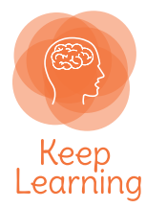

What should I know already? | What will I know by the end of the unit?
Drawing Skills  ● I can use a range of different media with control ● Line- control lines made  ● Tone- make light and dark lines and patterns by using and selecting different media  ● Texture- investigate and discuss a range of textures  ● Shape- draw shapes from observation and memory  Painting Skills  ● I can use a range of tools and techniques ● I can work on different scales  ● I can mix primary shades and create new colours  ● I can choose different colours for a purpose ● I can use different types of paint  ● I can try different printing techniques  Digital  ● Use simple graphics programs to create images and effects  ● Take photographs of their surroundings  Collage  ● Experiment and use a range of materials  ● Create and copy different images using different media  ● Use a variety of techniques  Drawing Skills  ● I can use a range of different media with control ● Line- control lines made  ● Tone- make light and dark lines and patterns by using and selecting different media  ● Texture- investigate and discuss a range of textures  ● Shape- draw shapes from observation and memory  Painting Skills  ● I can use a range of tools and techniques ● I can work on different scales  ● I can mix primary shades and create new colours  ● I can choose different colours for a purpose ● I can use different types of paint  ● I can try different printing techniques | Reconnect with and continue to build upon Skills outlined. New skills listed below.
Sculpture
● Reconnect with Andy Goldsworthy focus in AUT ● Explore sculpture with a range of malleable
materials
● Use a range of different tools to create different effects
● Experiment with constructing and joining different materials

Vocabulary |  | Biographical Information
Sculpture | Sculpture is a branch of the visual arts. It involves the creation of artistic objects in three dimensions—length, width, and height | Background  - Cornish artist  - Creates artwork inspired by sea creatures but made from plastic and rubbish found in the sea  - Based on Rame Peninsula  - Has made large and small scale pieces of art
Joins | A place or line where two or more things are connected or fastened together
Recycle | Convert (waste) into reusable material; use again
Pollution | The presence in or introduction into the environment of a substance which has harmful or poisonous effects

Image/diagram that helps me to articulate my knowledge/understanding | Investigate!
Liz Franklin: 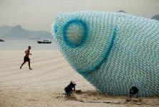  https://lizfranklin-art.weebly.com/  Sea Life Sculpture video:  https://youtu.be/pfvXkl80tmk  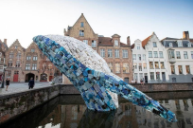 | Q: What is this? What is it made of?  Children could then bring in junk to make sculptures of their own sea creatures. They could then give them a name and label their features, how they live etc.

