Goonhavern Primary School- Art
TOPIC: What Makes Our Hearts Sing? Or How do Communities Celebrate Happy Times?  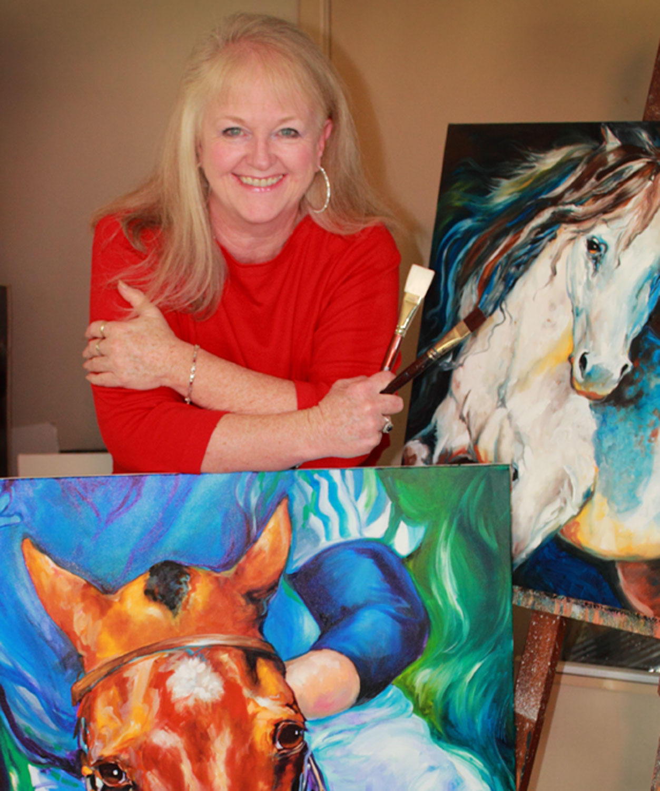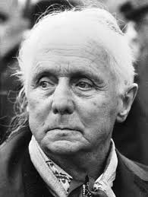 | YEAR: 2 | STRAND: Collage, Drawing, Digital and Artists
School Values
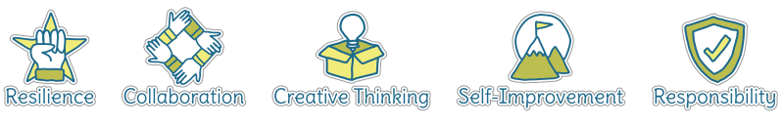
Five Ways to Wellbeing
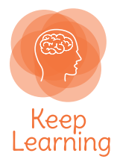

What should I know already? | What will I know by the end of the unit?
- How to create a collage using a variety of materials  - How to observe objects and copy them using line and shape  - How to create a picture using paint, holding and using painting tools correctly  - How to create a sculpture using clay  - How to use a camera to take a self-portrait  - That artists such as Van Gogh and Picasso all painted self-portraits  - That natural and man-made objects can be used to print creatively and create patterns  - That a variety of natural and man-made objects in our school environment have textures that can be captured by using a rubbing technique  - To be able to talk about my work and the work of other artists, expressing likes and dislikes | Collage | - Use a range of materials, including paint, pastels, digital images and rubbings  - Copy images using different media then create own work  - Sort and group materials for different purposes  - Use a variety of techniques
 | Drawing | - Line- control lines made from copying and inventing new lines  - Shape- draw shapes using observational skills, from memory and invent new shapes in artwork linked to nature
 | Digital | - Take photographs of things in nature eg leaves and bark, and use them in own artwork
 | Artists | - Find out about the work of different artists, craft-makers and designers  - Describe the similarities and differences between different practises and disciplines  - Copy the artwork of artists and begin to make links to own work
 | Evaluation | - Evaluate my work and that of other artists using the language of art, craft and design

Vocabulary
Artist | A person who creates paintings or drawings as profession or hobby | Medium | Material used to create a piece of art
Clay | A stiff, sticky earth that can be moulded when wet and is then dried to make pottery | Mixed media | A picture created using more than one type of medium
Cold colours | Colours associated with rest, peace and sadness including blue, green and purple | Observational drawings | A visual representation of something an artist sees
Collage | A picture made from a variety of materials | Palette | A thin board on which an artist lays and mixes colours
Colour wheel | A wheel of colours that shows the relationship between primary and secondary colours | Pastels | Crayons made from powdered pigments
Complementary colours | Colours that are opposite each other on the colour wheel | Pattern | A repeated decorative design
Craft-makers | People who are skilled at making things by hand | Secondary colour | A colour made by mixing two primary colours
Designers | People who plan the look of something before it is made | Shade | A colour mixed with black to make it darker
Details | Minor decorative features | Sketch | A quick, rough drawing
Evaluate | To make a judgement or have an opinion about | Technique | A way of doing something
Frottage | Technique of taking a rubbing from a textured surface to use in a piece of artwork | Tone | The lightness or darkness of a colour
Hot colours | Colours associated with heat, anger and energy including red, orange and yellow | Weaving | A technique that involves interlacing materials like threads, paper or wood
Line | A long narrow mark or band

Image/diagram that helps me to articulate my knowledge/understanding | Investigate!
Marcia Baldwin  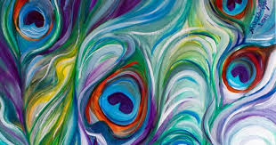  Max Ernst  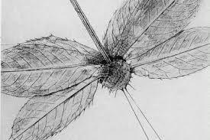  Mehendi Design  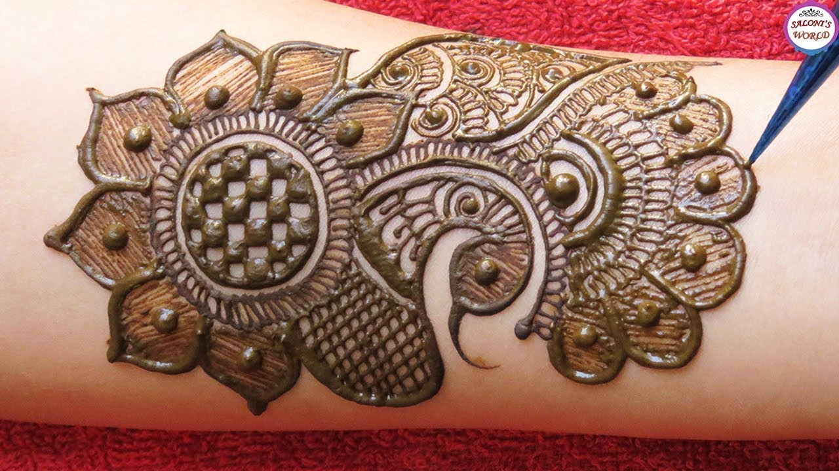 | Introduce collage inspired by feather paintings by Marcia Baldwin. Children use pastels, pencils and paint to create feathers in the style of Marcia Baldwin. Children can explore painting techniques using a variety of different sized cotton buds to create dots and sweeping lines.  Introduce the term ‘frottage.’ Children can investigate texture in nature by making rubbings or taking photos. Children could then tear their work to create a picture in the style of Max Ernst, the creator of this technique.  Children can explore the skills of drawing with lines and shapes by studying Mehendi body art. They will create their own hand patterns, taking their inspiration from nature and from other examples of hand art.  Children will then evaluate their skills, thinking about anything they might change or improve.

