Goonhavern Primary School- Art
TOPIC: How Does Your Garden Grow?  Claude Monet  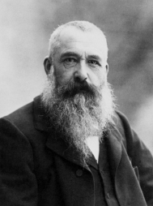 | YEAR: 2 | STRAND: Painting, Drawing, Sculpture and Artists
School Values
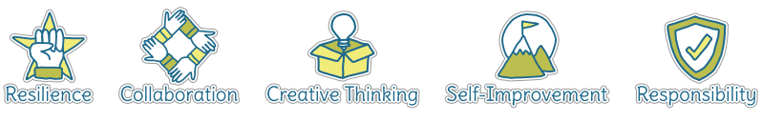
Five Ways to Wellbeing
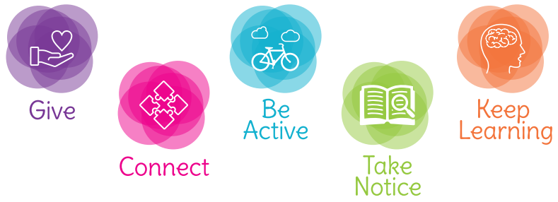

What should I know already? | What will I know by the end of the unit?
- How to create a collage using a variety of materials  - How to observe objects and copy them using line and shape  - How to create a picture using paint, holding and using painting tools correctly  - How to create a sculpture using clay  - How to use a camera to take a self-portrait  - That artists such as Van Gogh and Picasso all painted self-portraits  - That natural and man-made objects can be used to print creatively and create patterns  - That a variety of natural and man-made objects in our school environment have textures that can be captured by using a rubbing technique  - To be able to talk about my work and the work of other artists, expressing likes and dislikes | Painting | - Experiment with a range of tools and techniques  - Create tones of colour by adding white and shades by adding black  - Explore warm and cold colours and the emotions linked to these
 | Drawing | - Draw using a range of different pencil types (HB- Hardness B-Blackness)  - Explore and experiment with different pencil types to produce lines of different thickness, shade and tone  - Line- control lines made from copying and invent new lines  - Tone- make light and dark lines, patterns and shades by using and collecting different media  - Texture- discuss a range of different textures in drawing and how these can be achieved  - Shape- draw shapes from memory and invent new shapes in artwork
 | Sculpting | - Manipulate malleable materials for a purpose  - Experiment with constructing and joining different materials  - Create 3-D works from 2-D images
 | Artists | - Find out about the work of different artists  - Describe the similarities and differences between different practises and disciplines  - Copy the work of artists and begin to make links to own work

Vocabulary
Artist | A person who creates paintings or drawings as profession or hobby | Medium | Material used to create a piece of art
Clay | A stiff, sticky earth that can be moulded when wet and is then dried to make pottery | Mixed media | A picture created using more than one type of medium
Cold colours | Colours associated with rest, peace and sadness including blue, green and purple | Observational drawings | A visual representation of something an artist sees
Collage | A picture made from a variety of materials | Palette | A thin board on which an artist lays and mixes colours
Colour wheel | A wheel of colours that shows the relationship between primary and secondary colours | Pastels | Crayons made from powdered pigments
Complementary colours | Colours that are opposite each other on the colour wheel | Pattern | A repeated decorative design
Craft-makers | People who are skilled at making things by hand | Secondary colour | A colour made by mixing two primary colours
Designers | People who plan the look of something before it is made | Shade | A colour mixed with black to make it darker
Details | Minor decorative features | Sketch | A quick, rough drawing
Evaluate | To make a judgement or have an opinion about | Technique | A way of doing something
Frottage | Technique of taking a rubbing from a textured surface to use in a piece of artwork | Tone | The lightness or darkness of a colour
Hot colours | Colours associated with heat, anger and energy including red, orange and yellow | Weaving | A technique that involves interlacing materials like threads, paper or wood
Line | A long narrow mark or band

Biographical Information
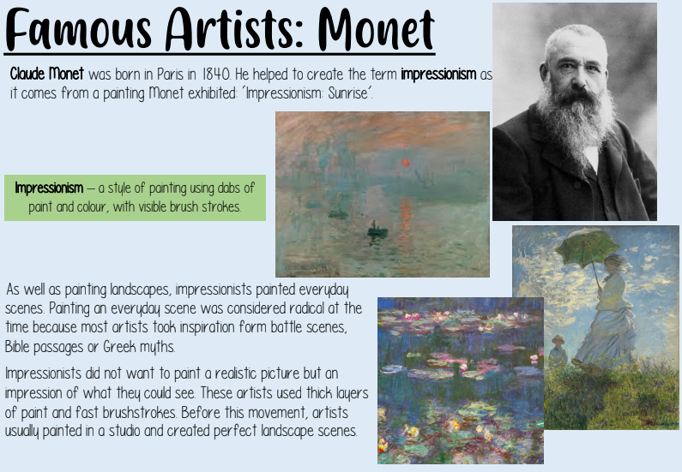
Image/diagram that helps me to articulate my knowledge/understanding | Investigate!
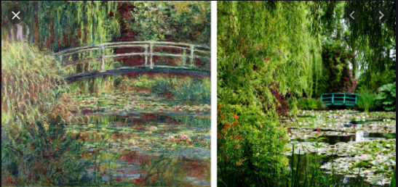  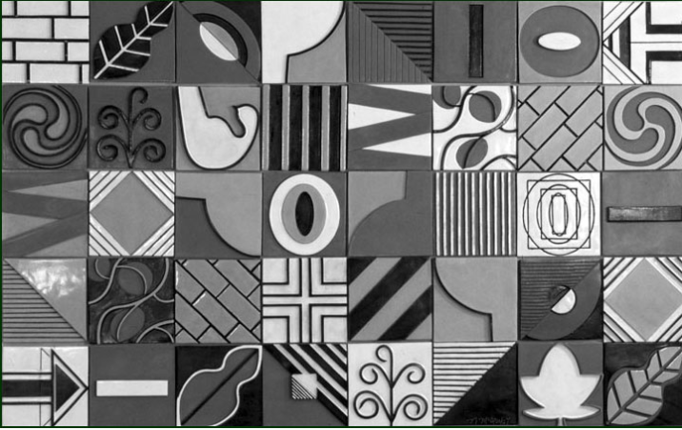 | Painting  - Introduce children to Monet’s artwork and share photographs of Monet’s garden at Giverny https://youtu.be/rjWx2WNXFF4  - Discuss the term ‘impressionism’ and what it means  - Children to sketch then paint views of our school grounds, experimenting with tone and colour  - Evaluate painting, identifying things I would change or improve  Drawing  - Children explore line, tone and shade using different types of pencil, working in the style of Nancy McCroskey. Children to look at her work ‘Suite in Black, Grey and White.’ http://www.nancymccroskey.com/muralshtml/blackwhitegray.html  - Each child to then draw a square inspired by their time outside which will then ‘fit’ together to form a whole class picture  - Evaluate drawing, identifying things I would change or improve  Weaving  - Children explore weaving techniques using paper strips (weft), weaving through card (warp) to create an Easter basket to hold a mini-egg  - Evaluate my basket, identifying things/ skills I would change or improve

