Goonhavern Primary School- Art
TOPIC: Is Cornwall the best place to live?  Alfred Wallis  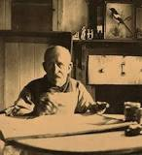 | YEAR: 2 | STRAND: Painting, Drawing, Sculpture and Artists
School Values

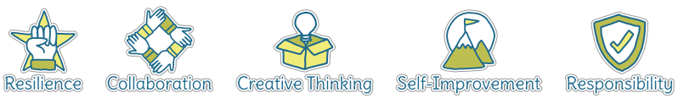
Five Ways to Wellbeing
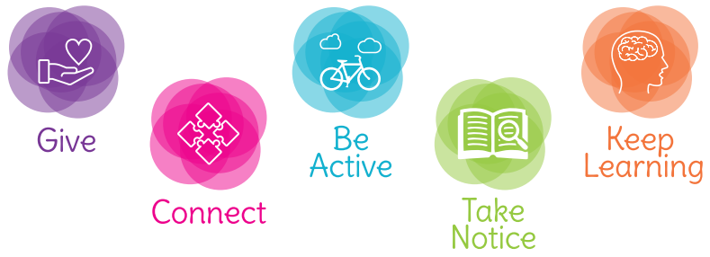

What should I know already? | What will I know by the end of the unit?
- How to create a collage using a variety of materials  - How to observe objects and copy them using line and shape  - How to create a picture using paint, holding and using painting tools correctly  - How to create a sculpture using clay  - How to use a camera to take a self-portrait  - That artists such as Van Gogh and Picasso all painted self-portraits  - That natural and man-made objects can be used to print creatively and create patterns  - That a variety of natural and man-made objects in our school environment have textures that can be captured by using a rubbing technique  - To be able to talk about my work and the work of other artists, expressing likes and dislikes | Painting | - Experiment with a range of tools and techniques  - Create tones of colour by adding white and shades by adding black  - Explore warm and cold colours and the emotions linked to these
 | Drawing | - Draw using a range of different pencil types (HB- Hardness B-Blackness)  - Explore and experiment with different pencil types to produce lines of different thickness, shade and tone  - Line- control lines made from copying and invent new lines  - Tone- make light and dark lines, patterns and shades by using and collecting different media  - Texture- discuss a range of different textures in drawing and how these can be achieved  - Shape- draw shapes from memory and invent new shapes in artwork
 | Sculpting | - Manipulate malleable materials for a purpose  - Experiment with constructing and joining different materials  - Create 3-D works from 2-D images
 | Artists | - Find out about the work of different artists  - Describe the similarities and differences between different practises and disciplines  - Copy the work of artists and begin to make links to own work
 | Digital | - Explore photographic techniques, taking photographs of variations of the same type of object  - Arrange photos creatively to produce original artwork
 | Photographic Collage | - Sort and group images for different purposes  - Creatively position photographic images to produce artwork  - Explore a variety of techniques

Vocabulary
Artist | A person who creates paintings or drawings as profession or hobby | Medium | Material used to create a piece of art
Clay | A stiff, sticky earth that can be moulded when wet and is then dried to make pottery | Mixed media | A picture created using more than one type of medium
Cold colours | Colours associated with rest, peace and sadness including blue, green and purple | Observational drawings | A visual representation of something an artist sees
Collage | A picture made from a variety of materials | Palette | A thin board on which an artist lays and mixes colours
Colour wheel | A wheel of colours that shows the relationship between primary and secondary colours | Pastels | Crayons made from powdered pigments
Complementary colours | Colours that are opposite each other on the colour wheel | Pattern | A repeated decorative design
Craft-makers | People who are skilled at making things by hand | Secondary colour | A colour made by mixing two primary colours
Designers | People who plan the look of something before it is made | Shade | A colour mixed with black to make it darker
Details | Minor decorative features | Sketch | A quick, rough drawing
Evaluate | To make a judgement or have an opinion about | Technique | A way of doing something
Frottage | Technique of taking a rubbing from a textured surface to use in a piece of artwork | Tone | The lightness or darkness of a colour
Hot colours | Colours associated with heat, anger and energy including red, orange and yellow | Weaving | A technique that involves interlacing materials like threads, paper or wood
Line | A long narrow mark or band

Image/diagram that helps me to articulate my knowledge/understanding | Investigate!
Alfred Wallis biographical information: https://www.tate.org.uk/kids/explore/who-is/who-alfred-wallis  Amiria Gale  https://www.amiriagale.com/shell-paintings/  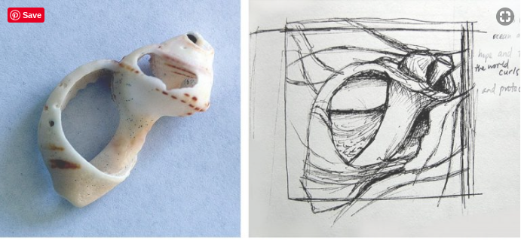  Barbara Hepworth  https://www.tate.org.uk/art/artists/dame-barbara-hepworth-1274/who-is-barbara-hepworth | Painting  - Introduce children to the works of Alfred Wallis  - Children to create images in Wallis’ naive style (see Tate link)  - Children create secondary colours to use in their work  - Evaluate my painting, identifying things I would change or improve  Drawing  - Look at examples of shell art by Amiria Gale and discuss mediums and techniques used. Children should be encouraged to use knowledge based on Spring Term experiences  - Children observe and draw a variety of shells using line, tone, shade and pattern to create texture and a sense of depth in their artwork  - Evaluate my drawing skills, identifying things I would change or improve. Modify my work in light of my evaluation  Sculpting  - Children look at images of sculptures by Barbara Hepworth and consider techniques that might be used to recreate aspects of her sculptures in their own work  - Children explore and develop sculpting and modelling skills to join pieces of clay to create their own Hepworth-inspired sculptures

