Goonhavern Primary School- Art
TOPIC: How did the first people on earth live?  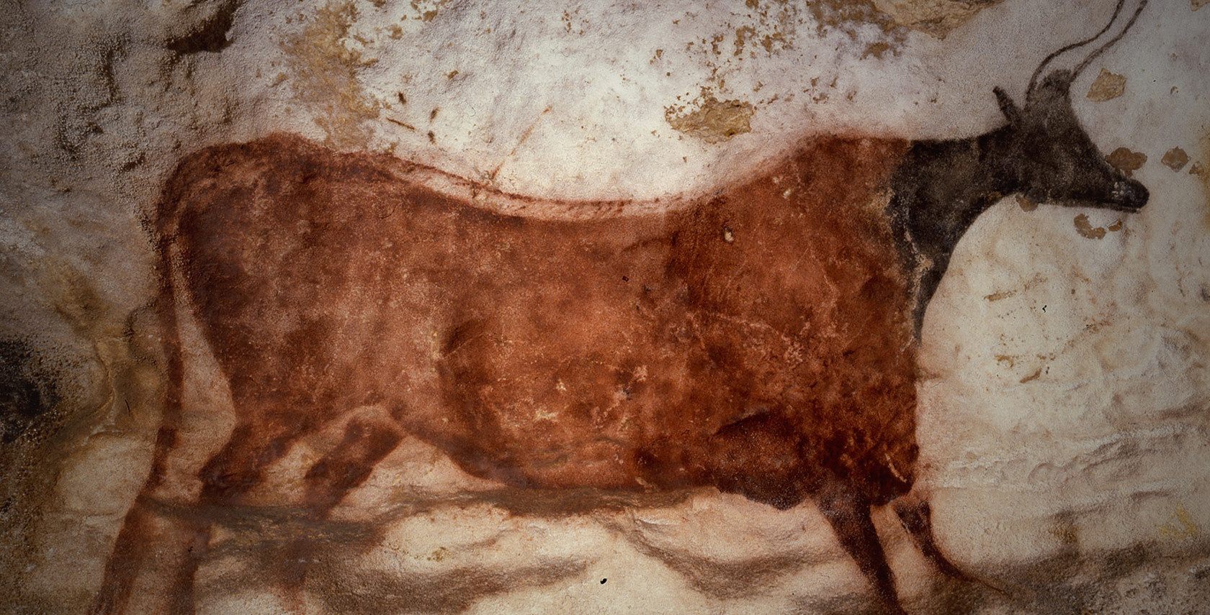 | YEAR: Y3 | STRAND: Drawing, Painting, Digital, Artist
School Values
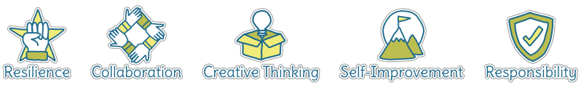
Five Ways to Wellbeing


What should I know already? | What will I know by the end of the unit?
- How to create a picture using paint, holding and using a variety of painting tools and other equipment correctly  - How to use paint and equipment in a variety of ways to create different effects such as dots and lines  - How to create pictures with texture using rubbings and tearing paper  - How to create a drawing using different lines and shapes  - How to create a sculpture using clay  - To be able to talk about my work and the work of other artists, expressing likes and dislikes | Drawing  - Use sketchbooks to collect and record information, famous artwork, annotations and drawn ideas. Start to draw for a sustained amount of time at own level  - Line- make marks and lines with a wide range of drawing implements, including different grades of pencil  - Tone- apply different tones by drawing in a different way  - Texture- create texture with a wider range of drawing implements
Sculpture
- Plan, design and make models from observation and own imagination
- Join clay with increasing accuracy and construct a simple base for extending and modelling
Artists
- Find out about the work of different artists, craft-makers and designers
- Make links to own artwork
- Investigate different cultures
Evaluation
- Evaluate my work and that of other artists using the language of art, craft and design

Vocabulary
annotations | A note added to a diagram or picture | pastels | Crayons made from powdered pigments
artist | A person who creates paintings or drawings as a profession or hobby | pattern | A repeated decorative design
charcoal | A lightweight black material created by burning carbon | Prehistoric | A time before history was recorded by writing
clay | A stiff sticky earth that can be moulded when wet and is then dried to make pottery | sculpt | To make a form by carving or casting
coil pots | Pots produced by stacking and joining colis of clay | sculpture | The art of making statues by carving, chiselling, modelling or casting
construct | To build or make something | shade | A colour mixed with black to make it darker
depth | A measurement from top to bottom | shape | The outside line of something
details | Minor decorative features | sketch | A quick, rough drawing or plan
dye | A substance used to colour or change the colour of something | technique | A way of doing something
evaluate | To make a judgement or have an opinion about | tone | The lightness or darkness of a colour
fabric | Cloth produced by weaving or knitting | texture | The feel or appearance of a surface
line | A long narrow mark or band
medium | Refers to the different materials that can be used to create a piece of artwork
natural materials | A product that comes from plants, animals or the ground

Image/diagram that helps me to articulate my knowledge/understanding | Investigate!
Lascaux Links:  https://www.lascaux.fr/en  https://www.khanacademy.org/humanities/ap-art-history/global-prehistory-ap/paleolithic-mesolithic-neolithic-apah/a/lascaux  Video:  https://youtu.be/UnSq0c7jM-A  https://youtu.be/ZjejoT1gFOc | Drawing  - Explore depth and tone using a range of pencils. Introduce the use of charcoal for added depth  Cave Painting  - Introduce examples of prehistoric art found in the Lascaux cave  - Look at the origins of cave art and the reasons behind them  - Try drawing in different textures such as sand, experience painting with different natural materials such as feathers, fingers and twigs. Try this onto paper attached to the underside of tables  - Make charcoal pencils and experiment with line making  - Using pastel and charcoal create pictures that tell a story and share each story  Fabric Dyeing  - Use a variety of natural materials to dye fabric as people would have done in the Stone Age. Explore the different effects that a range of materials has e.g. bark, berries  Clay  - Research, design and make Stone Age coil pots for food or drink  Artist  - Look at the work of Andy Goldsworthy (connection to Y1).  - Create a work in his style using natural materials

