Goonhavern Primary School- Art
TOPIC: Christianity/ Hinduism  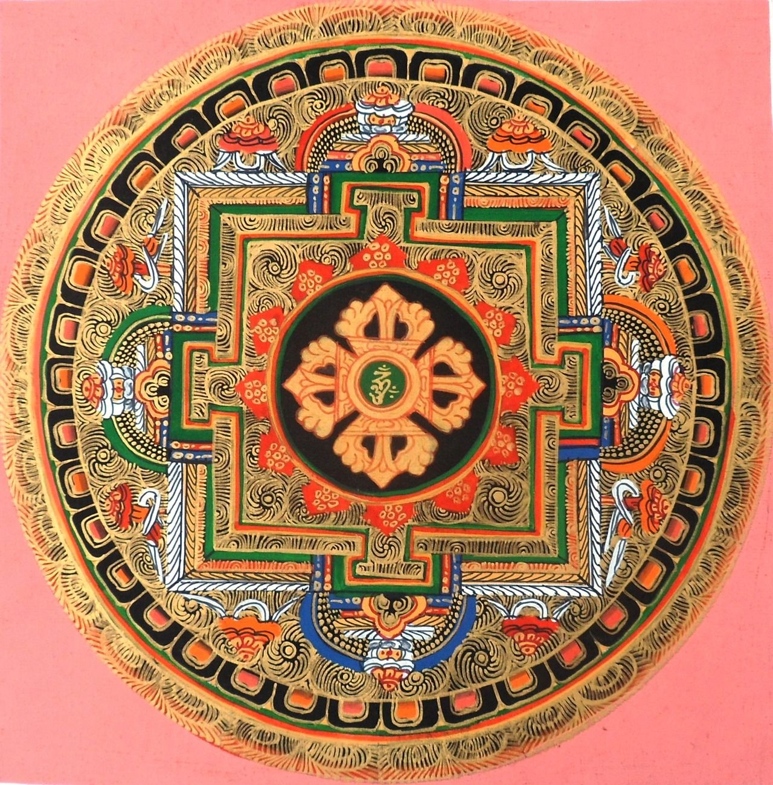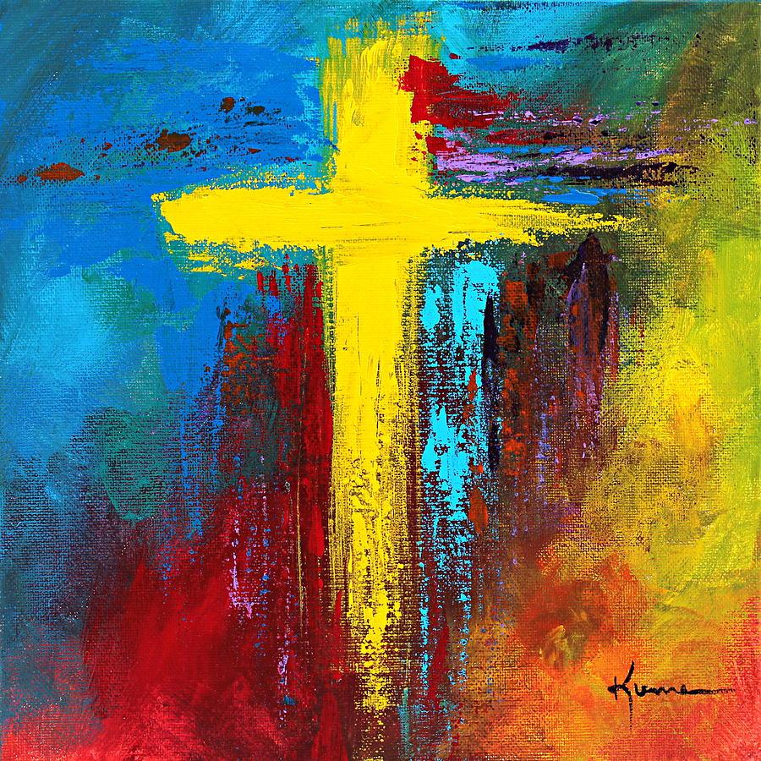 | YEAR: Y3 | STRAND: Drawing, Sculpture, Painting
School Values
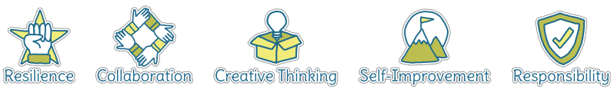
Five Ways to Wellbeing
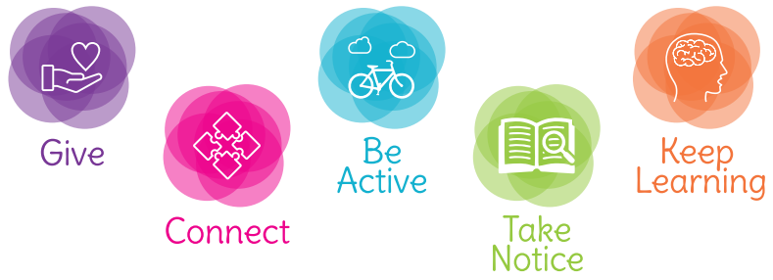

What should I know already? | What will I know by the end of the unit?
- How to create a picture using paint, holding and using a variety of painting tools and other equipment correctly  - How to use paint and equipment in a variety of ways to create different effects such as dots and lines  - How to create pictures with texture using rubbings and tearing paper  - How to create a drawing using different lines and shapes  - How to create a sculpture using clay  - To be able to talk about my work and the work of other artists, expressing likes and dislikes | Drawing  - Use sketchbooks to collect and record information, famous artwork, annotations and drawn ideas.  - Draw for a sustained amount of time at own level  - Line- experiment with different grades of pencil and other implements to create lines and marks  - Tone- apply different tones by drawing in a different way  - Texture- apply simple use of pattern and texture in drawings
Painting
- Experiment with different effects and textures
- Mix colours to create own desired colours using more specific colour language e.g. hue, tint, tone, shade
- Show increasing independence and creativity with the painting process
Sculpture
- Plan, design and make models from observation and own imagination
- Join clay with increasing accuracy and construct a simple base for extending and modelling
- Create surface pattern and texture in a variety of malleable materials using a range of tools

Artists
- Find out about the work of different artists, craft-makers and designers
- Make links to own artwork
- Investigate different cultures
Evaluation
- Evaluate my work and that of other artists using the language of art, craft and design

Vocabulary
annotations | A note added to a diagram or picture | pastels | Crayons made from powdered pigments
artist | A person who creates paintings or drawings as a profession or hobby | pattern | A repeated decorative design
charcoal | A lightweight black material created by burning carbon | sculpt | To make a form by carving or casting
clay | A stiff sticky earth that can be moulded when wet and is then dried to make pottery | sculpture | The art of making statues by carving, chiselling, modelling or casting
coil pots | Pots produced by stacking and joining colis of clay | shade | A colour mixed with black to make it darker
construct | To build or make something | shape | The outside line of something
depth | A measurement from top to bottom | sketch | A quick, rough drawing or plan
details | Minor decorative features | technique | A way of doing something
dye | A substance used to colour or change the colour of something | tone | The lightness or darkness of a colour
evaluate | To make a judgement or have an opinion about | texture | The feel or appearance of a surface
fabric | Cloth produced by weaving or knitting
hue | The actual colour of something
line | A long narrow mark or band
mandala | A symbolic picture of the universe
medium | Refers to the different materials that can be used to create a piece of artwork

Image/diagram that helps me to articulate my knowledge/understanding | Investigate!
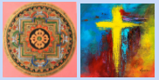  Sand Mandala video:  https://youtu.be/WBrYUlOYK0U  The Meaning of Mandala:  https://youtu.be/G58Pujijsqc  How to Draw Mandalas:  https://youtu.be/v7mpLtbgQbw  Mandalas in Nature:  https://artfulparent.com/mandalas-in-nature-mandala-art/ | Drawing  - Find examples of mandalas in Nature and sketch in sketchbooks  - Draw mandalas with a higher level of precision, freehand initially,then using a compass  Painting  - Create own mandala using different hues of paint  - Experiment with making mandalas using sand  - Create different cross images using a range of techniques  Sculpture  - Create lotus flower tiles adding lines to create texture  - Create cross/ dove tiles adding lines to create texture

