Goonhavern Primary School- Art
TOPIC: Georgia O’Keeffe  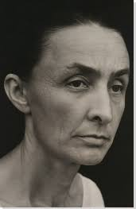 | YEAR: Y3 | STRAND: Wonders of the World
School Values

Five Ways to Wellbeing


What should I know already? | What will I know by the end of the unit?
Cultural Understanding  - Develop an understanding about different types and styles of painting- Seurat, Monet, Lowry.  - Identify and describe differences in paintings from a wide range of times and places.  - Develop an understanding of the different purposes of painting and the intention of the artist.  - Understand that a painting does not have to look like a photograph.  Knowledge and Skills  - Draw things I see, know and remember and be able to do so confidently.  - Develop, and use expressively, an increasing range of marks, lines and patterns.  - Explore and experiment with scale.  - Use a wide variety and develop control over a range of media.  - Select from, arrange and mix a variety of drawing media. | - Georgia painted close up views of flowers. She used oil paints in vibrant, bold colours. Painting the flowers at such a close range makes the viewer see the object in a completely different way.  - In 1929, O’Keeffe visited New Mexico and was amazed at the landscape; the incredible rock formations, the unusual light, the bones of animals dried out by the sun and the Navajo culture.  - Modernism- A movement in art to break with what has happened in the past and to find new ways to express feelings through art.  - Realism- A movement in art to show how objects actually are.  - Abstract art- To show objects just in terms of their lines, shapes and colours.  Knowledge and Skills  - Use a sketchbook to record their ideas, observations and imaginative drawings using an increasing range of marks, lines and patterns.  - Make choices from a range of different tools and surfaces.  - Use drawings as a basis for working in other media  - Explore a sense of scale

Vocabulary
Modernism | A movement in art to break with what has happened in the past and to find new ways to express feelings through art.
Realism | A movement in art to show how objects actually are.
Abstract | Abstract art- To show objects just in terms of their lines, shapes and colours.
Biographical Information
Full name | Georgia Totto O’Keeffe
Born | 15th November 1887 in Wisconsin, USA.
Family | One of seven children. Georgia’s mother encouraged her interest in art.
Died | 6th March 1986 aged 98 years old.
Education | She studied at the Art Institute of Chicago and had her first gallery show in 1916.
Later life | She began to lose her eyesight and in 1972 she painted her last unassisted painting.
Art movement | Modernism

Image/diagram that helps me to articulate my knowledge/understanding | Investigate!
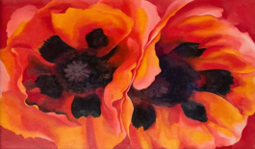 | 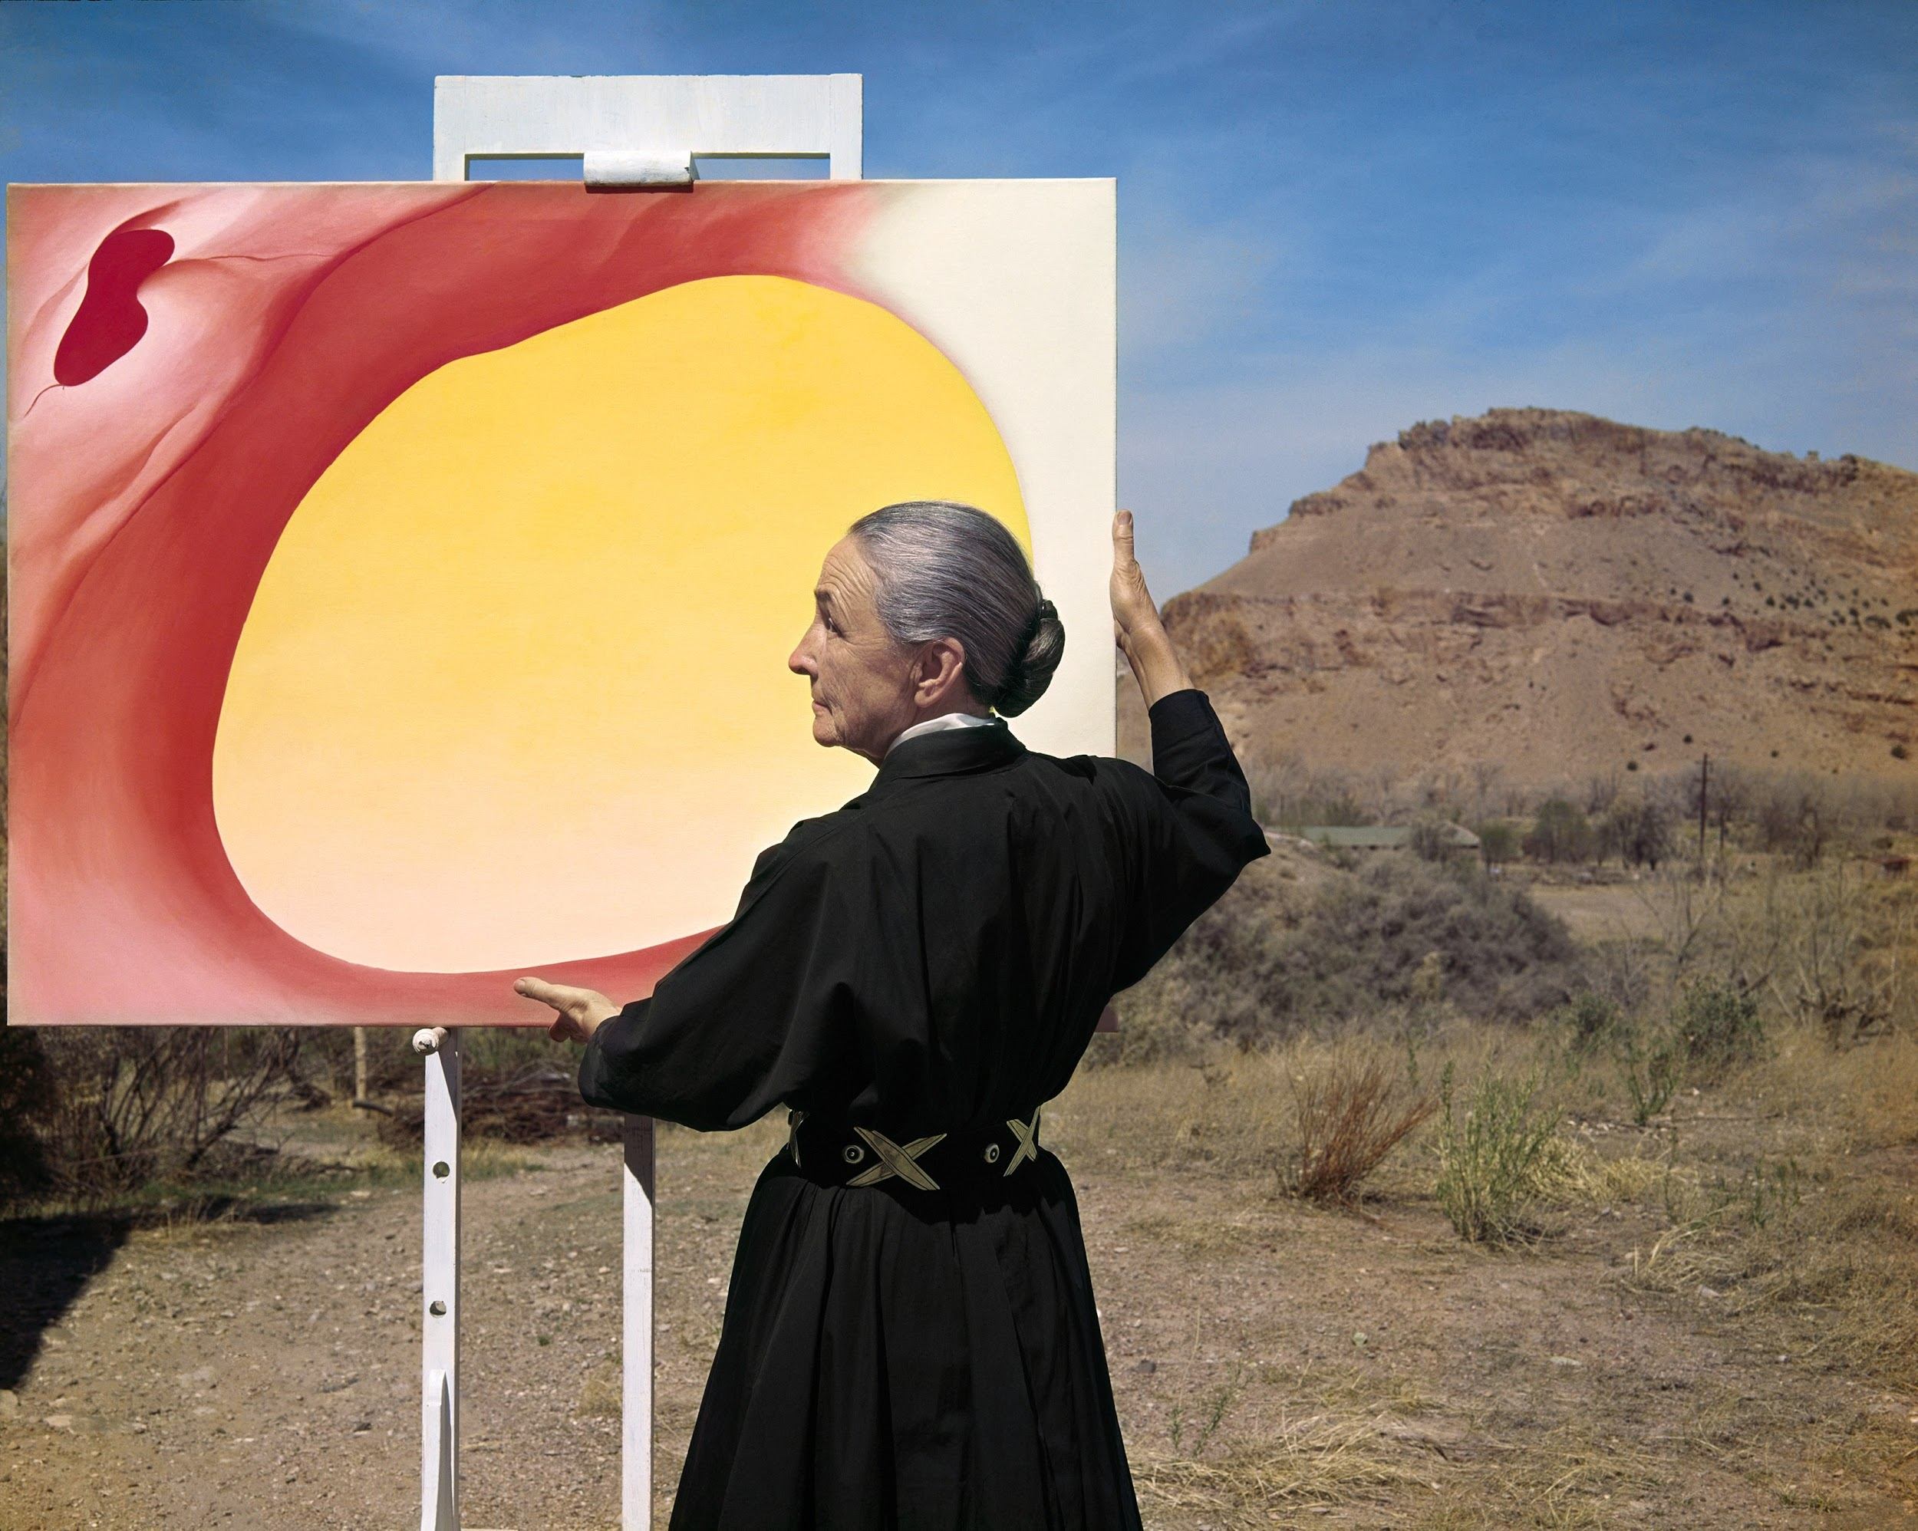  Q: What can you say about this picture of Georgia O’Keeffe?  Q: What questions does it make you want to ask?

