Goonhavern Primary School- Art
TOPIC: Beach School/ Cornwall  Kurt Jackson  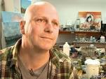 | YEAR: 4 | STRAND: Drawing, Painting, Collage and Artists
School Values
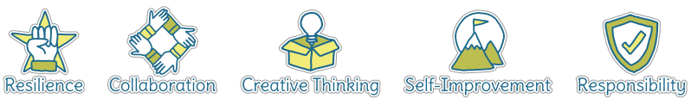
Five Ways to Wellbeing
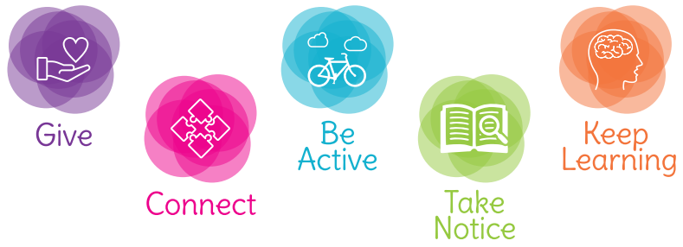

What should I know already? | What will I know by the end of the unit?
Drawing  - Use sketchbook to collect and record information, famous artwork, annotations and drawn ideas  - Start to draw for a sustained amount of time at my own level  - Line- make marks and lines with a wide range of drawing implements, including different grades of pencil  - Tone- apply different tones by drawing in a different way  - Texture- create texture with a wider range of drawing implements  - Shape- use of symmetry and shape in artwork  Painting  - Use paint and printing to create repeated patterns  - Mix a variety of colours and know which primary colours make secondary colours  - Print using a variety of materials, objects and techniques including layering  - Talk about the processes used to produce a simple print  Collage  - Copy images using a range of media and create own work  - Experiment with various textures, colours and patterns and create contrasting images  Artists  - Find out about the work of different artists, craft makers and designers  - Make links to own artwork  - Investigate different cultures | Drawing  - Use sketchbook to collect and record information, famous artwork, annotations and drawn ideas  - Draw for a sustained amount of time at my own level  - Line- experiment with different grades of pencil and other implements to create lines and marks  - Tone- apply different grades of pencil to achieve variation in tone  - Texture- apply simple use of pattern and texture in drawings  - Shape- begin to show awareness of shapes having a third dimension  Painting  - Experiment with different effects and textures according to what they need for the task  - Mix colours to create own desired colours, using more specific colour language e.g. tint, tone, shade, hue  - Interpret music, stories, poems and other stimuli in artwork  - Research, create and refine a print using a variety of techniques  Collage  - Use collage as a means of collecting ideas and information and building a visual vocabulary  - Incorporate textiles into artwork  - Resist printing e.g. marbling and screen-printing  - Create surface patterns and textures in a variety of malleable materials  Work of other artists  - Find out about the work of different artists, craft makers and designers  - Make links to their own artwork  - Investigate different cultures  Evaluation  - Evaluate my work and that of other artists using the language of art, craft and design

Vocabulary
artist | A person who creates art as a profession or hobby | pattern | A repeated decorative design
blending | Mixing two or more colours to soften lines | printing | A technique used to create an image using a reusable carved stamp. There are different types of printing.
blocking | Painting in simple blocks, or shapes, of colour | scumbling | Creating controlled scribbled marks
craft makers | People who are skilled at making things by hand | shade | A colour mixed with black to make it darker
designers | People who plan the look of something before it is made | shape | The outside line of something
details | Minor decorative features | sketch | A quick, rough drawing
evaluate | To make a judgement or have an opinion about | stippling | Small, distinct dots of colour are applied in patterns to form an image
hatching | An artistic technique used to create tonal or shading effects by drawing closely spaced parallel lines | technique | A way of doing something
line | A long narrow mark or band | texture | The feel or appearance of a surface
medium | Refers to the different materials that can be used to create a piece of art | tone | The lightness or darkness of a colour
mixed media | A picture created using more than one medium
observational drawings | A visual representation of something an artist sees
pastels | Crayons made from powdered pigments

Image/diagram that helps me to articulate my knowledge/understanding | Investigate!
Kurt Jackson:  https://www.kurtjackson.com/  Kurt Jackson Way of Working:  https://youtu.be/UCtqPjInNmA  https://youtu.be/ktMadM_ubME re-edit  Possible precursor to KJ:  Jackson Pollock:  https://www.tate.org.uk/art/artists/jackson-pollock-1785 | Use skills learnt this year to create a piece of art inspired by the work of Kurt Jackson  Drawing  - Children could gather sketches, materials, words whilst at Beach school, collect in sketchbooks  Painting  - Experiment creating work outside- does it feel different?  - Experiment with layers of paint, then washing them off- what effects can you create?  Collage  - Whilst at Beach school, collect objects on the beach to add to KJ collage- seaweed, pieces of rope, nurdles etc

