Goonhavern Primary School- Art
TOPIC: Who were the real Vikings?  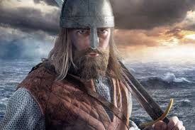 | YEAR: 5 | STRAND: Drawing, Collage, Sculpture and Artists
School Values
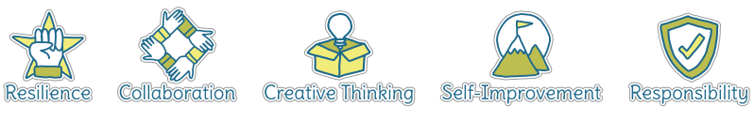
Five Ways to Wellbeing
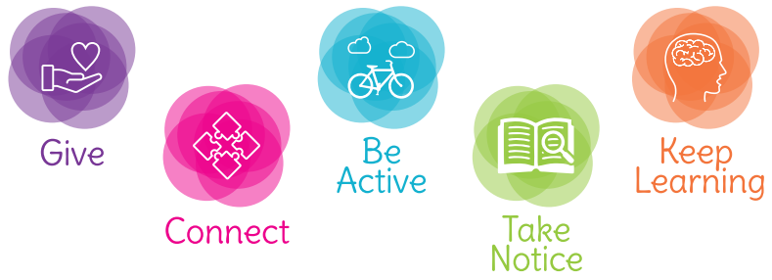

What should I know already? | What will I know by the end of the unit?
- How to create a collage using a variety of materials  - How to observe objects and copy them using lines and shapes  - To be able to talk about my work and the work of other artists, expressing likes and dislikes | Exploring and Developing Ideas  - Ask questions and make observations about stimuli, including about great artists, architects and designers in history as starting points for own work  - Investigate, collect and record information in the development of imaginative ideas including the use of sketchbooks  Investigating and Making  - Draw on experiences of different materials, techniques and processes when selecting and combining media to develop observations, ideas and feelings, matching their qualities to the purpose of the work  - Improve mastery of techniques  Knowledge and Understanding  - Be familiar with the roles and purposes of different artists working in different times and cultures, including individual artists who have particular significance in the history of art  - Be familiar with a range of materials and processes used in art, craft and design  - Know about visual and tactile elements including colour, pattern and texture and how these elements can be combined and organised for different purposes  - Develop techniques, including control and use of materials along with an increasing awareness of different kinds of art, craft and design  Evaluating and Developing Work  - Evaluate outcomes according to their views and intentions and use to inform future creative work

Vocabulary
artist | A person who creates art as a profession or hobby | mixed media | A picture created using more than one medium
cold colours | Colours associated with rest, peace and sadness e.g. blue, purple and green | observational drawings | A visual representation of something an artist sees
collage | A picture made from a variety of materials | pattern | A repeated decorative design
Craft makers | People who are skilled at making things by hand | score | Marked lines where two pieces will be joined together
designers | People who plan the look of something before it is made | sculpt | To make a 3-D piece of art by casting, chiselling or constructing
details | Minor decorative features | shape | The outside line of something
evaluate | To make a judgement or have an opinion about | sketch | A quick, rough drawing
hot colours | Colours associated with energy, anger and heat e.g. yellow, red and orange | tapestry | A strong cloth with coloured threads woven into it to create a picture or design, usually hung on a wall or used to cover furniture
jewellery | Decorative items worn for personal adornment | technique | A way of doing something
medium | Refers to the different materials that can be used to create a piece of art | texture | The feel or appearance of a surface
 |  | tone | The lightness or darkness of a colour

Image/diagram that helps me to articulate my knowledge/understanding | Investigate!
Inspiration:  https://www.jorvikvikingcentre.co.uk/  Styles of Viking Art:  http://www.hurstwic.org/history/articles/manufacturing/text/norse_art.htm  chrome-extension://bpmcpldpdmajfigpchkicefoigmkfalc/views/app.html  Viking Shield Designs:  http://www.hurstwic.org/history/articles/manufacturing/text/viking_shields.htm | Exploring and Developing Ideas  Investigate the links between faith and art. Research Norse gods- then design and sketch an item that includes a Norse god.  Investigating and Making  Jewellery- Research Viking jewellery. Draw designs for pieces of Viking jewellery incorporating Norse gods.  Knowledge and Understanding  Research Viking shield designs  Collage  Create a Viking collage- longship, shield, helmet

