Goonhavern Primary School- Art
TOPIC: Earth and Space  Peter Thorpe  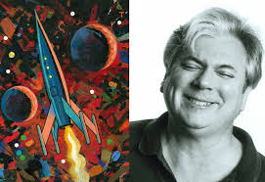 | YEAR: 5 | STRAND: Drawing, Painting, Sculpture and Other Artists
School Values
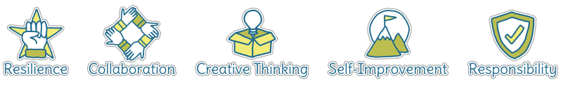
Five Ways to Wellbeing


What should I know already? | What will I know by the end of the unit?
- How to create a collage using a variety of materials  - How to observe objects and copy them using lines and shapes  - To be able to talk about my work and the work of other artists, expressing likes and dislikes | Exploring and Developing Ideas  - Ask questions and make observations about stimuli, including about great artists, architects and designers in history as starting points for own work  - Investigate, collect and record information in the development of imaginative ideas including the use of sketchbooks  Investigating and Making  - Draw on experiences of different materials, techniques and processes when selecting and combining media to develop observations, ideas and feelings, matching their qualities to the purpose of the work  - Improve mastery of techniques, including drawing, painting and sculpture  Knowledge and Understanding  - Be familiar with the roles and purposes of different artists working in different times and cultures, including individual artists who have particular significance in the history of art  - Be familiar with a range of materials and processes used in art, craft and design  - Know about visual and tactile elements including colour, pattern and texture and how these elements can be combined and organised for different purposes  - Develop techniques, including control and use of materials along with an increasing awareness of different kinds of art, craft and design  Evaluating and Developing Work  - Evaluate outcomes according to their views and intentions and use to inform future creative work

Vocabulary
abstract | Abstract art is art that does not attempt to represent an accurate depiction of a visual reality but instead use shapes, colours, forms and gestural marks to achieve its effect | medium | Refers to the different materials that can be used to create a piece of art
artist | A person who creates art as a profession or hobby | mixed media | A picture created using more than one medium
cold colours | Colours associated with rest, peace and sadness e.g. blue, purple and green | motif | A motif is a recurring fragment, theme or pattern that appears in a work of art
collage | A picture made from a variety of materials | pastels | Crayons made from powdered pigments
Craft makers | People who are skilled at making things by hand | pattern | A repeated decorative design
designers | People who plan the look of something before it is made | score | Marked lines where two pieces will be joined together
details | Minor decorative features | sculpt | To make a 3-D piece of art by casting, chiselling or constructing
evaluate | To make a judgement or have an opinion about | shape | The outside line of something
hot colours | Colours associated with energy, anger and heat e.g. yellow, red and orange | sketch | A quick, rough drawing
landscape | Landscape painting, the depiction of natural scenery in art. Landscape paintings may capture mountains, valleys, bodies of water, fields, forests, and coasts and may or may not include man-made structures as well as people | technique | A way of doing something
medium | Refers to the different materials that can be used to create a piece of art | texture | The feel or appearance of a surface
 |  | tone | The lightness or darkness of a colour

Image/diagram that helps me to articulate my knowledge/understanding | Investigate!
Peter Thorpe Biography:  http://peterthorpe.net/bio.html  http://peterthorpe.net/rockets  Abstract Art:  https://www.tate.org.uk/art/art-terms/a/abstract-art | Exploring and Developing Ideas  - Research and investigate Thorpe’s signature motifs.  Q: How does he combine colour and texture in his work?  Investigating and Making  - Use pastels to create a space background on black paper  - Rocketship- Choose 3 colours of oil pastels. Arrange the pastels in order from lightest shade, middle, and darkest shade- easiest way to demonstrate how to make something look 3 dimensional just by shading.  Q: Where does the light source come from (left, right, top or bottom)?  - Use lightest shade to colour a strip closest to the light source, follow that with the medium shade, and use the darkest shade on the parts that are furthest away from the light source.  - Blend the shades of oil pastel to create a 3d looking rocket  Evaluating and Developing Work  - Evaluate outcomes according to their views and intentions and use to inform future creative work

