Goonhavern Primary School- Design Technology
TOPIC: DT | YEAR: 1 | STRAND: Structures

What should I know already? | What will I know by the end of the unit?
I know what a building is | Design purposeful, functional, appealing products for themselves and other users based on design criteria
 | A building is a structure with a roof and walls, such as a house or factory
 | Some materials such as bricks, lego, some types of wood are stronger than others when building a structure
 | Some building materials can withstand the elements better than others
 | Some shaped structures are sturdier than others
 | Structures can be joined together using cement, nails or glue
School Values
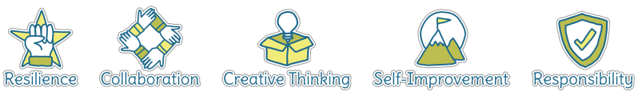
Five Ways to Wellbeing
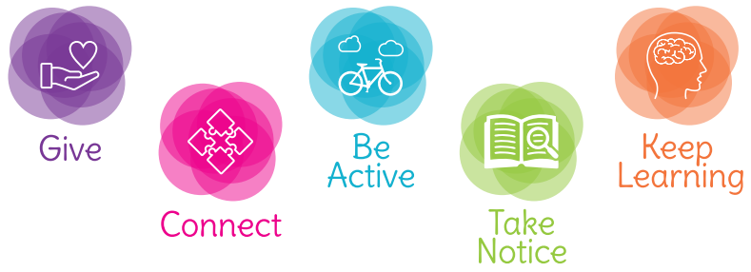

Vocabulary
Structure | A building or object made from seperate parts
Strong | Able to withstand pressure, force or wear
Strength | How strong something is
Weak | liable to break or give way under pressure; easily damaged.
Material | he matter from which a thing is or can be made
Elements | Wind, rain, snow, hail, sun, heat
Sturdy | strongly and solidly built.
Join | link/connect

Image/diagram that helps me to articulate my knowledge/understanding | Investigate!
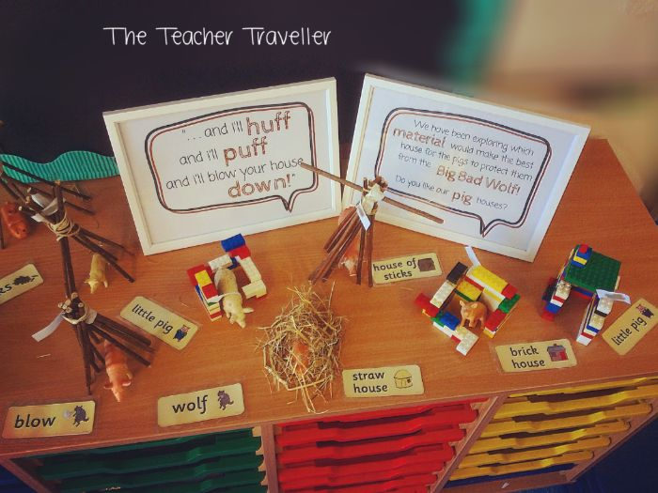  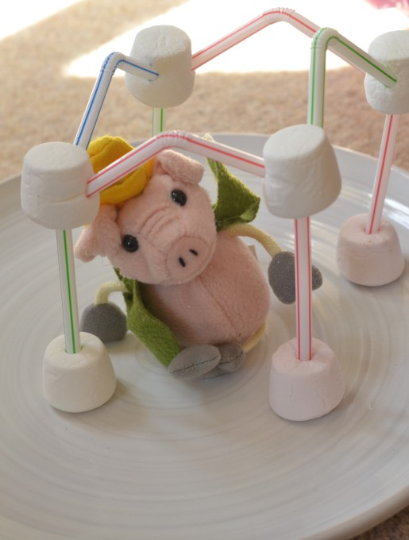 | Investigation into structures and strength of materials based on the story of Three Little Pigs.  Make own dens outside

