Goonhavern Primary School-Design Technology
TOPIC: DT | YEAR: 1 | STRAND: Textiles

What should I know already? | What will I know by the end of the unit?
A sock puppet is made out of sock and can be used using your hand  There are different types of materials  Scissors need to be used carefully especially in a busy classroom | Design  - I know I need to design my product before I make using a simple diagram and labels to show important pieces  - A template is a shaped piece of rigid material used as a pattern for processes such as cutting out, shaping, or drilling.  - I can use a template already made to help me with my design  Make  - Scissors can be used to cut fabric and sharper scissors may be needed for thicker/more rigid materials  - Some materials are soft, fleecy, felt, furry, or velvet  - Some materials are rigid and are not easy to alter their shape  Evaluate  I could make my puppet better by:  - Using a different material  - Taking more time with the making  - Adding more elements of interest to my design
School Values
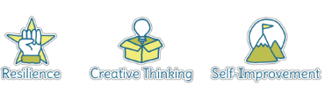
Five Ways to Wellbeing
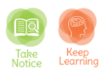

Vocabulary
Fabric | A cloth material
Felt | A thick and soft fabric
Rigid | Does not easily move/mould/cut
Design | a plan or drawing produced to show the look and function or workings of a building, garment, or other object before it is made.
Template | a shaped piece of rigid material used as a pattern for processes such as cutting out, shaping, or drilling
Model | a thing used as an example to follow or imitate
Textiles | A type of cloth or woven fabric
Puppet | A movable model of an animal/person controlled by a hand

Image/diagram that helps me to articulate my knowledge/understanding | Investigate!
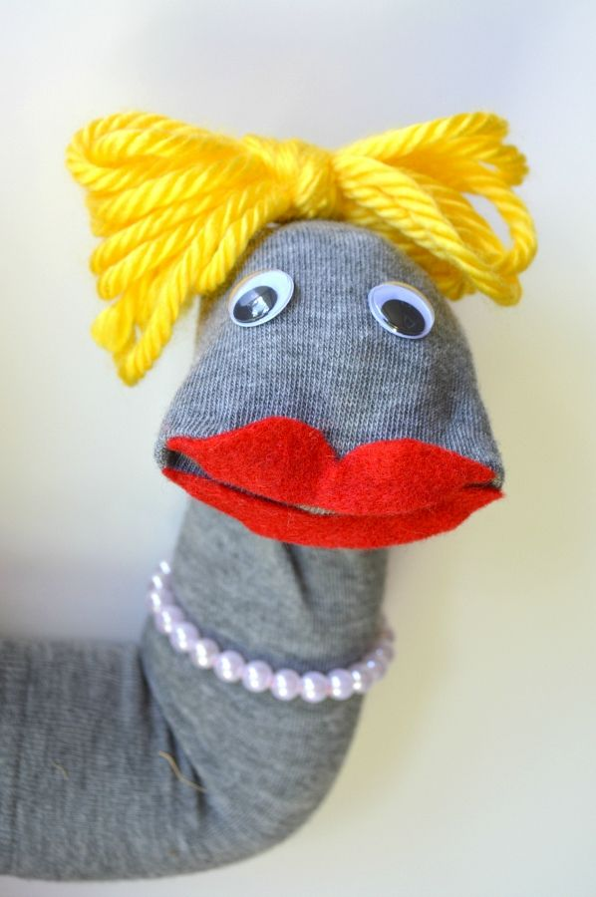 | Create sock puppets from a story being read in literacy/reading or of a sea creature learned about in Geography using glue to attach chosen design features on.

