Goonhavern Primary School- Design Technology
TOPIC: Design Technology | YEAR: 1 | STRAND: Mechanisms

What should I know already? | What will I know by the end of the unit?
 | Design: That I can make a working model to practise my design.
 | Design: How to draw a labeled diagram showing where the movement will take place.
 | Make: How to cut accurately with scissors.
 | Make: To select materials appropriate to the task in hand.
 | Make: How to strengthen or stiffen materials.
 | Evaluate: Tell you what was successful about my product and what I could do to further improve it.
 | Describe simple mechanisms that are used in everyday products.
School Values
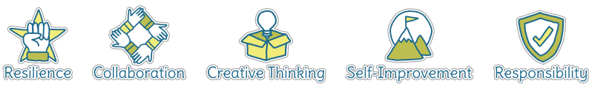
Five Ways to Wellbeing


Vocabulary
Mechanism | A system of parts working together (in a machine)
Model | a thing used as an example to follow or imitate.
Label | Gives information
Diagram | A simplified drawing of a structure or workings of something
Materials | Items needed to make the project
Strengthen | Make something stronger
Split-pin | A pin that can be split join two parts together and make them move

Image/diagram that helps me to articulate my knowledge/understanding | Investigate!
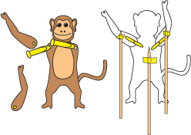 | Explore using split pins to create different movements. Design and create puppets from a familiar story.  Link to English - familiar stories.

