Goonhavern Primary School- Design Technology
TOPIC: DT | YEAR: 1 | STRAND: Food

What should I know already? | What will I know by the end of the unit?
- How to use simple tools to effect changes to materials. For example, safely using hammers and saws in reception.  - The names of a range of healthy foods - including fruits and vegetables grown and eaten in school.  - It is important to eat a variety of different foods. | How to chop, mix and peel ingredients safely and hygienically.
 | How to measure or weigh using one of the following: measuring cups, analogue or digital scales.
 | How to assemble or cook ingredients.
 | That all food comes from plants and animals.
 | That we can follow recipes (that combine images and text) to create different foods.
 | That fruit is a healthy food choice.
School Values
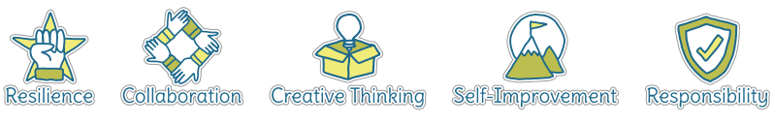
Five Ways to Wellbeing
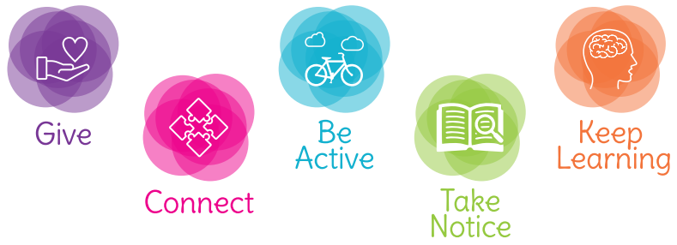

Vocabulary
Peel | Remove the outer covering or skin from fruit or vegetables.
Chop | Cut something into pieces with a knife.
Mix | Combine ingredients together.
Fruit | Product from a plant that contains seeds and can be eaten.
Crumble | A mixture of flour and fat that is rubbed to the texture of breadcrumbs and cooked as a topping for fruit.
Healthy (food) | Foods that are good for your body.
Skewer | A long piece of wood used to hold food together.

Image/diagram that helps me to articulate my knowledge/understanding | Projects
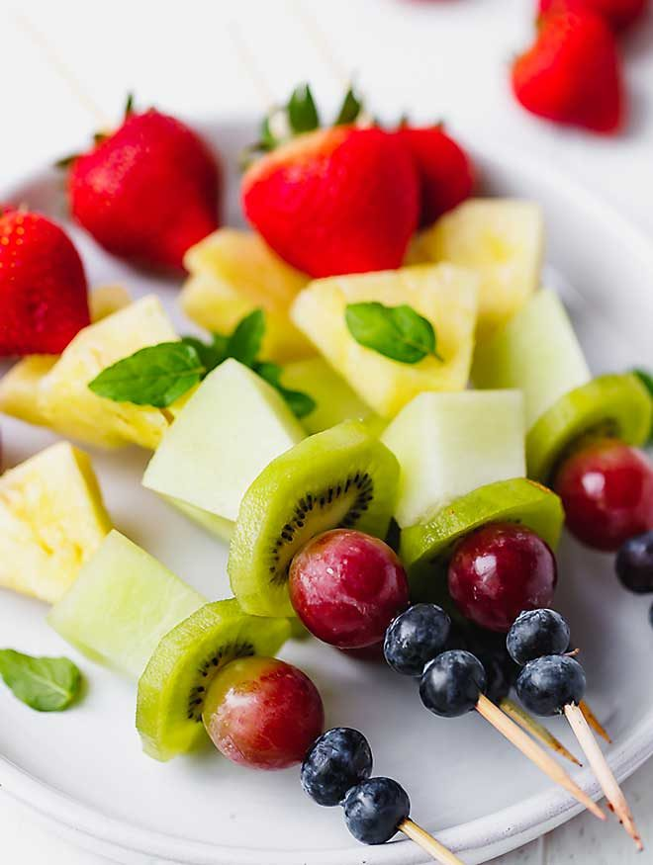 | - Design a healthy snack for a real-life audience (fruit salad/fruit kebab), including: designing, making, evaluating and growing fruit from seed. (Depending on the context, this could include marketing and selling, incorporating maths/English links.)  - How to follow a recipe to create a fruit-based dessert using Gruffalo Crumble as inspiration. (This should link to instructional writing.)

