Goonhavern Primary School- Design Technology
TOPIC: DT | YEAR: 2 | STRAND: Structures

What should I know already? | What will I know by the end of the unit?
- That some building materials are stronger and sturdier than others and can withstand the elements better | - Design purposeful, functional, appealing products for themselves and other users based on design criteria  - Benefits of Insect Hotels  - Supplement the increasing loss of natural habitats.  - Encourage insects to help control pests.  - Support biodiversity and ecological balance in the garden.  - A bug hotel structure needs to have lots of narrow gaps and entrances for bugs/insects to come and go  - Best time to build a bug hotel is early autumn  - A bug hotel needs a firm base  - Structures can be secured with string, wire or pull ties  - Some materials can withstand the elements better than others  - Some shaped structures are sturdier than others  - Structures can be joined/fitted together using cement, nails or glue
School Values
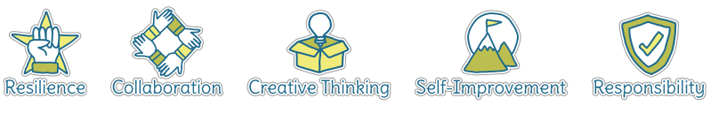
Five Ways to Wellbeing
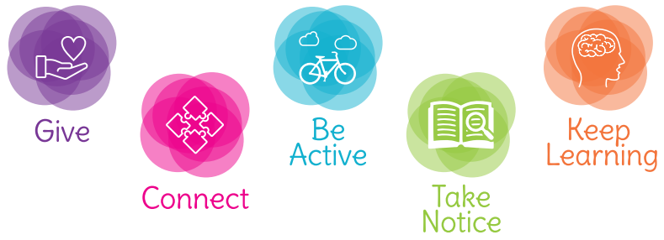

Vocabulary
Structure | A building or object made from seperate parts
Strong | Able to withstand pressure, force or wear
Strength | How strong something is
Weak | liable to break or give way under pressure; easily damaged.
Material | he matter from which a thing is or can be made
Elements | Wind, rain, snow, hail, sun, heat
Sturdy | strongly and solidly built.
Join | link/connect
Birdbox | Place for a bird to rest

Image/diagram that helps me to articulate my knowledge/understanding | Investigate!
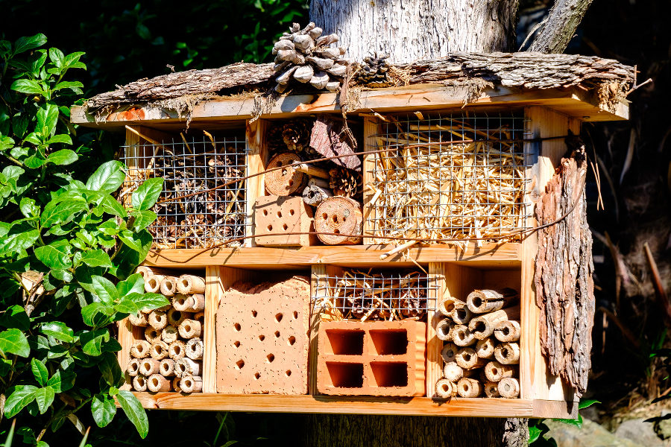 | Link to Science- design and make bug hotels or bird boxes.

