Goonhavern Primary School- Design Technology
TOPIC: DT | YEAR: 2 | STRAND: Textiles

What should I know already? | What will I know by the end of the unit?
A sock puppet is made out of sock and can be used using your hand  There are different types of materials  Scissors need to be used carefully especially in a busy classroom  Some materials are harder to cut  I can use a template to help me with my design | Design  - I know I need to design my product before I make using a simple diagram and labels to show important pieces  - I can explain how my design will work and why I have chosen it  Make  - Scissors can be used to cut fabric and sharper scissors may be needed for thicker/more rigid materials  - Some materials are soft, fleecy, felt, furry, or velvet  - Some materials are rigid and are not easy to alter their shape  Evaluate  I could make my fixing better by:  - Using a different material  - Using a stronger material  - Making it stronger by using more stitches or tying it tighter  - Technical knowledge  - Sewing is stitching cloth, leather, furs, or other materials, using a needle and thread.  - Sewing can be done on a sewing machine, or by hand.  - "Plain" sewing is mostly done to make or mend clothing and household furnishings such as curtains, sheets, upholstery, and table linens.
School Values
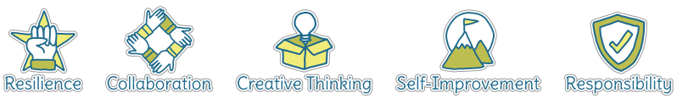
Five Ways to Wellbeing
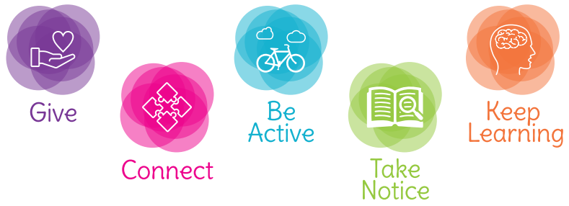

Vocabulary
Fabric | A cloth material
Felt | A thick and soft fabric
Rigid | Does not easily move/mould/cut
Design | a plan or drawing produced to show the look and function or workings of a building, garment, or other object before it is made.
Template | a shaped piece of rigid material used as a pattern for processes such as cutting out, shaping, or drilling
Model | a thing used as an example to follow or imitate
Textiles | A type of cloth or woven fabric
Sewing | The action that joins together
Needle | a very fine slender piece of polished metal with a point at one end and a hole or eye for thread at the other, used in sewing.
Thread | a long, thin strand of cotton, nylon, or other fibres used in sewing or weaving.

Image/diagram that helps me to articulate my knowledge/understanding | Investigate!
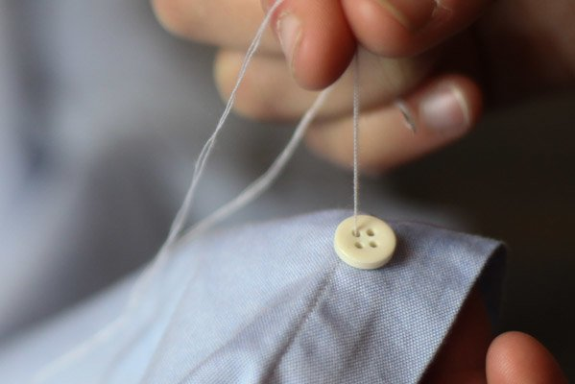 | Use sewing to simple but practical tasks,  E.g. sewing a button on, fixing clothing or a toy, sewing on badges.  Open up a sewing ‘factory’ or mending shop-children could bring in items from home that need to be fixed

