Goonhavern Primary School- Design Technology
TOPIC: Design Technology | YEAR: 2 | STRAND: Mechanisms

What should I know already? | What will I know by the end of the unit?
- Design: That I can make a working model to practise my design.  - Design: How to draw a labeled diagram showing where the movement will take place.  - Make: How to cut accurately with scissors.  - Make: To select materials appropriate to the task in hand.  - Make: How to strengthen or stiffen materials.  - Evaluate: Tell you what was successful about my product and what I could do to further improve it.  - Describe simple mechanisms that are used in everyday products. | I know that I can join materials in different ways including: PVA glue, hot glue guns, glue stick, stapling and sticky tape.
 | I know that mechanisms can be used to create different movements.
 | Design: That I can make a working model of different mechanisms.
 | Design: That I can create a list of materials that I need to make my product.
 | Design: That I can hide my mechanism by layering card (or similar on top).
 | Make: I can use scissors with a high degree of accuracy.
 | Make: To select materials appropriate to the task in hand.
 | Evaluate: How to improve a design after self evaluating.
School Values
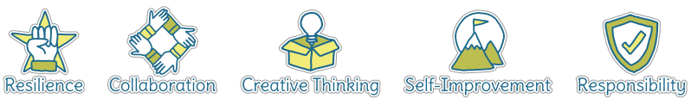
Five Ways to Wellbeing
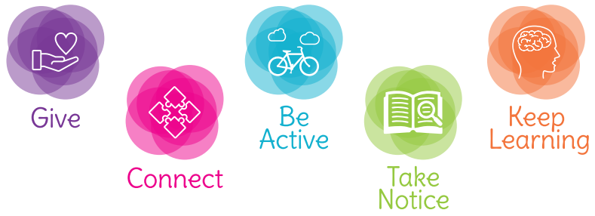

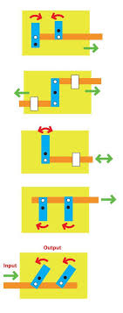 | Vocabulary
 | Mechanism | A system of parts working together (in a machine)
 | Model | a thing used as an example to follow or imitate.
 | Label | Gives information
 | Diagram | A simplified drawing of a structure or workings of something
 | Materials | Items needed to make the project
 | Pivot | the central point, pin, or shaft on which a mechanism turns
 | Dowell | a pin fitting into a hole in an abutting piece to prevent motion or slipping
 | Slider | a knob or lever that is moved horizontally or vertically to control a variable, such as the volume of a radio.
 | Evaluate | Reflect on positive aspects and ways to improve
 | Input | Something that goes in
 | Output | The product that comes out

Image/diagram that helps me to articulate my knowledge/understanding | Investigate!
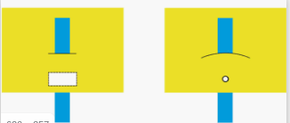 | To create a moving picture that can be manipulated by a Nursery pupil, based on a chosen whole-class theme.

