Goonhavern Primary School- Design Technology
TOPIC: DT | YEAR: 2 | STRAND: Food

What should I know already? | What will I know by the end of the unit?
- How to chop, mix and peel ingredients safely and hygienically.  - How to measure or weigh using one of the following: measuring cups, analogue and digital scales.  - How to assemble or cook ingredients.  - That all food comes from plants and animals.  - That we can follow recipes (that combine images and text) to create different foods.  - That fruit is a healthy food choice. | That food has to be farmed, grown elsewhere (e.g. home) or caught.
 | How to name and sort foods into the five groups in ‘The Eat-Well Plate.’
 | Repetition: How to measure or weigh using one of the following: measuring cups, analogue and digital scales.
 | Repetition: to chop, mix and peel and to be able to grate.
 | Repetition: that we can follow recipes (that combine images and text) to create different foods.
 | Be able to describe flavours and textures.
School Values
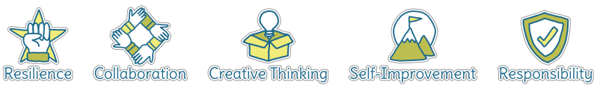
Five Ways to Wellbeing
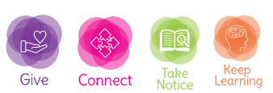

Vocabulary
Hygienic | Ensuring cleanliness so germs are not spread
Ingredients | Foods that are combined to make a dish
Chewy | Food that needs chewing hard before it’s swallowed
Crunchy | Food that makes a crunch sound when you eat it
Soft | easy to mould, cut, compress, or fold; not hard or firm to the touch
Crisp | A substance that is firm, dry and brittle
Sweet | Having the taste of sugar/honey
Savoury | Food that is salty or spicy rather than sweet
Bitter | Food that has a sharp taste or smell
Dairy | Containing or made from milk
Protein | Food that is a fuel source for the body
Carbohydrates | Food that gives us slow releasing energy
Fruit and Veg | Food that is grown from the ground or plants
Fat and sugars | Found in some foods and can be harmful to our bodies

Image/diagram that helps me to articulate my knowledge/understanding | Project
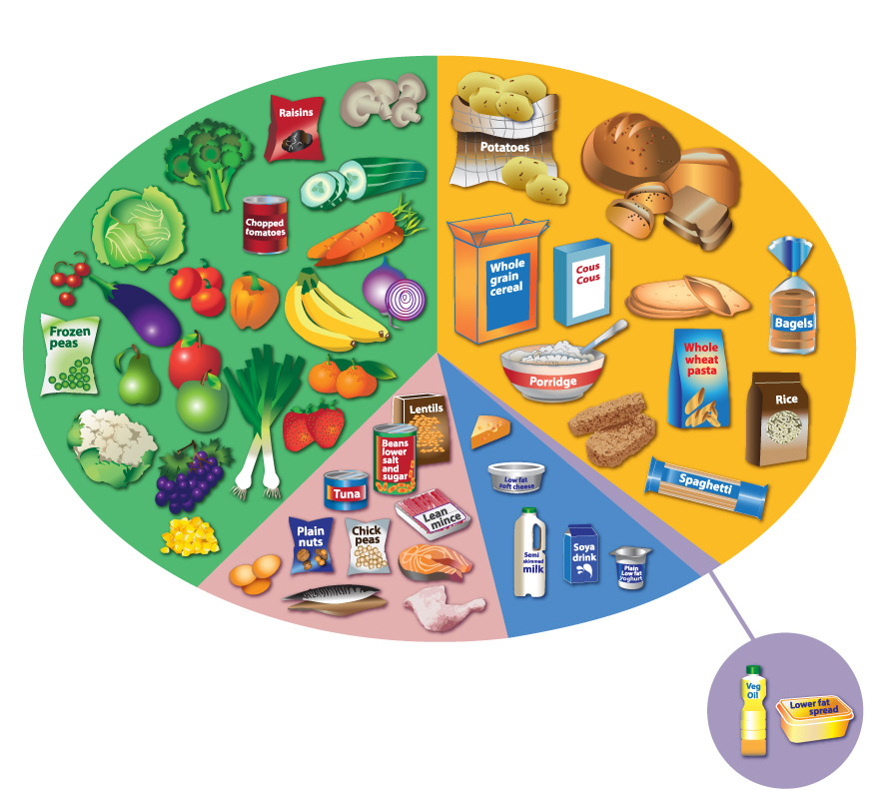 | Make Cornish Pasties- link to Cornwall topic. Make own versions of pasties using eat well plate to inform recipe

