Goonhavern Primary School- Design Technology
TOPIC: DT | YEAR: 3 | STRAND: Structures

What should I know already? | What will I know by the end of the unit?
- That some building materials are stronger and sturdier than others and can withstand the elements better  - Some materials can be joined together using nails, glue, string or cement | - Different structures and shapes are better at absorbing heavy loads  - I can create a design that has a good engineered result  - I know which techniques e.g. bunching straws together will work to give the bridge strength  - That bridges support weight horizontally and vertically  - The relationship between the tension and applied forces is important as too much of either and your bridge will collapse or sag and buckle  - The most important shape in engineering is the triangle  - You can strengthen a rectangle by adding supports to its corners  - There are different types of bridges: a suspension bridge, a arch bridge, a truss bridge and a cable stayed bridge
School Values
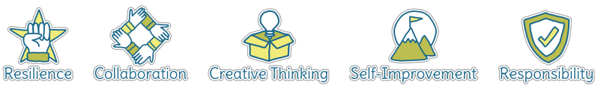
Five Ways to Wellbeing
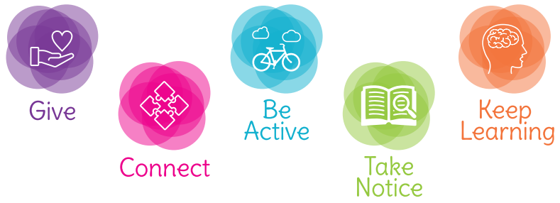

Vocabulary
Structure | A building or object made from separate parts
Strong | Able to withstand pressure, force or wear
Strength | How strong something is
Weak | liable to break or give way under pressure; easily damaged.
Material | he matter from which a thing is or can be made
Elements | Wind, rain, snow, hail, sun, heat
Sturdy | Strongly and solidly built.
Join | Link/connect

Image/diagram that helps me to articulate my knowledge/understanding | Investigate!
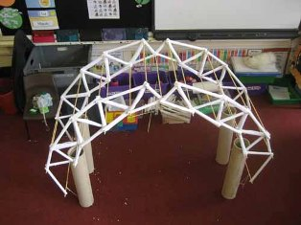 | Link to ‘Wonders of the World’ topic-  Bridges/link to Wonders of the World. Make models out of art straws first. Then use jelutong and dowling. Evaluate by testing strength with weights. Limit number of resources available.

