Goonhavern Primary School- Design Technology
TOPIC: DT | YEAR: 3 | STRAND: Food

What should I know already? | What will I know by the end of the unit?
- That food has to be farmed, grown elsewhere (e.g. home) or caught.  - How to name and sort foods into the five groups in ‘The Eat well plate.’  - How to measure or weigh using one of the following: measuring cups, analogue and digital scales.  - How to chop, mix and peel and grate.  - That we can follow recipes (that combine images and text) to create different foods.  - Be able to describe flavours and textures. | How to prepare ingredients hygienically using appropriate utensils.
 | How to measure ingredients to the nearest gram accurately.
 | How to follow a recipe and combine ingredients.
 | How to assemble or cook ingredients (controlling the temperature of the oven or hob as required).
 | How to make a product look attractive.
 | How to grow plants from seed to be used in my cooking.
 | That I can forage for food and use this in my cooking
 | How to use cooking equipment, including hobs and ovens safely.
School Values
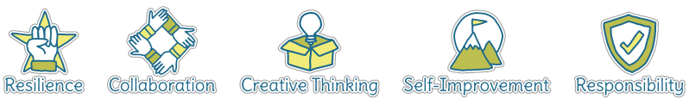
Five Ways to Wellbeing
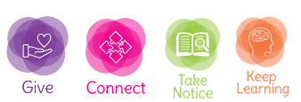

Vocabulary
Hygienic | Practise of keeping clean so germs aren’t spread
Ingredients | Combination of food used to make a dish
Sweet | Taste of sugar or honey
Savoury | Taste of salt, sour or spicy
Utensils | Equipment used in the kitchen for cooking and eating
Temperature | Measurement of heat
Forage | Find food grown in the wild
Dairy | Food that contains milk
Protein | Gives muscles fuel
Carbohydrates | Gives the body slow releasing energy
Fruit and Veg | Grown naturally on plants or in the ground
Fat and sugars | To be eat in moderation as part of a healthy diet

Image/diagram that helps me to articulate my knowledge/understanding | Projects:
