Goonhavern Primary School- Design Technology
TOPIC: Design Technology | YEAR: 3 | STRAND: Mechanisms

What should I know already? | What will I know by the end of the unit?
- I know that I can join materials in different ways including: PVA glue, hot glue guns, glue stick, stapling and sticky tape.  - I know that mechanisms can be used to create different movements.  - Design: That I can make a working model of different mechanisms.  - Design: That I can create a list of materials that I need to make my product.  - Design: That I can hide my mechanism by layering card (or similar on top).  - Make: I can use scissors with a high degree of accuracy.  - Make: To select materials appropriate to the task in hand.  - Evaluate: How to improve a design after self evaluating. | That compressed air can be used to create movements.
 | That mechanisms can be used to create different movements.
 | Design: How to put together a step-by-step plan of how to create a product.
 | Design: To communicate my design through diagrams.
Make : select from and use a wider range of tools and equipment to perform practical tasks
[for example, cutting, shaping, joining and finishing], accurately
Evaluate: evaluate their ideas and products against their own design criteria and consider the
views of others to improve their work
School Values
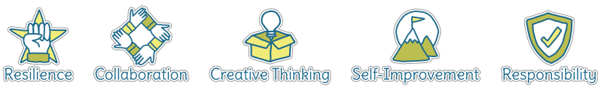
Five Ways to Wellbeing
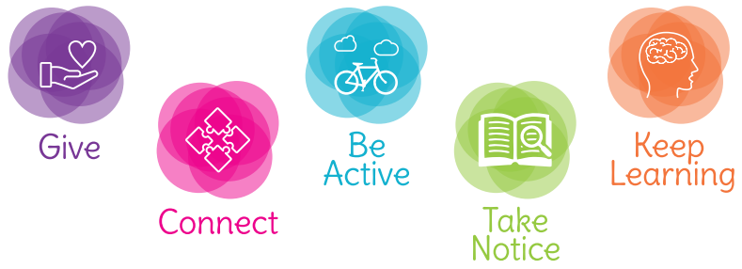

Vocabulary
Mechanism | Components that work together (in a machine)
Pneumatic | Operated by air or gas under pressure
Compressed Air | Air under pressure
Diagram | A simplified drawing that gives an explanation
Materials | Combination of items used together to make something
Pivot | the central point, pin, or shaft on which a mechanism turns
Syringine | a tube with a nozzle and piston or bulb for sucking in and ejecting
Lever | a rigid bar resting on a pivot, used to move a heavy or firmly fixed load with one end when pressure is applied to the other.

Image/diagram that helps me to articulate my knowledge/understanding | Investigate!
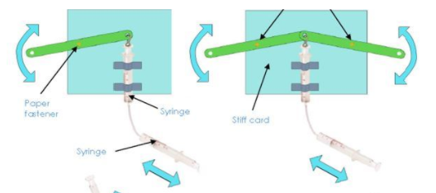  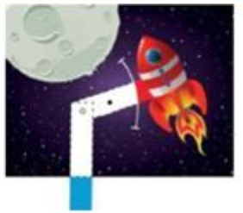 | Explore how pneumatics work by experimenting with different mechanisms (refer to Year 2 knowledge organiser for further ideas).  Use pneumatics to create a moving picture based around a chosen theme or topic-based on a story in literacy

