Goonhavern Primary School- Design Technology
TOPIC: DT | YEAR: 4 | STRAND: Food

What should I know already? | What will I know by the end of the unit?
- That food has to be farmed, grown elsewhere (e.g. home) or caught.  - How to name and sort foods into the five groups in ‘The Eat Well plate.’  - How to measure or weigh using one of the following: measuring cups, analogue and digital scales.  - How to chop, mix and peel and grate.  - That we can follow recipes (that combine images and text) to create different foods.  - Be able to describe flavours and textures. | How to prepare ingredients hygienically using appropriate utensils.
 | How to measure ingredients to the nearest gram accurately.
 | How to follow a recipe and combine ingredients.
 | How to assemble or cook ingredients (controlling the temperature of the oven or hob as required).
 | How to use cooking equipment, including hobs and ovens safely.
 | How to grow herbs from seed to be used in my cooking.
 | How to use knives to dice (onions).
 | That food is grown and caught in the UK, Europe and the wider world.
 | The origin of the spices they are cooking with.
School Values
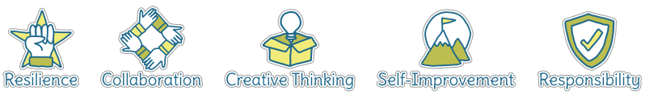
Five Ways to Wellbeing
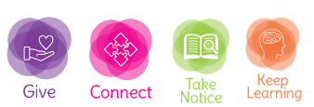

Vocabulary
Hygienic | Practise of cleanliness to prevent spread of germs
Ingredients | Combination of food used to make a dish
Kneading | Work into dough or paste with hands
Spices | An aromatic or punjugent substance used to flavour food
MIld | Not a strong taste
Spicy | Can feel ‘hot’ to taste
Dice | Cut into dice like shapes
Protein | Provides fuel for our muscles
Carbohydrates | Provide slow releasing energy
Lentils | A type of pulse that’s high in protein
Fat and sugars | A part of food we should eat in moderation

Image/diagram that helps me to articulate my knowledge/understanding | Projects
 | Judaism Cooking

