Goonhavern Primary School- Design Technology
TOPIC: Design Technology | YEAR: 4 | STRAND: Mechanisms

What should I know already? | What will I know by the end of the unit?
I know that I can join materials in different ways including: PVA glue, hot glue guns, glue stick, stapling and sticky tape.  I know that mechanisms can be used to create different movements.  Design: That I can make a working model of different mechanisms.  Design: That I can create a list of materials that I need to make my product.  Design: That I can hide my mechanism by layering card (or similar on top).  Make: I can use scissors with a high degree of accuracy.  Make: To select materials appropriate to the task in hand.  Evaluate: How to improve a design after self evaluating. | How to measure to the nearest millimetre
 | How to saw accurately at 90 degrees and 45 degrees, using a bench hook.
 | How to tie a lashing.
 | How to tie a reef knot.
 | That triangles are strong shapes.
 | How to drill accurately
 | How to use a glue gun safely
 | How to draw a scale diagram where the scale is 1:1
 | How to draw a scale diagram from a side profile.
 | How to strengthen a design
School Values
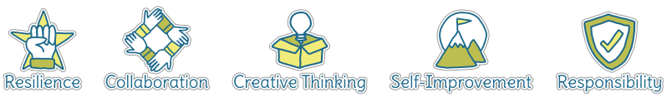
Five Ways to Wellbeing


Vocabulary
Mechanism | a system of parts working together in a machine; a piece of machinery.
Lashing | A cord used to tighten something securely
Millimetre | A unit of measurement
Diagram | A simple drawing to give an explanation of how something works
Lashing | A cord used to tighten something securely
Pivot | The central point on which something turns/moves
Reef Knot | A type of knot
Lever | a rigid bar resting on a pivot, used to move a heavy or firmly fixed load with one end when pressure is applied to the other.

Image/diagram that helps me to articulate my knowledge/understanding | Investigate!
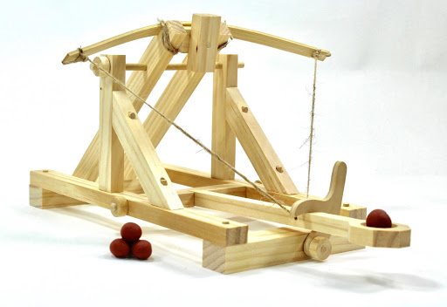 | Design and make a Catapult

