Goonhavern Primary School- Design Technology
TOPIC: DT | YEAR: 5 | STRAND: Food

What should I know already? | What will I know by the end of the unit?
- How to prepare ingredients hygienically using appropriate utensils.  - How to measure ingredients to the nearest gram accurately.  - How to follow a recipe and combine ingredients.  - How to assemble or cook ingredients (controlling the temperature of the oven or hob as required).  - How to use cooking equipment, including hobs and ovens safely.  - How to grow plants from seed to be used in my cooking.  - How to use knives to dice (onions)  - That food is grown and caught in the UK, Europe and the wider world.  - How to chop, mix and peel and grate. | How ingredients (including dairy/meat) should be stored and handled with reasons (using knowledge of microorganisms).
 | How to measure accurately and calculate ratios of ingredients to scale up or down from a recipe.
 | A range of baking and cooking techniques. MAKE THESE SPECIFIC TO WHAT YOU ARE MAKING.
 | How to create and refine recipes, including ingredients, methods, cooking times and temperatures.
 | Understand and apply the principles of a healthy and varied diet.
 | Understand seasonality and know where and how a variety of ingredients are grown, reared, caught and processed.
School Values
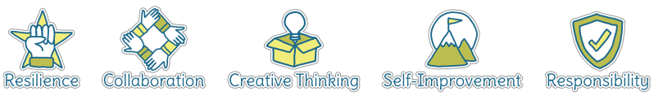
Five Ways to Wellbeing


Vocabulary
Processed food | Food altered in some way during preparation
Nutrients | A substance that provides nourishment essential for growth
Seasonality | Time of year
Hygiene | Practise of cleanliness to prevent the spread of germs
Protein | Helps fuel muscles
Carbohydrates | Slow releasing energy
Fruit and Veg | Food that gives us vitamins and nutrients
Fat and sugars | Food that should be consumed in moderation
Yeast | Yeast causes the formation of carbon dioxide gas through fermentation of the sugars in the bread dough.

Image/diagram that helps me to articulate my knowledge/understanding | Projects
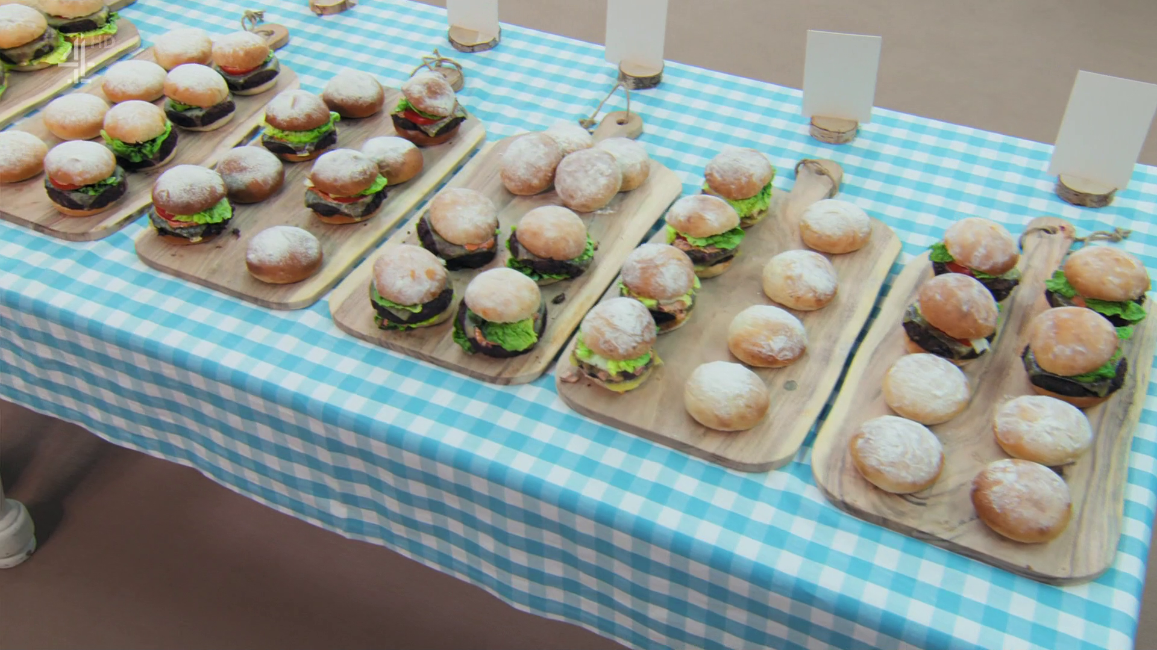 | Great British Bake Off: Bread Week.  - Signature Challenge: basic bread recipe, scaling up/down ingredients.  - Technical Challenge (pizza dough and creating recipes)  - Show Stopper.  This includes designing, making and evaluating at each stage.  (Science: link to Properties and Changes in Materials.)

