Goonhavern Primary School- Design Technology
TOPIC: Design Technology | YEAR: 5 | STRAND: Mechanisms

What should I know already? | What will I know by the end of the unit?
I know that I can join materials in different ways including: PVA glue, hot glue guns, glue stick, stapling and sticky tape.  I know that mechanisms can be used to create different movements.  Design: That I can make a working model of different mechanisms.  Design: That I can create a list of materials that I need to make my product.  Design: That I can hide my mechanism by layering card (or similar on top).  Make: I can use scissors with a high degree of accuracy.  Make: I can make mechanisms with levers, pivots and pneumatics  Make: To select materials appropriate to the task in hand.  Evaluate: How to improve a design after self evaluating. | Pulleys are a wheel with a grooved rim around which a cord passes, which acts to change the direction of a force applied to the cord and is used to raise heavy weights.
 | When you put two or more wheels together, and run a rope around them, you have created a great lifting machine
 | Pulleys are used to reduce the time and energy taken to lift heavy objects
 | Looping the rope over more wheels increases the upward force
 | Measurements are taken to quantify the relationship between the number of pulleys used and the distance that the weight is moved, e.g. with six pulleys the weight is lifted one sixth of the distance.
 | Pulleys are used everyday in building sites, gyms, blinds curtains
 | It is sometimes called a block and tackle
School Values
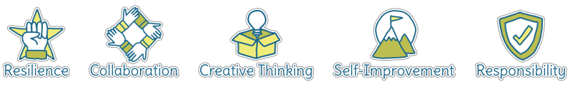
Five Ways to Wellbeing
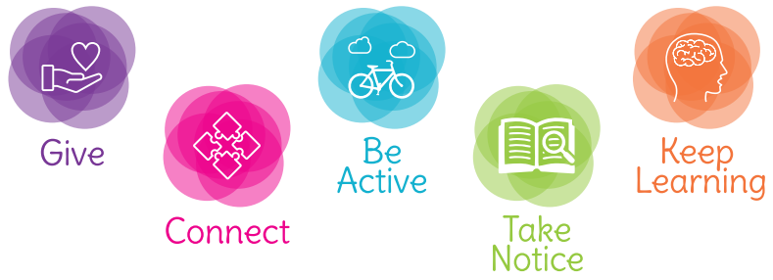

Vocabulary
Mechanism | a system of parts working together in a machine; a piece of machinery.
Pulleys | a wheel with a grooved rim around which a cord passes, which acts to change the direction of a force applied to the cord and is used to raise heavy weights.
Diagram | A simple drawing to give an explanation of how something works
Pivot | The central point on which something turns/moves
Lever | a rigid bar resting on a pivot, used to move a heavy or firmly fixed load with one end when pressure is applied to the other.
Force | Amount of energy inputted

Image/diagram that helps me to articulate my knowledge/understanding | Investigate!
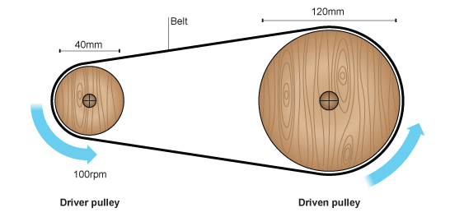  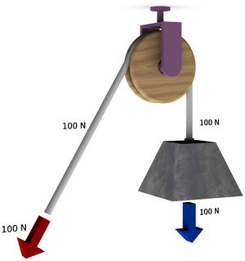 | Pupils could carry out an investigation themselves using pulleys, measuring the size of the force and the distance moved for different numbers of pulleys, plotting the results on a graph, and calculating the work done to identify a pattern in the results.(links to maths)  Design a pulling machine used to help someone with limited mobility  They could explore and research more complex examples of pulleys in real life e.g. in exercise equipment, rock-climbing, cranes etc.

