Goonhavern Primary School- Design Technology
TOPIC: DT | YEAR: 6 | STRAND: Food

What should I know already? | What will I know by the end of the unit?
- How to prepare ingredients hygienically using appropriate utensils.  - How to measure ingredients to the nearest gram accurately.  - How to follow a recipe and combine ingredients.  - How to assemble or cook ingredients (controlling the temperature of the oven or hob as required).  - How to use cooking equipment, including hobs and ovens safely.  - How to grow plants from seed to be used in my cooking.  - How to use knives to dice (onions)  - That food is grown and caught in the UK, Europe and the wider world.  - How to chop, mix and peel and grate. | How ingredients (including dairy/meat) should be stored and handled with reasons (using knowledge of microorganisms).
 | How to measure accurately and calculate ratios of ingredients to scale up or down from a recipe.
 | A range of baking and cooking techniques. MAKE THESE SPECIFIC TO WHAT YOU ARE MAKING.
 | How to create and refine recipes, including ingredients, methods, cooking times and temperatures.
 | Understand and apply the principles of a healthy and varied diet.
 | Understand seasonality and know where and how a variety of ingredients are grown, reared, caught and processed.
School Values

Five Ways to Wellbeing


Vocabulary
Processed food | Food that has been altered during its preparation
Nutrients | Substance that provides nutrients for health and growth
Seasonality | Time of year
Hygiene | Practice of cleanliness to prevent the spread of germs
Protein | Provides fuel for our bodies and muscles
Carbohydrates | Slow releasing energy
Fruit and Veg | Natural food that provides vitamins and nutrients
Fat and sugars | Food we should eat in moderation
Yeast | east causes the formation of carbon dioxide gas through fermentation of the sugars in the bread dough.

Image/diagram that helps me to articulate my knowledge/understanding | Projects
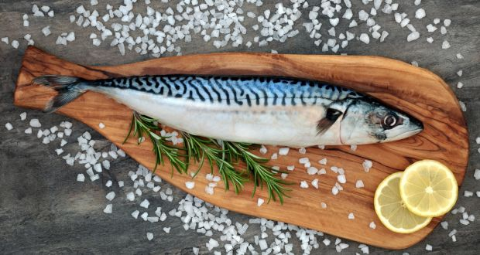 | - Summer term - link with Birmingham School visit. Cook and prepare fresh mackerel that have been caught. Add ingredients and cook in tin foil on a beach BBQ.

