Goonhavern Primary School- Design Technology
TOPIC: Design Technology | YEAR: 6 | STRAND: Mechanisms

What should I know already? | What will I know by the end of the unit?
I know that I can join materials in different ways including: PVA glue, hot glue guns, glue stick, stapling and sticky tape.  I know that mechanisms can be used to create different movements.  Design: That I can make a working model of different mechanisms.  Design: That I can create a list of materials that I need to make my product.  Design: That I can hide my mechanism by layering card (or similar on top).  Make: I can use scissors with a high degree of accuracy.  Make: I can make mechanisms with levers, pivots and pneumatics  Make: To select materials appropriate to the task in hand.  Evaluate: How to improve a design after self evaluating. | A labyrinth is a complicated irregular network of passages or paths in which it is difficult to find one's way; a maze.
 | How to construct a labyrinth using cardboard
 | Hydraulic systems use pressurized liquid to transmit and magnify forces
School Values
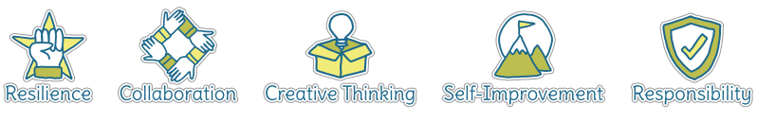
Five Ways to Wellbeing


Vocabulary
Mechanism | a system of parts working together in a machine; a piece of machinery.
Pulleys | a wheel with a grooved rim around which a cord passes, which acts to change the direction of a force applied to the cord and is used to raise heavy weights.
Diagram | A simple drawing to give an explanation of how something works
Pneumonic | Compression of pressured air
Syringe | a tube with a nozzle and piston or bulb for sucking in and ejecting
Force | Amount of energy inputted

Image/diagram that helps me to articulate my knowledge/understanding | Investigate!
- 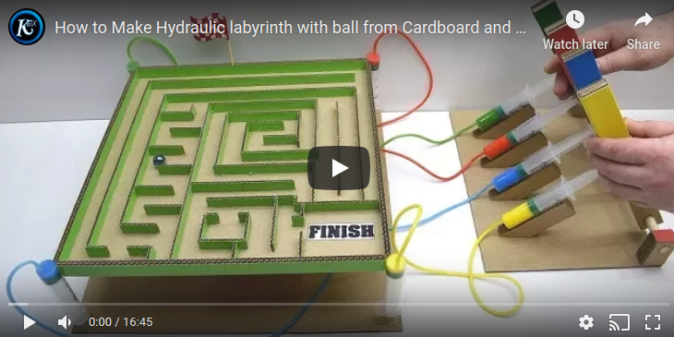 | Make a pneumonic labyrinth game

