Goonhavern Primary School-Geography
TOPIC: Why are Oceans Important? | YEAR: 1 | STRAND: Oceans and Sea

What should I know already? | What will I know by the end of the unit?
- About different people/communities in the world  - Recognise natural and built things in the environment  - Understand different technology in their environment | Locational Knowledge  Name and locate the world’s seven continents and five oceans  - There are seven continents named Africa, Antarctica, Asia, Australia/Oceania, Europe, North America, and South America  - Asia is the largest continent  - There are 5 oceans-Indian, Pacific, Atlantic,Southern and Artic  - 70% of the earth is covered by oceans  - The largest ocean is the Pacific  - During winter the Arctic ocean is frozen  Place Knowledge  Understand geographical similarities and differences through studying the human and physical geography of a small area of the UK and of a small area in contrasting non-European country.  - Cornwall is surrounded by the Atlantic ocean  - South Africa is surrounded by the Atlantic and Indian Ocean.  - Both places are peninsulas  - Both locations use the ocean for surfing  - Both locations use the ocean for fishing however different types are caught  - Cornwall and South Africa have opposite seasons  - Ocean temperature is different  Human and Physical Geography  Use basic geographical vocab to refer to beach, cliff, coast, sea, ocean, river, port and harbour  - Beaches are used for Tourism in both countries  - The ocean and tide is dependent on the moon  - There are dangerous sea creatures in South Africa such as great white sharks  - Oceans are providers of important jobs and people work at ports and harbours  - Coast Guards are employed to keep us safe in oceans  - Rivers feed into the oceans and where they meet is called an estuary  Geographical Skills and fieldwork  Use world maps, atlases and globes to identify the UK and its countries as well as the countries, continents and oceans studied at this key stage  - I can locate where each ocean is on a map/globe  - I can locate the uk and south africa on a map
School Values
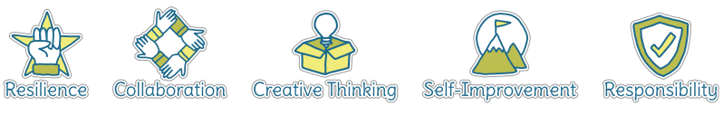
Five Ways to Wellbeing
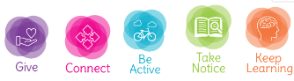

Vocabulary
Ocean | A very large expanse of sea, in particular each of the main areas into which the sea is divided geographically.
Sea | The expanse of salt water that covers most of the earth's surface and surrounds its land masses.
Cliff | A steep rock face, especially at the edge of the sea.
Coast | The part of the land adjoining or near the sea.
River | A large natural stream of water flowing in a channel to the sea, a lake, or another river.
Port | A town or city with a harbour or access to navigable water where ships load or unload.
Harbour | A place on the coast where ships may moor in shelter.
Peninsula | A piece of land almost surrounded by water.

Image/diagram that helps me to articulate my knowledge/understanding | Investigate!
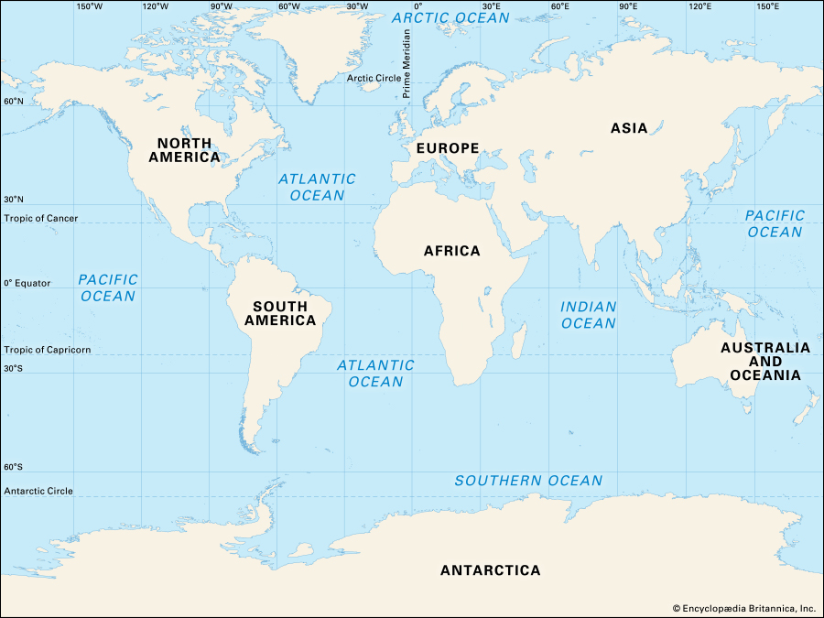  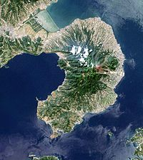 | What is an ocean? What are the differences in the oceans? Compare Cornwall to South Africa. Look at photos can you tell the difference?  How do we use the ocean? Why is it important?  How does the ocean help lives and how is it a danger to lives?  What can we find in Cornwall in the sea?  Visit to a local beach- rockpooling.  What can you find? How does it survive? Would you find that in South Africa?  Visit from a fisherman/lifeguard/surfer to talk about the ocean for them . Interview.

