Goonhavern Primary School- Geography
TOPIC: How to Navigate the Great Outdoors | YEAR: 1 | STRAND: Forests/ Woods

What should I know already? | What will I know by the end of the unit?
- About different people/communities in the world  - Recognise natural and built things in the environment  - Understand different technology in their environment | Human and Physical Geography  Use vocab to refer to physical features including forest, hill, mountain  - A forest is a large area covered by trees, it is larger than woods  - We depend on forests for survival because of the oxygen release  - In Britain there are 34 mountains  - Mount Everest is the tallest mountain  Geographical skills and fieldwork  Use simple compass directions (north, south, east and west) and locational and directional language to describe the location of features and routes on map  - Maps and plans are views from above or a ‘bird’s eye view’ of a place  - They are 2-D (two-dimensional) drawings of our 3-D world.  - hey help us find our way around and show where different places are in relation to each other (distance and direction).  - Map symbols are small images that represent human (man-made) and physical (natural) features of the landscape.  - Symbols are useful as they prevent maps from becoming overcrowded with too many word labels. Map keys show what each symbol represents.  - An aerial photo is a photograph taken from above. Photos from above help people draw maps accurately.
School Values

Five Ways to Wellbeing


Vocabulary
Forest | A large area covered chiefly with trees and undergrowth.
Hill | A naturally raised area of land
Mountain | A mountain is a large landform that rises above the surrounding land in a limited area, usually in the form of a peak.
Compass | An instrument containing a magnetized pointer which shows the direction of magnetic north and bearings from it.
Aerial Photograph | A photo taken from above
Bird’s Eye View | A view from above
Direction | Locational term used to describe where things are in relation to each other
Distance | How far apart two places are from each other
Location | Where a place is situated in the world
Symbols | Small images which show manmade and natural features on a map.
Scale | This is to do with the level of detail and size of the area shown on a map. If a map shows a very large area of the world such as a continent, it has a very small scale and not much detail will be shown. If it shows a small area such as a village, it has a large scale and will show lots of detail

Image/diagram that helps me to articulate my knowledge/understanding | Investigate!
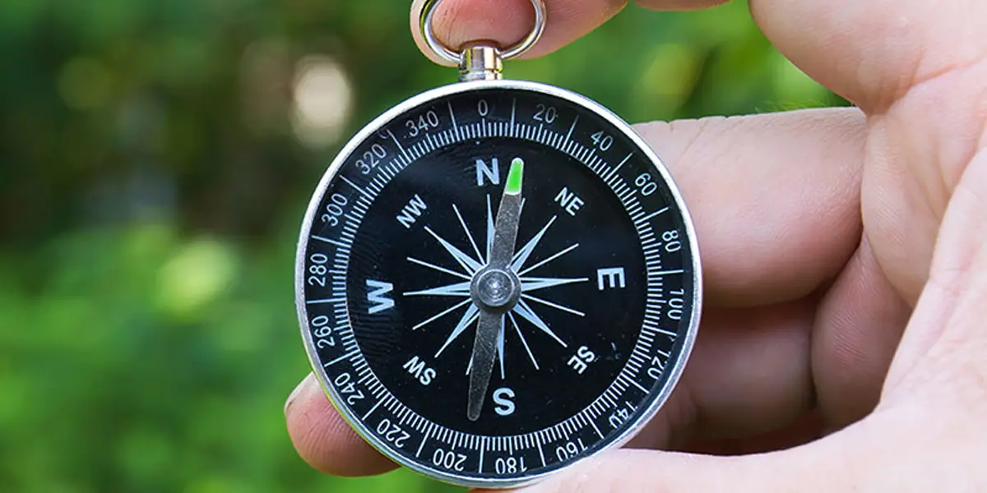  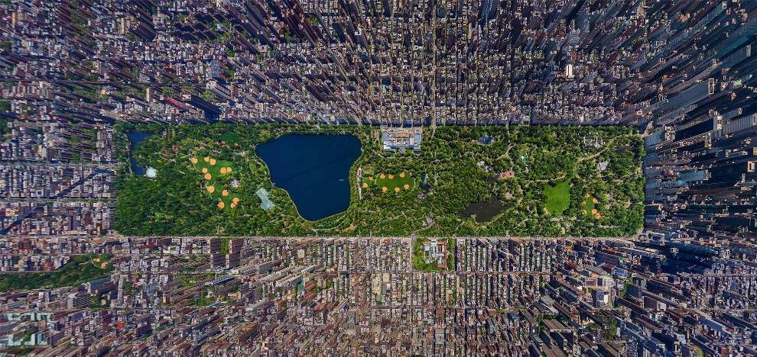  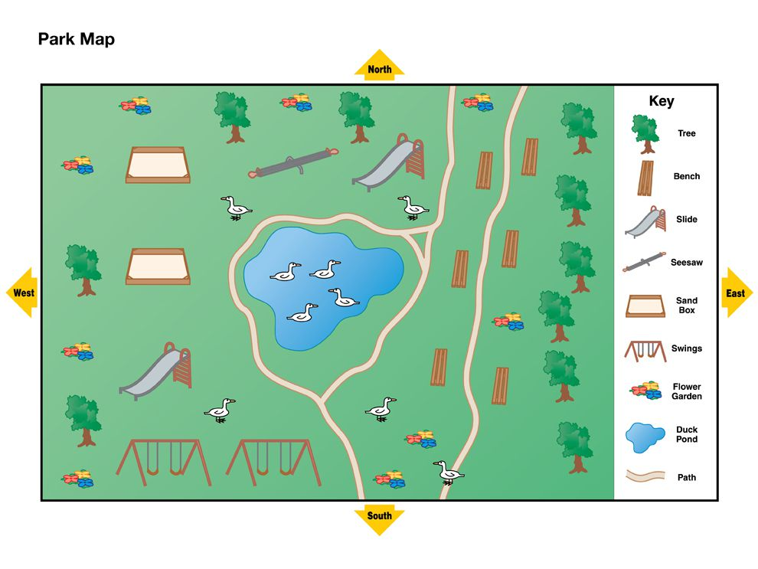 | What is a forest? What is a mountain/hill? How do explorers navigate around them?  Where are they in the UK?  What do they look like on a map?  Links to the Gruffalo-visit to some woods (could even be locally in Goonhavern) Give directions to characters in the book.  Go exploring with a compass, navigate around the school grounds using directional language. Go on an exploring adventure-role play of some famous explorers.  Create a map of the ‘great outdoors’  Use drones and ipads (if possible) to take aerial photos.  Look at aerial photos of places (e.g. mount everest). What would it look like on a map?

