Goonhavern Primary School- Geography
TOPIC: Geography | YEAR: 2 | STRAND: Is Cornwall the best place to live?

What should I know already? | What will I know by the end of the unit?
- Names of the 7 continents and 5 oceans  - Location of the UK and the countries that make it  - Names of the countries that make up the UK  - About a compass and north, south, east and west | Locational Knowledge  Name, locate and identify characteristics of the four countries and capital cities of the UK and it’s surrounding seas.  Know where Cornwall is and the seas that surround it.  - Cornwall is a county in the South West of England  - There are 48 counties in England  - Cornwall is a peninsula surrounded by the atlantic ocean  - Cornwall can be accessed by the Tamar Bridge over the the River Tamar  - You can reach Cornwall by train, car, boat or aeroplane  - London (the capital city) is 300 miles away  Place Knowledge  Understand geographical similarities and differences through studying the human and physical geography of a small area of the UK and of a small area in a contrasting European country  - There are 300 beaches in Cornwall  - The waves on Cornwall’s beach can reach over 25ft  - Cornwall has the longest coastline in Britain-679km  - Cornwall has its own language  - Cornwall has its own flag  - Cornwall is a popular tourist destination  - Truro is the only city in Cornwall  - There are many seaside towns that are popular with tourists  - The Cornish pasty was first made for tin miners  - In the 1900s half of the world clay came from Cornwall  Identify seasonal and daily weather patterns in the UK and the location of hot and cold areas of the world in relation to the Equator and the North and South  - Cornwall can expect well over 1500 hours of sunshine annually  - May to July average around 7 hours of sunshine a day.  - From a sailor's and windsurfer's viewpoint, the exposed coastal waters around the county yield a mean wind speed force 4 - 5 in winter and 3 - 4 in summer.  Geographical skills and fieldwork  Use aerial photographs and plan perspectives to recognise landmarks and basic human and physical features; devise a simple map and use a simple key  - A key helps to show landmarks and physical features on a map  - Maps may show visible features, such as rivers and lakes, forests, buildings, and roads.  - They may also show things that cannot be seen, such as boundaries and temperatures.
School Values

Five Ways to Wellbeing


Vocabulary
County | A division of a country.
Cornwall | A county in England.
Weather | The state of atmosphere.
Climate | Temperature.
Equator | A line to divide the southern and northern hemispheres.
Season | Four divisions of the year marked by weather patterns.
Landmarks | A feature of a landscape or town.
Human | Manmade.
Physical | Natural.

Image/diagram that helps me to articulate my knowledge/understanding | Investigate!
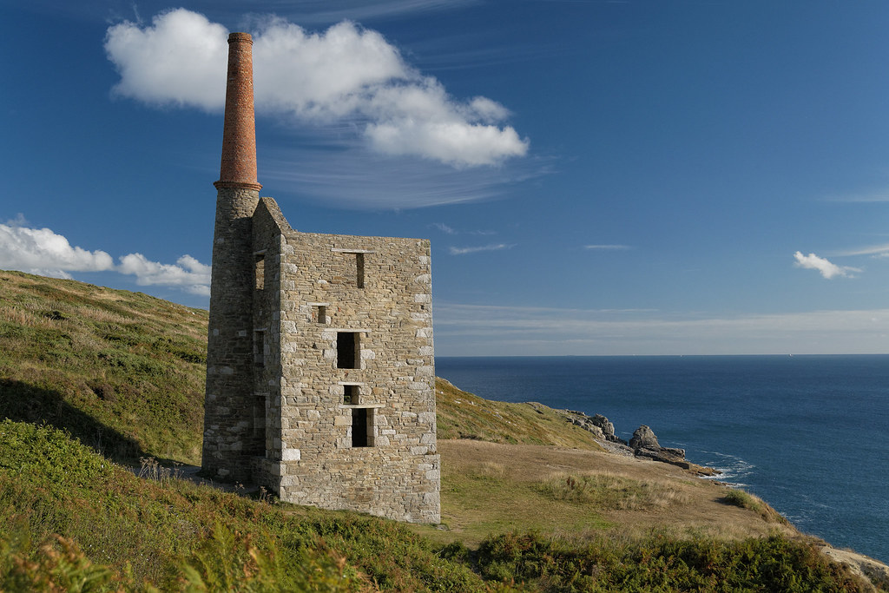  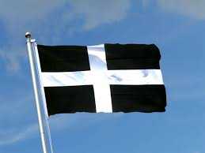 | Where is Cornwall?  How does it compare to other counties or places in Europe? CHOOSE A LOCATION TO COMPARE IT WITH.  What is the weather like in Cornwall? How does this affect us/ jobs/ lifestyle?  Compare to a place with different weather patterns.  Visit significant landmarks in Cornwall, e.g. tin mine. Compare human and physical landmarks. Create a map of Cornwall. Link to writing a visitor guide to Cornwall.

