Goonhavern Primary School- Geography
TOPIC: How Do We Help Our Planet? | YEAR: 2 | STRAND: How does the UK help our planet?

What should I know already? | What will I know by the end of the unit?
- Names of the 7 continents and 5 oceans-  - The oceans are being filled with pollution  - You can separate some of your rubbish for recycling.  - Recycling helps the environment.  - Our rubbish is taken away by the Council. | Locational Knowledge  Name, locate and identify characteristics of the four countries and capital cities of the UK and it’s surrounding seas  - The UK is made up of four countries-england, scotland, wales and northern ireland  - Northern Ireland is not part of Great Britain  - The capital of England is London  - The capital of Wales is Cardiff  - The capital of Scotland is Edinburogh  - The capital of Northern Ireland is Belfast  - Recycling is an important topic across the UK  - 45% of households recycle in the UK  - The UK creates 31 million tonnes of waste a year  - In the UK we throw away 13 billion steel cans every year, stacked on top of each other, you could make 3 piles of cans that would reach to the moon  Human and physical geography  Use basic geographical vocab for city, town, village, factory, farm, house, office, shop  - The different land uses in the UK including: housing healthcare factories education transport recreation retail business and they all create waste.  - There is more pollution in cities in the UK than in villages or small towns  - You can recycle paper, glass, tin and card.  - Some shops are opening that encourage us to reuse and reduce  - If we recycle we contribute to saving the planet
School Values
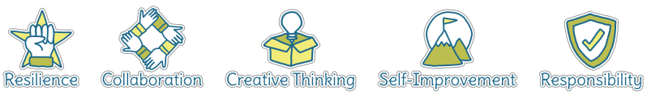
Five Ways to Wellbeing
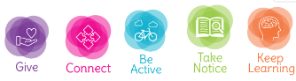

Vocabulary
Recycle | To turn waste into a reusable material.
Reuse | To use something many times before it’s disposed of.
Reduce | Cut down/make smaller.
Environment | Our natural world.
Global warming | Heating of the planet due to the impact of humans.
Sustainable | To be kept a certain level/last a long time.
Economical | Careful not to waste.
Waste | Not used/ left over.
Landfill | A place where waste is kept. Waste is usually buried in landfills.
Land Use | What the land is used for
Retail | The activity of selling goods to the public.

Image/diagram that helps me to articulate my knowledge/understanding | Investigate!
How does recycling, reducing and reusing affect our county, country and the wider world? Which parts of the UK are doing their bit to save our planet?
What is happening across the world to ensure these 3 things are happening? Where are they happening? What’s the impact?
Find creative ways of reusing different household items
Visit to a local recycling centre/ visit to the Refill Store.

