Goonhavern Primary School-Geography
TOPIC: Geography | YEAR: 3 | STRAND: Where in the World can we find Wonder?

What should I know already? | What will I know by the end of the unit?
- The world’s seven continents and five oceans  - Names of some cities in the UK  - Identify weather patterns in relation to the equator and the poles  - How to use world maps, atlases and globes to identify the UK  - Know south, north, west and east | Locational Knowledge  Know the ‘wonders of the world’ and locate their country on a map.  Find out about wonders nearby and locate them on a map  Geographical skills and fieldwork  Use maps, atlases and globes to locate countries and their continents.  - The seven natural wonders of the world are Mount Everest, the Great Barrier Reef, the Harbor of Rio de Janeiro, Victoria Falls, the Northern Lights, Parícutin, and the Grand Canyon  - Mount Everest is in the Himalayas in Nepal  - The Great Barrier Reef is in Australia  - The Harbour of Rio is in Brazil  - Victoria Falls is in Zimbabwe  - Northern Light can be seen in the most northern hemisphere of the earth  - Paricutin is in Mexico  - Grand Canyon is in North America  Human and Physical geography  Have physical geography knowledge of mountains, volcanoes and different climate zones. Know how these are formed and how they are identified  - A mountain is a landform that rises high above the surrounding terrain in a limited area. They are made from rocks and earth.  - Generally, mountains are higher than 600 metres.  - Everest is 29,035 feet or 8848 meters high.  - It is over 60 million years old. Everest was formed by the movement of the Indian tectonic plate pushing up and against the Asian plate.  - Everest grows by about a quarter of an inch (0.25") every  - Some of the natural wonders are there because of the climate zones they are in  - Most canyons were formed by a process of long-time erosion from a plateau or table-land level.  - Coral reefs begin to form when free-swimming coral larvae attach to submerged rocks or other hard surfaces along the edges of islands or continents.  - Waterfalls are created when the riverbed changes suddenly from hard rock to soft rock.
School Values


Five Ways to Wellbeing


Vocabulary
Wonder | Something/somewhere regarded as remarkable.
Mountain | a large natural elevation of the earth's surface rising abruptly from the surrounding level; a large steep hill.
Volcano | a mountain or hill, typically conical, having a crater or vent through which lava, rock fragments, hot vapour, and gas are or have been erupted from the earth's crust.
Natural | Naturally created without intervention of humans.
Manmade | Created by humans.

Image/diagram that helps me to articulate my knowledge/understanding | Investigate!
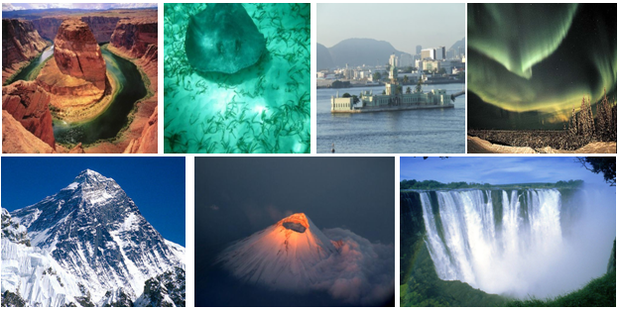 | Why are these places called ‘wonders’?  Where have we seen wonder before? Where can we find wonder locally? Which place has more ‘wonder’?  What are some man made wonders?  What would it be like to visit these locations? Why do people visit? How are they protected?

