Goonhavern Primary School- Geography
TOPIC: Geography | YEAR: 4 | STRAND: How Does Food Travel?

What should I know already? | What will I know by the end of the unit?
- The world’s seven continents and five oceans  - Names of some cities in the UK  - Identify weather patterns in relation to the equator and the poles  - How to use world maps, atlases and globes to identify the UK  - Know south, north, west and east  - Local geography from our community  - The wonders of world-where they are and how they were formed  - How to draw a sketch map and use a key | Locational knowledge:  Europe, north and south america  - Europe is the second smallest continent in size but the third largest in population.  - The European continent houses 50 countries.  - North America is the third largest continent in size and the fourth largest when we consider population.  - The North American continent houses 23 countries.  - There are 12 countries in South America.  Place Knowledge  Similarities between UK and South America through study of physical and human geography in food growth  - Crops commonly grown in the United Kingdom include cereals, chiefly wheat, oats and barley; root vegetables, chiefly potatoes and sugar beet; pulse crops such as beans or peas; forage crops such as cabbages, vetches, rape and kale; fruit, particularly apples and pears; and hay for animal feed.  - There are about 280,000 farms in Britain that provide us with different food  - Many crops thrive in the tropical climates of South America.  - Cashews and Brazil nuts are cultivated. Fruits such as avocado, pineapple, papaya, and guava are also native to tropical South America. Two very important cash crops are coffee and cacao, which is the source of cocoa, the base ingredient in chocolate  Human and Physical Geography  How is land used and how are natural resources including food grown and distributed ?  - The food we eat makes up about 30% of our carbon footprint.  - Knowing how far it has travelled and how it has been stored is essential if we wish to reduce the environmental impact.  - 95% of our fruit comes from abroad due to different climate zones suitable for growing food  - Whilst only 1% of food is transported by air, it accounts for 11% of carbon emissions.  - The most common form of transporting food once it’s reached the country of destination is by lorry. 25% of all journeys made in the UK will be taking food from destination to destination until it’s stacked on a supermarket shelf near you.  - Buying fair trade produce ensures that everyone in the supply chain is being treated fairly.  - There are 8 billion people on planet earth, and all of us need feeding. My not wasting food, and not eating too much meat we are making sure that everyone in the world can eat.
School Values
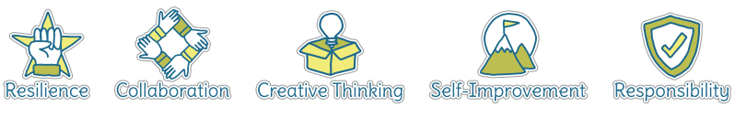
Fives Ways to Wellbeing


Vocabulary
Crops | A plant that is grown on a large scale commercially, especially a cereal, fruit, or vegetable.
Climate | The weather conditions in an area in general or over a long period.
Transport | How something travels.
Food Miles | A mile over which a food item is transported during the journey from producer to consumer, as a unit of measurement of the fuel used to transport it.
Carbon Emissions | Emissions means the release of greenhouse gases into the atmosphere over a specified area and period of time.
Tropical | The region of places near the equator.
Climate Zones | Climate zones are areas with distinct climates, which occur in east-west direction around the Earth.

Image/diagram that helps me to articulate my knowledge/understanding | Investigate!
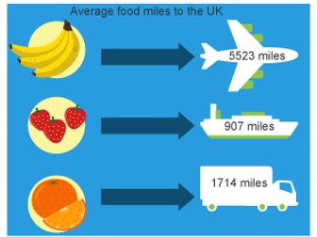 | What food can be grown in different parts of the world and why?  What is grown in the UK? What food is grown in South America? How does it get here? Is it better to buy food grown locally?  Grow own food and test in different temperatures if possible  Visit to a local farm that provides food to find out about the process  Find out about fair trade in South America and its importance  Physically draw food miles onto a world map with the climate zones drawn on

