Goonhavern Primary School- Geography
TOPIC: Geography | YEAR: 5 | STRAND: What is it like to work in Cornwall?

What should I know already? | What will I know by the end of the unit?
- The world’s seven continents and five oceans  - Names of some cities in the UK  - Identify weather patterns in relation to the equator and the poles  - How to use world maps, atlases and globes to identify the UK  - Know south, north, west and east  - Local geography from our community  - The wonders of world-where they are and how they were formed  - How to draw a sketch map and use a key  - Where food is grown and why and how it is transported  - Facts about our coastline and how we can protect it | Locational Knowledge:  What do we know about Cornwall?  - Cornwall is a county in the South West of England  - It has a population of over half a million  - Cornwall has the longest coastline in Britain  - Cornwall attracts 5 million tourists a year  - Cornwall forms the tip of the south-west peninsula of the island of Great Britain, and  is therefore exposed to the full force of the prevailing winds that blow in from the  Atlantic Ocean.  - The north and south coasts have different characteristics. The north coast on the  Celtic Sea, part of the Atlantic Ocean, is more exposed and therefore has a wilder  Nature.  - The south coast, dubbed the "Cornish Riviera", is more sheltered and there are several broad estuaries offering safe anchorages.  - Many parts of Cornwall are protected due to having Area of Outstanding Natural Beauty (AONB) status. There are many endangered and protected species throughout the county.  Human Geography  How has Cornwall been used by humans for work? How is this different to other countries?  - Cornwall began to industrialise in the middle of the eighteenth century when mining for copper and tin began in earnest.  - The china clay industry based around St Austell is characterised by what used to be white pyramids but are now largely grassed-over mounds.  - Fishing has always been vital to the survival of the Cornish. The oldest, large scale, well documented fishery in Cornwall is the Pilchard fishery. Pilchards have been renamed as Cornish sardines in recent years, but they are the same fish  - Over-fishing and chemical-focussed agricultural practices are having a devastating impact on the environment and our landscape.  - Tourism is a massive part of Cornish life and provide the income for many people  Physical Geography  What makes it different to other countries? How might this affect work?  - Cornwall has over 300 beaches  - Cornwall’s border is almost entirely formed by the River Tamar  - The Southern most westerly point is called Landsend  - Cornwall also includes the Isles of Scilly  - Cornwall has a mild climate compared to the rest of the UK  - The county flower is the rare cornish heath  - Cornwall has the capacity to be leaders in generating wind energy through offshore and onshore turbine farms.  Geographical Skills and Fieldwork  Use fieldwork to observe, measure, record and present the human and physical features in the local area
School Values

Five Ways to Wellbeing


Vocabulary
Population | All the inhabitants of a particular place.
Industrialise | Develop industries in (a country or region) on a wide scale.
Mining | The process or industry of obtaining coal or other minerals from a mine.
China clay | Kaolin, also called china clay, soft white clay that is an essential ingredient in the manufacture of china and porcelain and is widely used in the making of paper, rubber, paint, and many other products.
Tourism | The commercial organization and operation of holidays and visits to places of interest.
Industry | Economic activity concerned with the processing of raw materials and manufacture of goods in factories.

Image/diagram that helps me to articulate my knowledge/understanding | Investigate!
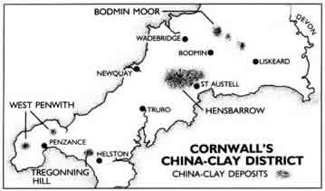  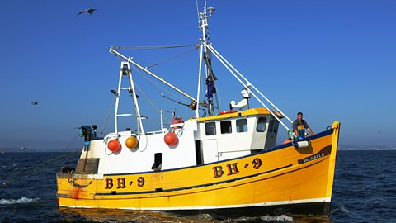 | What jobs are unique to Cornwall? What jobs are most popular? Why?  How does the physical geography of this county affect work?  Visit different workplaces and gather data, tourism industry, fishing industry and find out about past work in Cornwall (e.g. China clay industry)

