Goonhavern Primary School- Geography
TOPIC: Geography | YEAR: 6 | STRAND: Rivers

What should I know already? | What will I know by the end of the unit?
- The world’s seven continents and five oceans  - Names of some cities in the UK  - Identify weather patterns in relation to the equator and the poles  - How to use world maps, atlases and globes to identify the UK  - Know south, north, west and east  - Local geography from our community  - The wonders of world-where they are and how they were formed  - How to draw a sketch map and use a key  - Where food is grown and why and how it is transported  - Facts about our coastline and how we can protect it  - Where the Biomes of the world are  - Industry in Cornwall | I know what a river is  - A river is a path that water takes as it flows downhill normally towards another river, lake, sea or ocean  - Rivers come in many shapes and sizes and often join together to make a larger river  - As rivers are a source of water many plants live nearby or in them  - Most inland human settlements were originally formed around rivers as they are important for trade, bathing and drinking  - Rivers can flood at which point they can become very dangerous  I know terminology for a river  - The source is the beginning of a river and some come from underground springs or snow and ice off a mountain  - A tributary is a river or stream that leads into a larger river  - The watershed is an area of land that drains into a specific river  - Floodplain is a low lying area of land that becomes covered in water when a river overflows  - The path a river takes is called a channel  - Riverbank is the land immediately alongside a river  - Confluence is the junction between two rivers  - Flow is the name for the amount of water a river can hold-this can change throughout the year (e.g. rainy season)  - The mouth is the end point of a river  I know names of significant rivers in the world  - The River Nile is considered the longest river in the world. It runs through North East Africa  - The Amazon river if you count its tributaries is actually longer than the Nile. It holds more water than any other river and is responsible for a fifth of the fresh water going into the world’s oceans.  - The Yangtze is the longest river in Asia. It is fed by the mountain ranges in China. It flows through China  - The Thames is the longest river in the UK but is short compared to the other rivers. It has an estuary that feeds into the North Sea  - The Mississippi River is the longest in North America  - Due to global warming, these important rivers are rising which has a devastating impact on habitats and the environment.  Human Life on Rivers  - Rivers provided early humans with water to drink and fish to eat  - When people learned to build and use boats, rivers supplied a cheap and easy way to travel.  - Floodplains provided fertile soil for crops, and the system called irrigation allowed people to use rivers to water their fields.  - Flood defences are important to mitigate impacts of flooding.  - Today, many places use rivers to produce electric power. Hydroelectric dams, such as the Hoover Dam on the Colorado River in the USA, use the fast flow of rivers to generate great amounts of electricity.  - Lots of people like to use rivers for recreational activities as well, such as: fishing, bird watching, walking, canoeing, sailing and windsurfing.
School Values
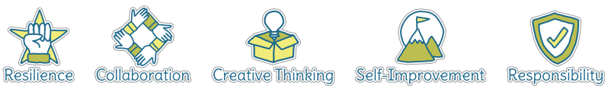
Five Ways to Wellbeing


Vocabulary
River bank | The lank that runs alongside a river.
Recreational | Something done for enjoyment.
Flow | The speed of the water movement.
Hydroelectric | Relating to or denoting the generation of electricity using flowing water (typically from a reservoir held behind a dam or barrage) to drive a turbine which powers a generator.
Irrigation | The supply of water to land or crops to help growth, typically by means of channels.
Tributies | Smaller streams and rivers that form to make a larger one.
Confluence | When two rivers meet.
Source | Where the river starts.
Mouth | Where the river meets the sea.

Image/diagram that helps me to articulate my knowledge/understanding | Investigate!
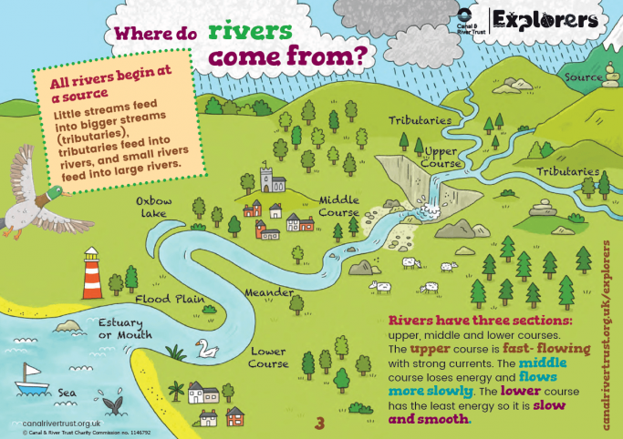  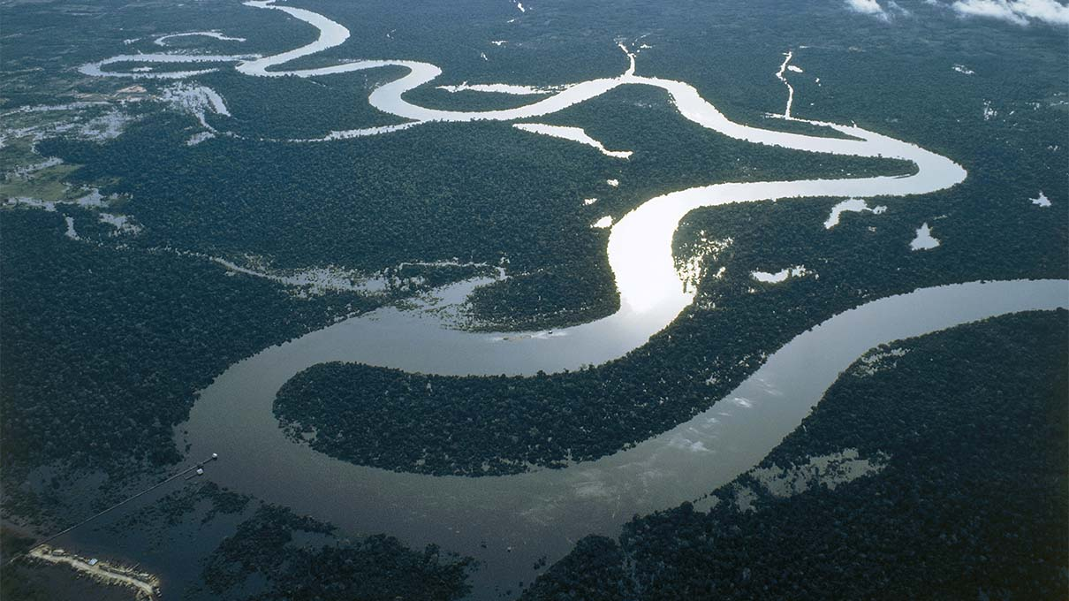  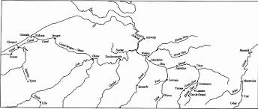 | Would we survive without rivers? Who are they most important to? How do they support humans, animals and plants? How do rivers change over the course of a year?  Make sketch maps of famous rivers and local rivers.  Visit a local river and investigate the flow and identify different features.

