Goonhavern Primary School- Geography
TOPIC: Geography | YEAR: 6 | STRAND: How does Cornwall Compare to Birmingham?

What should I know already? | What will I know by the end of the unit?
- The world’s seven continents and five oceans  - Names of some cities in the UK  - Identify weather patterns in relation to the equator and the poles  - How to use world maps, atlases and globes to identify the UK  - Know south, north, west and east  - Local geography from our community  - The wonders of world-where they are and how they were formed  - How to draw a sketch map and use a key  - Where food is grown and why and how it is transported  - Facts about our coastline and how we can protect it  - Where the Biomes of the world are  - Industry in Cornwall | Locational Knowledge  - Birmingham is a major city in England’s West Midlands region,  - Birmingham is home to 1.1 million people  - It is one of the most culturally diverse cities in the UK.  - is considered to be the social, cultural, financial, and commercial centre of both the East and West Midlands  - Birmingham is the 8th most populous metropolitan area in Europe.  - Birmingham lies near the geographic centre of England, at the crossing points of the national railway and motorway systems. It is about 177 km northwest of the capital city, London.  Physical Geography  - The temperatures tend to be mild, between 15-20°C in summer and around 5°C in the winter months. December, January and February are the rainiest months of the year, but regardless of season, each month usually sees over 15 days of rain.  - Birmingham claims to be one of the greenest cities in the UK, with over 8,000 acres of park land and open space. Is this true? In what ways is Birmingham ‘green’ as a city and which areas could be improved?  - Using bike paths and public transport reduces carbon emissions in the city.  Human Geography  - It has more canals than Venice and is the centre of the UK’s canal network. The canals range from taking you high above houses in the suburbs to deep below the buildings in the city centre  - Birmingham’s iconic buildings can help you navigate the city.  - West of the centre is the new Library of Birmingham, nicknamed “the wedding cake.”  - Birmingham's major cultural institutions – including the City of Birmingham Symphony Orchestra, the Birmingham Royal Ballet, the Birmingham Repertory Theatre, the Library of Birmingham and the Barber Institute of Fine Arts – enjoy international reputations  - Like all cities around the world, there is a mixture of wealth and poverty.
School Values

Five Ways to Wellbeing


Vocabulary
Culturally diverse | The existence of a variety of cultural or ethnic groups within a society.
Canal | Manmade river.
Suburbs | Quieter area on the outskirts of the city.
Financial | Relating to money.
Commercial | Trading, selling to make a profit.
Metropolitan | Relating to or denoting a metropolis or large city.
International | Existing, occurring, or carried on between nations.

Image/diagram that helps me to articulate my knowledge/understanding | Investigate!
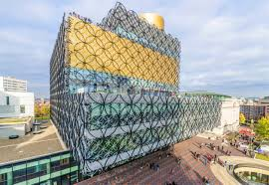  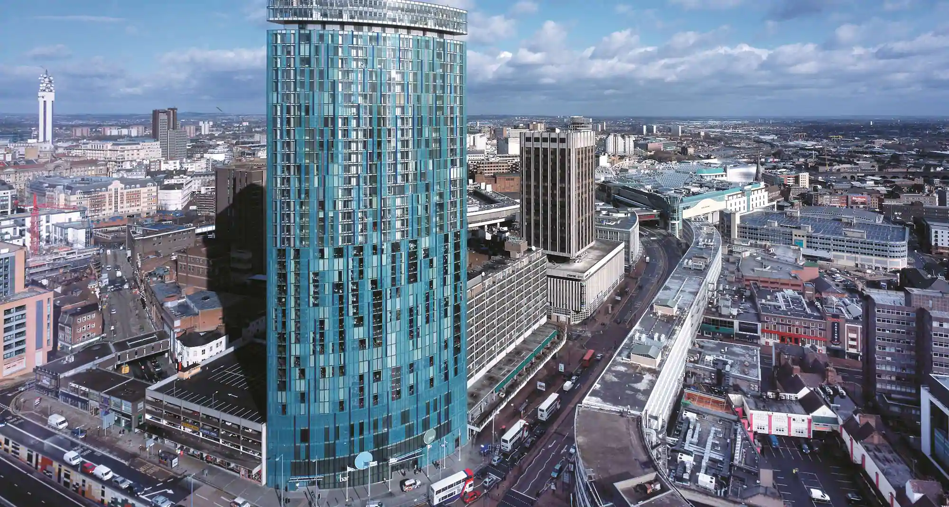 | Pre-trip: (possible trip to Truro)  What do we know about our nearest city?  How do we think Birmingham will be the same/different?  Look at photos to compare  Trip: How do we navigate around a big city? How is the city being used by most people? Observational data collection.  Post Trip: Did my expectations meet the reality? What are the pros and cons of living in Truro/Birmingham?

