Goonhavern Primary School- History
TOPIC: Life in 1950s Britain- Was the 1950’s a good time to live in Britain? | YEAR: 1 | STRAND: Changes within Living Memory
School Values


Five Ways to Wellbeing


What should I know already? | What will I know by the end of the unit?
- That our queen is Queen Elizabeth II | Chronology (Chr)  Pupils should develop an awareness of the past, using common words and phrases relating to the passing of time. They should know where the people and events they study fit within a chronological framework | There are people alive today who lived in the 1950’s. (Pupils’ grandparents and great grandparents.)
 |  | The coronation took place in 1953 and people watched it on black and white television.
 | Concepts and processes (Con)  They should use a wide vocabulary of everyday historical terms.  They should ask and answer questions, choosing and using parts of stories and other sources to show that they know and understand key features of events, i.e. significance, change and continuity, similarities and differences, causes and consequences | WW2 was over but there was still food rationing. Food and cooking was more basic, mainly meat and vegetables. (No fast-foods chains)
 |  | Wealthier people had cars but most used buses, trains or bicycles to get around. There was less road traffic than today. Very few could afford to go abroad on holiday. Most had British seaside holidays.
 |  | Wealthier people had a telephone in their house but most had to use a public pay phone. People relied on radio, newspapers and the cinema (Pathe) for information about what was going on in the world. Home computers and the internet were far in the future.
Methods of enquiry (Enq)
They should understand some of the ways in which we find out about the past and identify different ways in which it is represented

Vocabulary
century | One hundred years
cinema | A theatre where films are shown for public entertainment
coronation | the ceremony of crowning a sovereign or a sovereign's consort.
decade | Ten years
radio | The activity or industry of broadcasting sound programmes to the public
rationing | Allow each person to have only a fixed amount of (an item)
television | A device with a screen for receiving television signals.
traffic | Vehicles moving on a public highway
transport | A system or means of conveying people or goods from place to place
Windrush | Relating to or denoting the people who emigrated from the Caribbean to Britain on the British ship the Empire Windrush in 1948.

Image/diagram that helps me to articulate my knowledge/understanding | Investigate!
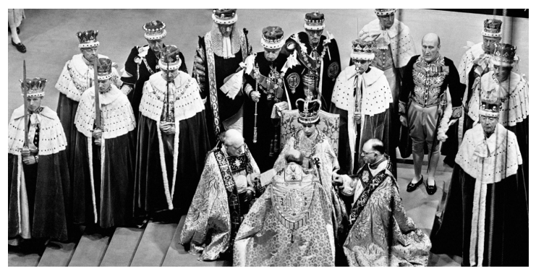  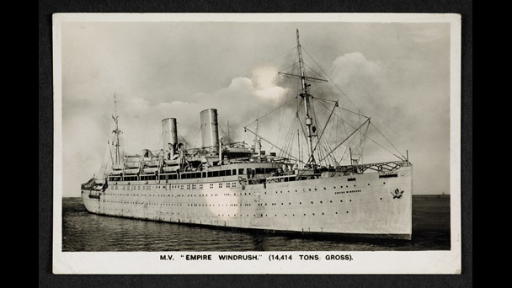  Windrush video link: https://youtu.be/VGuAX_Px464  Link to ‘Am I Part of History?’ unit | Assessment Questions  -How long ago was the 1950’s?  -Is it possible to meet and talk to people who can remember the 1950’s?  -Which century did the decade of the 1950’s belong to?  -What century do we live in?  -What is a coronation?  -Whose coronation took place in 1953?  -Elizabeth is still queen today – change or continuity?  -How did more people than ever before see what happened during the coronation ceremony?  -What was rationing? (link to WW2)  -In what ways was food similar and different to today?  -What foods do we have that would not have been common in the 1950’s?  -What kitchen appliances did they have and which had not yet been invented?  -What forms of transport did people use?  -Which forms of transport do we use today?  -What changes do you think someone from the 50’s might like or dislikes about today’s world?  -How did people communicate with each other in the 1950’s before mobile phones, texting, emails and social media?  -Where did people get their news from in those days before most people had TVs in their home and before anyone had personal computers?

