Goonhavern Primary School- History
TOPIC: Am I part of History?  Family Tree | YEAR: 1 | STRAND: Changes within Living Memory
School Values
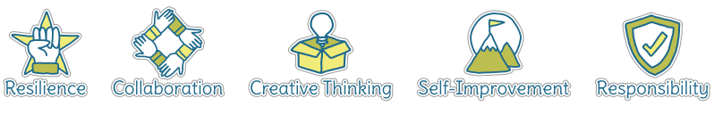

Five Ways to Wellbeing
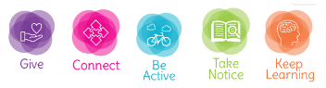

What should I know already? | What will I know by the end of the unit?
- That I am part of a family  - That my family has ancestors  - That we can find out about our family history in a variety of ways | Methods of enquiry (Enq)  They should understand some of the ways in which we find out about the past and identify different ways in which it is represented | I can use different methods of enquiry to find out about my past
 | Chronology (Chr)  Pupils should develop an awareness of the past, using common words and phrases relating to the passing of time. They should know where the people and events they study fit within a chronological framework | That some aspects of life were different when my parents and grandparents were children
 |  | That some aspects of life were the same when my parents and grandparents were children

Vocabulary
Family | A group of one or more parents and their children living together as a unit  All the descendants of a common ancestor
Family Tree | A diagram showing the relationship between people in several generations of a family.
Grandparent | A parent of one's father or mother; a grandmother or grandfather.
Parent | A person's father or mother.
Windrush | Relating to or denoting the people who emigrated from the Caribbean to Britain on the British ship the Empire Windrush in 1948.

Image/diagram that helps me to articulate my knowledge/understanding | Investigate!
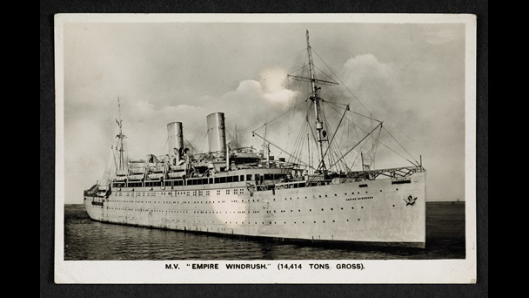  Windrush video link: https://youtu.be/VGuAX_Px464  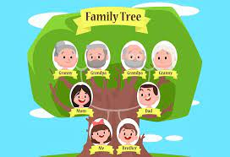 | Who is in your family tree? Make a family tree  Interview a parent or grandparent- what was life like when they were your age?

