Goonhavern Primary School- History
TOPIC: Should we be grateful to I.K. Brunel? | YEAR: 2 | STRAND: Significant Individuals

What should I know already? | What will I know by the end of the unit?
That the actions of people in the past have an impact on our lives today | Chronology (Chr)  Pupils should develop an awareness of the past, using common words and phrases relating to the passing of time. They should know where the people and events they study fit within a chronological framework | Isambard Kingdom Brunel was a famous engineer from Victorian times who wore a distinctive ‘stovepipe’ hat.  He was responsible for designing bridges (Avon Gorge), docks (Cardiff), steam ships (Great Western) and railway tunnels (Box), many of which are still in use today.  He was Chief Engineer for the Great Western Railway and designer of many of its bridges and viaducts.  The Royal Albert Bridge is a railway bridge designed by Brunel which spans the River Tamar, connecting Devon to Cornwall  -It was named after Prince Albert, Queen Victoria’s husband, who opened it in 1859.  It has been strengthened during the 20th Century but is still in use today as a railway bridge 160 years after it was opened.  In 1962 a road bridge across the Tamar was built right next to the Royal Albert Bridge.
 | Concepts and processes (Con)  They should use a wide vocabulary of everyday historical terms.  They should ask and answer questions, choosing and using parts of stories and other sources to show that they know and understand key features of events, i.e. significance, change and continuity, similarities and differences, causes and consequences. | -Who was Brunel? When did he live and why do we still talk about him today?  -Was Brunel lucky or clever in his early career?  -What were some of his finest achievements as an engineer? Did he ever fail or make mistakes?  -How do we decide what name to give buildings, ships and bridges?
School Values

Five Ways to Wellbeing


Vocabulary
achievement | A thing done successfully with effort, skill, or courage
bridge | A structure carrying a road, path, railway, etc. across a river, road, or other obstacle
design | A plan or drawing produced to show the look and function or workings of a building, garment, or other object before it is made
engineer | A person who designs, builds, or maintains engines, machines, or structures
railway | A network of tracks with the trains, organization, and personnel required for its working
track | Lines that a train runs on
tunnel | An artificial underground passage, especially one built through a hill or under a building, road, or river
viaduct | A long bridge-like structure, typically a series of arches, carrying a road or railway across a valley or other low ground
Victorian | Relating to the reign of Queen Victoria

Image/diagram that helps me to articulate my knowledge/understanding | Investigate!
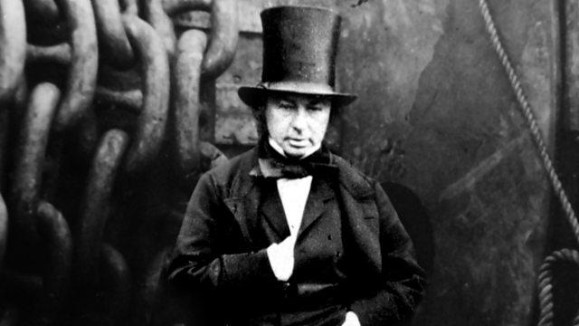  Make explicit link between Queen Victoria and Queen Elizabeth and Family Trees (Y1)  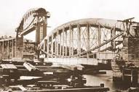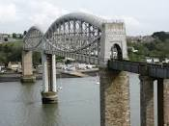  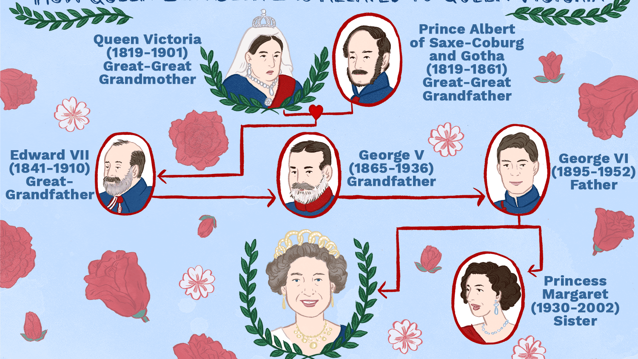 | Assessment Questions  When was Brunel born? How long did he live?  -Which century did he live in?  -Who was the king or queen during his lifetime?  -How long have trains been crossing the River Tamar on Brunel’s Royal Albert Bridge?  -What does an engineer do?  -How did Brunel become so interested in engineering?  -Was Brunel, lucky or clever or both in his career? (survived drowning etc)  -What successes did he achieve as an engineer?  -Did he ever fail or get things wrong as an engineer?  -How do we decide what name to give buildings, ships and bridges?  -Who was Prince Albert and why was the bridge named after him?  -Why do we invite members of the royal family to open buildings and bridges?  -Would it be right to rename the bridge?  -Looking at the Royal Albert Bridge, how do we know it was designed by Brunel?  -Is the Bridge exactly the same today as it was when it was opened in 1859?  -Compare photos of the Royal Albert Bridge from Victorian times with photos from today. What differences can you see?  Assessment Questions  How old are you?  -How old do the oldest people live to be?  -Would anyone alive today be old enough to have lived at the same time as Christopher Columbus?  -Would anyone alive today have been alive in 1969 when Armstrong set foot on the moon?  -What is trade? What does a merchant do?  -Why did Columbus set sail across the Atlantic? What did he hope to find and why?  -How did Columbus cross the expanse of the Atlantic Ocean and how long did it take?  -What dangers did he face?  -How would we travel across the Atlantic Ocean? Would we get there faster or slower than Columbus?  -What is an astronaut?  -What words did Armstrong say as he became the first person to set foot on the moon?  -How did the Americans react when the Russians put a man in space before them?  -Were cameras around in Columbus’ time?  -What about in Armstrong’s time?  -When were the very first photos taken?  - Can photographs and film footage help us to work out what happened in the past?

