Goonhavern Primary School- History
TOPIC: Explorers- Who was the greatest explorer, Columbus or Armstrong? | YEAR: 2 | STRAND: Significant Individuals

What should I know already? | What will I know by the end of the unit?
That the actions of people in the past have an impact on our lives today | Essential knowledge and subject specific vocabulary | -Christopher Columbus was an Italian merchant and explorer (b:1451; d: 1506)  -He made four voyages across the Atlantic Ocean and discovered the New World (the Americas).  -He was actually looking for a trade route to the Far East because he wanted to buy spices there.  -He called the people of the Americas ‘Indians’ and did not treat them well: he was very cruel to them and took their gold. Many died.
-Neil Armstrong was an American astronaut who was the first man to set foot on the moon. (born: 1930; died: 2012)
-He was commander of the Apollo 11 space mission which included Buzz Aldrin and Michael Collins
-The moon landing took place on 20th July, 1969. Landing safely on the moon was difficult because of rocks and boulders.
 | Enquiry focus and sequencing questions | -What made Columbus set sail across the Atlantic Ocean?  -What difficulties and dangers did he face on his voyages?  -How did he treat the people of the Americas?  -Why were the Americans so keen to be first to send a man to the moon?  -What difficulties and dangers did the crew of Apollo 11 face during their voyage?  -What evidence do we have for Columbus’ and Armstrong’s voyages?
School Values

Five Ways to Wellbeing


Vocabulary
astronaut | A person who is trained to travel in a spacecraft
Atlantic | Of or adjoining the Atlantic Ocean
crew | A group of people who work on and operate a ship, aircraft, etc
explorer | A person who explores a new or unfamiliar area
mission | An important assignment given to a person or group of people, typically involving travel
moon | The natural satellite of the earth, visible (chiefly at night) by reflected light from the sun
ocean | A very large expanse of sea
space | The area directly outside of Earth's atmosphere
trade | Trade is the buying and selling of goods and services

Image/diagram that helps me to articulate my knowledge/understanding | Investigate!
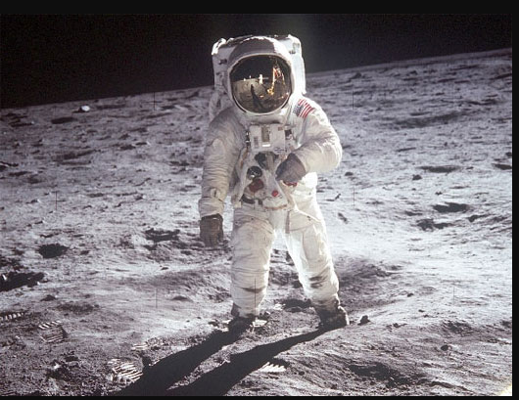  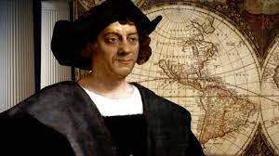 | What was similar/ different about their ‘missions’?  Why did they do what they did?

