Goonhavern Primary School- History
TOPIC: The Stone Age-How did people live in prehistoric Britain? What key changes occurred between the Stone, Bronze and Iron Ages? | YEAR: 3 | STRAND: Settlements

What should I know already? | What will I know by the end of the unit?
We know that historians use sources to find out what happened in the past. | THE STONE AGE  I know that during the Old Stone Age people survived by hunting animals and gathering nuts and berries.  I know that in the New Stone Age people began to grow crops and domesticate animals. This was the start of farming. | - The Stone Age lasted more than 2 million years. It is divided into Old, Middle and New Stone Ages.  - The Old Stone Age began 2.5 million years ago and lasted until the end of the great Ice Age about 11,000 years ago. (99% of human history!)  - During the Old Stone Age small groups of nomadic humans lived by following and hunting herds of wild animals. They gathered wild fruit, nuts and berries. Their weapons and tools were made of stone, bone and wood.  - In the New Stone Age (about 8,000 years ago in Britain) things began to change. Humans started to grow crops and to domesticate animals. They lived a more settled lifestyle and began to build houses like the ones at Skara Brae in the Orkney Islands.
 | SKARA BRAE  I know that the New Stone Age people of Skara Brae lived in houses made of stone and that they made their own pottery, furniture, clothes and weapons. | - Skara Brae is a New Stone Age settlement which was buried beneath sand dunes for thousands of years. It was discovered in 1850 when a huge storm blew away the sand and uncovered the ancient stone houses.  - Archaeologists studied the houses and found evidence of the lives of the people who lived there. They survived by fishing, hunting and farming. They were skilled at weaving and pottery. They even had stone furniture including beds and storage cupboards!
 | BRONZE AND IRON AGES  I know that during the Bronze Age people learnt how to smelt metal and how to make stronger tools and weapons and beautiful jewellery. | - The Bronze Age began about 4000 years ago in Britain. People learnt how to smelt. This means heating up rocks to release hot liquid metal. This metal could then be poured into a mould to be made into weapons, tools and jewellery. Metal tools were much stronger than stone tools.  - Bronze Age people were religious. We think they worshipped the Sun and the Moon and the coming and going of the seasons. They did not write anything down so we cannot know for sure.  - They built huge stone circles like the one at Stonehenge in Wiltshire. This would have taken a lot of hard work and organisation. Some of the huge stones were transported hundreds of miles from Wales.
 | I know that Iron Age people lived together in tribes which often fought each other. They lived in hill forts to protect themselves from their enemies | - The Iron Age began about 2500 years ago in Britain. The people lived in tribes with names such as the Iceni and Trinovantes. The tribes often fought each other in battle, using iron swords, shields and spears. Iron was harder than bronze.  - To protect themselves against their enemies the Iron Age tribes lived in hill forts. They dug ditches and made earth banks to make their forts difficult to attack. They could also see their enemies approaching and get ready to fight them.
School Values
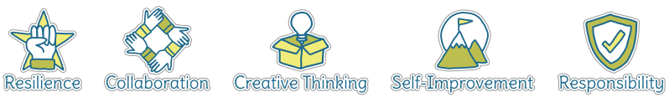
Five Ways to Wellbeing


Vocabulary
archaeologist | Someone who studies the remains of the prehistoric past
artefact | An object or item from the prehistoric past
evidence | Anything which is used to prove (or disprove) something
farmer, farming | Growing crops and rearing domesticated animals for food
flint | A hard stone used for tool making purposes
hill fort | A circular fortified enclosure on top of a hill
hunter-gatherers | People who survive by hunting animals for their meat and foraging for natural food such as nuts and berries
mammoth | A large woolly creature (now extinct) similar to an elephant
nomad, nomadic | Moving around to follow the animals which you hunt.
pottery | Pots, plates and dishes and ornaments made of clay
religion | The beliefs people have about who created the world and what happens to them when they die
smelting | Heating up rocks to release molten metal
tribe | A group of people who live, farm and fight together

Image/diagram that helps me to articulate my knowledge/understanding | Investigate!
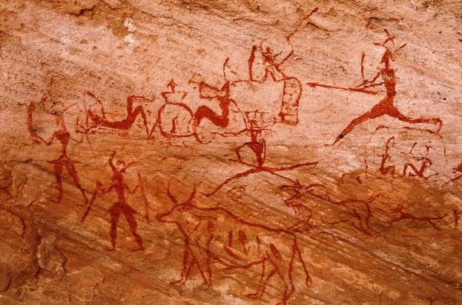  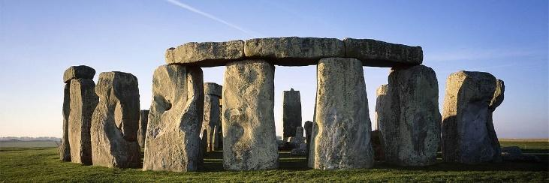  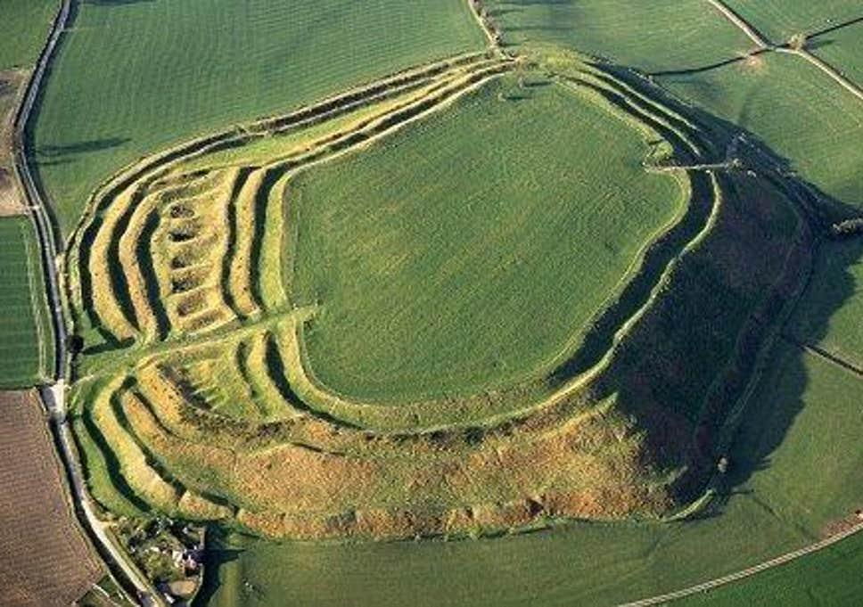  Make link to Art unit | Link to Lascaux cave paintings (Art unit)

