Goonhavern Primary School- History
TOPIC: Roman Invasion- What did the Romans do for us? | YEAR: 3 | STRAND: Invasion and Settlement

What should I know already? | What will I know by the end of the unit?
That the Romans were one of the most important ancient civilisations.  That they were most powerful between 40BC and 455AD.  That the arrival of the Romans into Britain dramatically changed the way people lived in Britain.  That evidence of the Romans can still be seen today in buildings, writing, latin, artefacts and artwork.  That Rome was the centre of the Roman Empire - and that the Emperor was the most powerful man.  That the Romans had their own number system called numerals. | Building an empire | That the Romans first invaded Britain in 55-54BC.  The man leading the invasion was Julius Caesar but this attempt failed and he was forced to return home.
 | Successful invasion | Emperor Claudius finally made a successful invasion of Britain in 43AD.
 | Allies | Queen Cartimandua was the Queen of the Brigantes (people from northern England). She formed a large tribe who pledged loyalty to Rome after they invaded.
 | Enemies | Boudicca was Queen of the Iceni tribe (east anglia area) who fought against Roman rule and led a revolt in 60/61AD.  But the Roman army was too well trained and disciplined to be beaten, even though they were outnumbered!
 | Developments | That before the Romans Britain had no road structure or central government. That the Romans built roads, towns, ports and even Hadrian’s wall (73 miles of wall dividing England from Scotland).  They also introduced new and innovative farming techniques to increase farming output. Running hot water, bathing houses, theatre and sporting events all developed under the Roman occupation.
 | Leaving a legacy | The Romans left many buildings, roads and developments behind - they also left parts of their language here.  Many words we use today come from Latin - and any town which ends in -cester, -caster, chester was originally a Roman town!
School Values

Five Ways to Wellbeing


Vocabulary
Rome | Capital of Italy on the Tiber - also the ancient capital of the Roman Empire
Emperor | The ruler of the Roma empire
Empire | The land and/or countries occupied and ruled by the ancient Romans
Legion | A division of between 3,000 -6,000 fighting men, including cavalry and infantry who formed the Roman armies
Centurian | A smaller division of 100 men within a Roman legion
Barbarian | A member of a people not belonging to, or fighting against, the Roman empire
Slave | A person who is captured or owned by another and forced to obey them
Roman numerals | A system of using letters to represent numbers - designed and used by the Romans and still in use today
Villa | A large country house of Roman times - usually consisting of a farm and residential buildings arranged around a central courtyard
Amphitheatre | An open air circular or oval building with a central space surrounded by tiers of seating for spectators. Used for entertainment by the Romans - particularly drama and sporting events.
Pantheon | A Roman temple dedicated to all the Gods of Pagan Roman belief
Chariot | A 2-wheeled vehicle pulled by a horse/horses used in both racing events and in warfare
Temple | A building devoted to the worship of a particular God - a place where offerings could be made
Baths | A building or series of buildings which contained rooms designed for bathing, relaxing and socialising in ancient Rome. These were mainly used by men but women had their own baths or rooms for similar reasons.

Image/diagram that helps me to articulate my knowledge/understanding | Investigate!
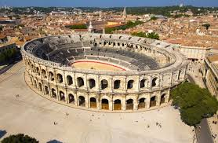  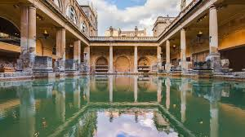  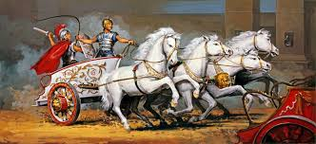 | What buildings and artefacts help us understand how the Romans lived?  What entertainment did the Romans enjoy?  What was it like to be a Roman citizen?  What was it like to be a Roman slave?  Why was the Roman army so successful?  When the Romans came to Britain was it a good thing or a bad thing?  Why do you think some British tribes allied themselves to the Romans and some fought against them?  What would you have done?  Diversity- Septimius Severus  https://en.wikipedia.org/wiki/Septimius_Severus

