Goonhavern Primary School- History
TOPIC: Anglo-Saxons and Vikings | YEAR: 4 | STRAND: Invaders and Settlers

What should I know already? | What will I know by the end of the unit?
- The Romans ruled Britain from 43 to 410 A.D. | I know that after the Romans left Britain, many groups of invaders came across the North Sea in their ships from mainland Europe to attack the islands of Britain. | - The Romans left Britain in the early 5th Century A.D. because Rome was being attacked by barbarian tribes. This left Britain vulnerable to attack from Europe because there was no Roman army to defend our shores.  - The first groups to arrive from about 500 A.D. onwards were the Angles, the Saxons and the Jutes. (One of these groups - the Angles - gave their name to our country, England.)  - We call these groups the Anglo-Saxons.
 | I know that the first invaders were the Anglo-Saxons who came from Germany, Belgium and Holland. They drove the people of Britain (the Celts) off their land and then settled down there to farm.  The Anglo-Saxons built villages and towns all over the east and middle of England. | - The Anglo-Saxons arrived in their ships from Germany, Holland and Belgium and attacked the east coast of Britain.  - They drove the people of Britain - the Celts - out of their lands. The Celts fled to the far west of Britain to escape the Anglo-Saxons. Cornwall was one of the places in western Britain that the Celts fled to.  - The Anglo-Saxons settled down to farm on the lands they had invaded. They spent most of their time working on the land, growing food and looking after animals.  - They mainly lived in villages and small towns.  - The earl was the most important man in the local area. Below him were the thanes (lords), the peasants (poor free farmers) and the slaves.
 | The Anglo-Saxons were originally pagans but later on converted to Christianity.  The Anglo-Saxons built churches, abbeys and monasteries in their towns and villages to show that they were true and devoted Christians. | - At first, the Anglo-Saxons were pagans. This means they believed in many gods. Woden was the most important god. (Wednesday was named after him. Tuesday, Thursday and Friday are also named after Anglo-Saxon gods.)  - Then in 597 A.D. the Pope sent a monk called Augustine to Britain to convert the Anglo-Saxons to Christianity.  - It took nearly one hundred years for all of the Anglo-Saxons to be converted.  - Monasteries were centres of learning. Monks and nuns spent their time in prayer. They also studied and worked in fields and workshops. Monks copied out books by hand and decorated the pages in beautiful colours.
 | The next invaders to arrive in Britain were the Vikings who came to Britain from Scandinavia (Norway, Denmark and Sweden).  These fierce warriors arrived in long-ships and raided Anglo-Saxon settlements, burning  churches and stealing treasure.  The Vikings were traders and explorers as well as raiders. They travelled great distances in their long-ships. | - The Vikings came from northern Europe or Scandinavia. They sailed across the North Sea to Britain in their long-ships.  - By the time the Vikings arrived on the shores of Britain in the late 700’s A.D. the Anglo-Saxons had built many beautiful churches and abbeys  - The Vikings raided and plundered these churches and abbeys, killing monks and stealing their treasure.  - The first of these terrifying raids took place at Lindisfarne in 793 A.D. where Viking raiders attacked the abbey of St. Cuthbert.  - This event and others like it helped to give the Vikings a brutal reputation but it is important to remember that they were also explorers, traders, farmers and craftsmen and women.  - The Vikings travelled far and wide in their long-ships and traded goods wherever they went. They visited Russia, the lands around the Mediterranean and even crossed the Atlantic Ocean to Newfoundland (part of modern Canada).  Fact check:  There is no evidencethat the Vikings ever wore horned helmets!
 | The Anglo-Saxons and Vikings struggled for control of England. They often fought each other in battle, but at other times they did deals and tried to live together peacefully.  Alfred the Great was an Anglo-Saxon king who is remembered for battling against the Vikings and preventing them from taking over the whole of England. | - The Anglo-Saxons and Vikings struggled against each other for hundreds of years. At first, it seemed as if the Vikings were going to destroy the Anglo-Saxons. They were almost impossible to defeat in battle. Their most ferocious warriors literally went beserk in battle. Anglo-Saxon Kings such as Alfred, Athelstan, Edgar and Ethelred used different tactics to try and stop the Viking onslaught.  - Sometimes they made treaties with the Vikings and sometimes they fought them in battle. King Ethelred tried giving the Vikings money (Danegeld) to stop them attacking. This did not work because the Vikings took the money and carried on attacking.  - During the late 800’s A.D. King Alfred was probably the most successful at dealing with the Vikings. He succeeded in uniting the Anglo-Saxon Kingdoms to fight against the Vikings and eventually made peace with them.
School Values

Five Ways to Wellbeing


Vocabulary
Anglo-Saxons | the Angles, Saxons and Jutes
invader | a person or group that invades a country, region, or other place
earl | a rich and important Anglo-Saxon noble
thane | an Anglo-Saxon lord
peasant | a poor free farmer
slave | a worker who belongs to another man and is forced to work for him
Christian | a believer in Christianity
Christianity | the religion based on the person and teachings of Jesus Christ
Scandinavia | the region of northern Europe which includes Denmark, Norway, Sweden and the island of Iceland
plunder | to steal wealth and treasure from someone, usually using violence or brutality
long-ship | a long, narrow warship, powered by both oar and sail with many rowers, used by the Vikings
trader | a person who buys and sells goods
treaty | an agreement between two sides to prevent fighting or war

Image/diagram that helps me to articulate my knowledge/understanding | Investigate!
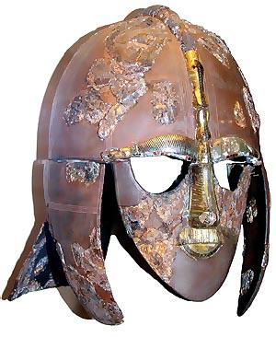
The famous Sutton Hoo helmet is from Anglo-Saxon times.

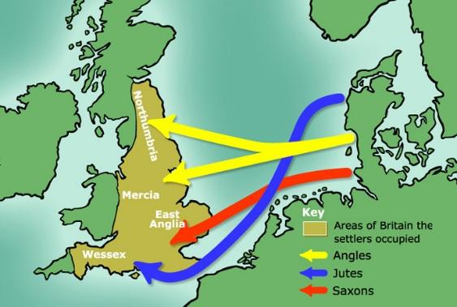
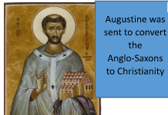

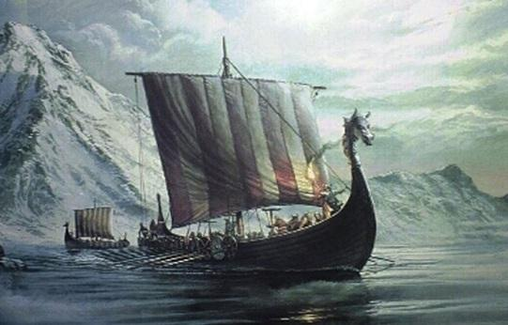
A Viking long-ship

