**Thematic Study (Y6): How did the British public respond to Black Soldiers? What was the experience of Black American soldiers in World War 2? (To be converted to KO)**

* WW1 introductory starting point
* WW2 trench warfare
* Many black soldiers stationed in Cornwall- Launceston Square story
* U.S attitudes towards race ironic considering black U.S. soldiers were fighting Nazi regime
* Descendants of slaves

**Unit: Black Soldiers who fought for Democracy in 20th Century**

**Pedagogy: Critically evaluating photographs (zoom in/out) (SEE BELOW)**

**WW2 first, then THEMATIC STUDY**

|  |
| --- |
| **Vocabulary** |
| * **GI** * **Segregation** * **Discrimination** * **Combat Personnel/ Support roles** * **Jim Crow** * **Public opinion** * **Prejudice** * **Racist/ Racism** * **African American** * **Coloured (sink photo)** * **Person of colour** |

* **Photographic starting point- what do you see? Think? Wonder?**

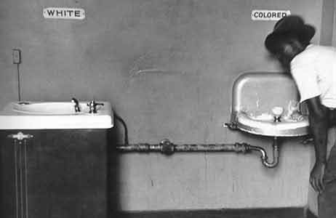

* How were black GIs received by the British public?
* Segregation

- back home- what was life like in the USA?

- were black soldiers treated as equals in the US Army?

- Attitudes in the UK? How welcome were black soldiers in the UK? Cornwall?

- The battle of Bamber Bridge- who was to blame? Launceston Square?

- How popular were GIs in wartime Britain?What happened when they went home? VV Movement (precursor to MLK/ Civil Rights)

- Why did GIs find Britain different to the US?

- Local dimension, connection

* Visit War Graves website <https://www.cwgc.org/> - focus on a soldier who gave up his life? Black soldiers fighting other wars?
* Own research projects- e.g. other theatres of war etc