Goonhavern Primary School- History
TOPIC: Black History | YEAR: 6 | STRAND: Changes in an aspect of social history

What should I know already? | What will I know by the end of the unit?
Everyone in our school has the same rights. It makes no difference what colour our skin is or where our families came from in the past. | I know that in the past African people were taken by ship across the Atlantic Ocean to work as slaves in North America and the West indies  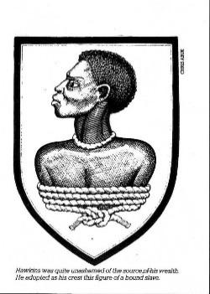  The crest of John Hawkins, the first English slave trader | - From the 16th to the 19th Century, hundreds of thousands of Africans were transported across the Atlantic Ocean in slave ships owned by European slave traders.  - Slave traders such as Edward Colston became very rich by selling these Africans to white plantation owners in America and the West Indies.  - The Africans never saw their homes again and were forced to work as slaves on American plantations for the rest of their lives. The white plantation owners made lots of money by selling the crops grown on their plantations.  - Crops such as cotton and tobacco were grown on the plantations. The slaves had to work very hard on these crops all year round. They received no pay and punishments were severe for any who tried to run away.
 | I know that Rosa Parks refused to give up her seat on a bus to a white person and that she was arrested for this  I know that there was a bus boycott in Montgomery, Alabama, and that this was a very significant event in the Civil Rights movement. | - In 1955 a woman called Rosa Parks, a shop assistant from Montgomery, Alabama, refused to give up her seat to a white person on a bus.  - Rosa was arrested for doing this and forced to pay a fine.  - Rosa was a campaigner for civil rights. She wanted black people to be treated fairly and to have the same rights as white Americans.  - Rosa Parks, Martin Luther King and other campaigners organised a successful boycott of the buses in Montgomery in 1956  Buses were desegregated (black and whites could now mix freely together) and this showed that peaceful protest could be a successful way of bringing about change.
 | I know that African American people still did not have the same rights as white people in the 20th Century even though slavery had ended 100 years before | - Slavery was abolished (banned) in the lands of the British Empire in 1833. The USA was not part of the British Empire in 1833.  - Slavery did not end in the USA until the 1860’s after a civil war between Americans who wanted slavery to end (Yankees) and those who wanted it to continue (Confederates).  - African Americans still lived very hard lives after slavery was brought to an end in the USA. In the late 19th Century Jim Crow Laws were passed in many states forcing them to live separately from whites.  - In the 20th Century, African Americans and whites had to attend separate schools, hospitals, restaurants and laundries. They sat in separate areas on buses and trains. Some cafes refused to serve black people. This was known as segregation.
 | I know that segregation has ended in the USA and that black people and white people have the same rights.  I know that many black Americans continue to live in poverty and do not believe that they are treated equally. | - Martin Luther King went on to be America’s most famous Civil Rights campaigner. He made a very important speech in 1963 (‘I have a dream.’)  - Many changes happened after Martin Luther King’s speech, including the passing of the Civil Rights Act and black people being allowed to vote for first time in elections  - In 1968 Martin Luther King was shot dead by a white man. This led to rioting and violence in American cities such as Los Angeles and Detroit.  - It is now over 50 years since the death of Martin Luther King. Many African Americans are still living in poverty. Many believe that they are still not treated as equals.  - This has led to more rioting and violence in American cities in the 21st Century. There is often tension between African Americans and the police.  - On 25th May 2020, in the American city of Minnieapolis, an African American called George Floyd was killed by a white police officer who placed his knee on Floyd’s neck for 8 minutes and 43 seconds. This event has led to the huge Black Lives Matter protests in America, Britain and beyond.
School Values
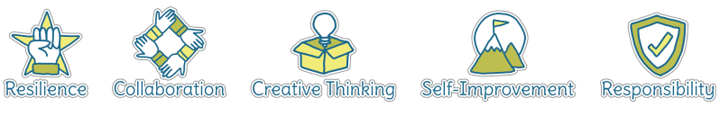
Five Ways to Wellbeing
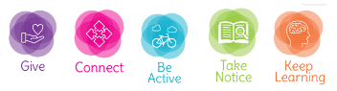

Vocabulary
Africa | One of the world’s largest continents (see link with KS1 geography)
African American | An American with African ancestors who were brought to America against their will to work as slaves
boycott | A form of protest where people refuse to buy or use the goods or services provided by a business or company
campaigner | Someone who works hard as part of a group to bring about changes they wish to see
Civil rights | These are the basic rights which all humans should have, e.g. the right to an education, the right to good healthcare, the right to be treated as an equal
civil war | A war fought between two or more groups of people who live in the same country
cotton | A plant that is used in the making of fabric for clothes
Jim Crow Laws | A set of laws which stated that black people had to use separate schools, toilets, hospitals and cafes. They were not allowed to go into buildings which were ‘For whites only’.
North America | One of the world’s largest continents – see link with KS1 geography
plantation | A very large farm which grows a crop such as cotton and tobacco. (These were usually owned by white European Americans.)
segregation | This is what happens when the law makes different groups of people live separate lives, using separate schools and other public services
slave | A person who is treated as someone else’s property and has no rights of their own. (Slaves have no rights and are often punished very harshly by their owners if they do not work hard enough or try to escape.)

Image/diagram that helps me to articulate my knowledge/understanding | Investigate!
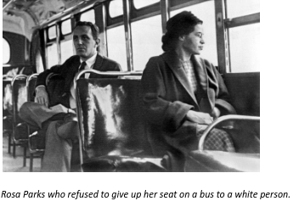  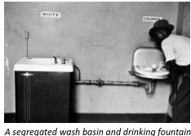  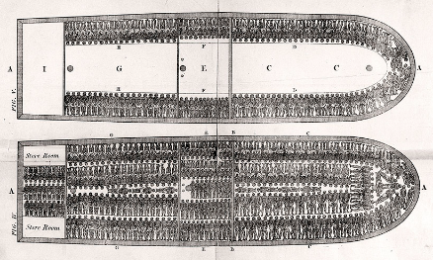  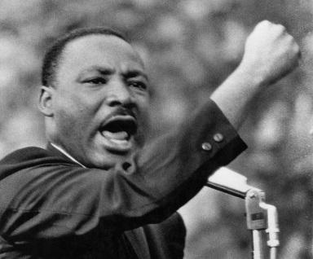  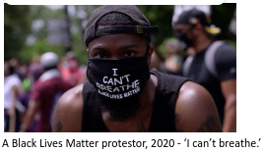 | Q: What do you see? Think? Wonder?

