Goonhavern Primary School- History
TOPIC: Black History- BLM- How did the British public treat black American soldiers during World War Two? | YEAR: 6 | STRAND: Changes in an aspect of social history

What should I know already? | What will I know by the end of the unit?
- Britain and the United States of America (USA) were allies in the Second World War. They fought against Nazi Germany and its ally, Japan.  - Modern black Americans, including those who fought for the USA in the First and Second World Wars, are the descendants of Africans who were brought to America to work as slaves. | - The United States joined the Second World War on Britain’s side in December 1941.  - Britain and America now joined forces to prepare to attack Nazi Germany which had occupied much of Europe by this time.  - American soldiers were shipped across the Atlantic Ocean and started arriving in Britain in large numbers in 1942.  - The American soldiers were known as GIs. (It is not known for certain what these two letters stood for!)  - Most of the GIs stationed in Britain were white but about 140,000 were black or African Americans.
School Values

Five Ways to Wellbeing


Vocabulary
Allies | Countries which fight alongside each other to defeat a common enemy
American | Someone who comes from the United States of America (USA)
Atlantic Ocean | A massive ocean that separates American from Europe
GI | A term used to describe American soldiers
Jim Crow laws | Racist laws passed by American states which forced black people to live apart from whites and banned them from using the same facilities and services
Segregated/Segregation | To separate races of people so that they are forbidden by law from mixing together

Image/diagram that helps me to articulate my knowledge/understanding | Investigate!
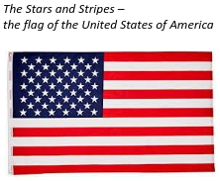  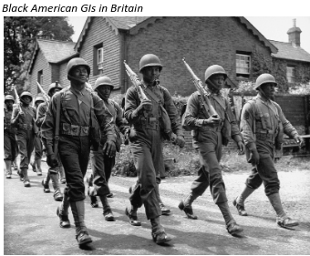  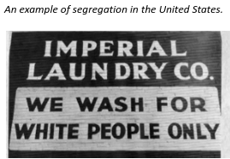  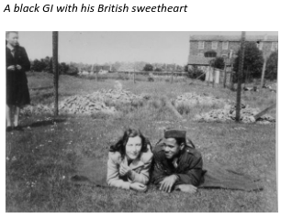  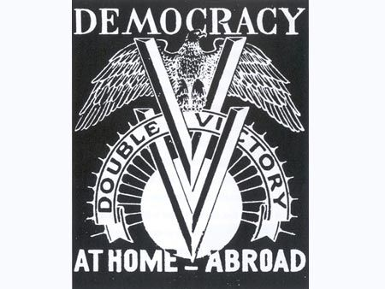 | Q: What do you see? Think? Wonder?  Q: How does what you have learnt relate to the present day, for example BLM?  Q: What was the Launceston gunfight?  Link: https://launcestonthen.co.uk/index.php/the-war-years/battle-of-launceston-court-martial/  Q: Who were the ‘Red Tails’?  Link: https://www.historyonthenet.com/red-tail-squadron
Thematic Study
Link: https://docs.google.com/document/d/1aXyJjTC2qH6c6DjpS-VxTWg4DCTKlfhJEGqljjKgA8g/edit

Children to research their own thematic study based on the treatment of black American soldiers and their studies of the two units.

