**Goonhavern Primary School**

**logo 2**

**Nurture the seed and together we will grow**

Calculation Policy

**Introduction**

This calculation guidance has been written in line with the programmes of study taken from the revised National Curriculum for Mathematics (2014). It provides guidance on appropriate calculation methods and progression. The content is set out in yearly blocks under the following headings: addition, subtraction, multiplication and division.

This guidance aims to develop, model and explain core understandings and mathematical principles and progression to ensure consistency in the teaching and learning of mathematics in our school.

Children will use mental methods as their first port of call taught through Big Maths when appropriate and it is **crucial** that these mental strategies are discreetly taught and linked to written strategies, but for calculations that they cannot do in their heads, they will need to use an efficient written method accurately and with confidence.

This guidance recognises that in all stages the use of pictorial and concrete resources is essential in developing pupils’ conceptual understanding before moving onto more abstract methods.

The overall aims of this guidance are that, when children leave our school they:

* have good understanding of the four operations supported by a fluency and understanding of the fundamentals of mathematics
* have developed an efficient, reliable, formal written method of calculation for all operations
* can use these methods accurately with confidence and understanding
* can use known facts in a variety of different contexts and apply the best strategy when problem solving
* can make use of concrete and pictorial resources to support calculation before moving onto the abstract
* can use calculation to justify answers and reason

**Addition**

**EYFS**

**Statutory Requirements:**

* **Early Learning Goal** – Children should count reliably with numbers from one to 20, place them in order and say which number is one more or one less than a given number. Use quantities and objects, add and subtract two single-digit numbers and count on or back to find the answer. Count on from first group to add two groups of object.

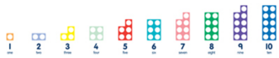Children in EYFS first learn about addition by playing with real objects and pictures. As they begin to build confidence with counting groups of objects they will progress to adding groups by combing them. Children should begin to construct simple number sentences verbally and with pictures initially before moving onto formal recording.

**A range of language linked to addition should be used:**

**plus**

**add**

**more**

**total**

**altogether**

**make**

**how many more is . . .?**

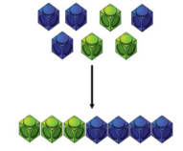



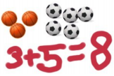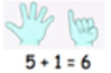

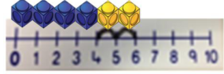

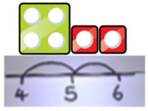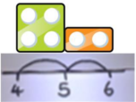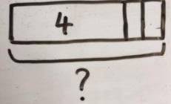

Adding in jumps bigger than one.

**Year 1**

**Statutory Requirements:**

* read, write and interpret mathematical statements involving addition (+) and equals (=) signs – THIS MEANS THE SAME AS – relate this to balance number sentences and scales
* represent and use number bonds and related subtraction facts within 20
* add one-digit and two-digit numbers to 20, including zero
* solve one-step problems that involve addition, using concrete objects and pictorial representations, and missing number problems such as 9 = □ + 7

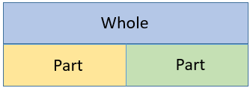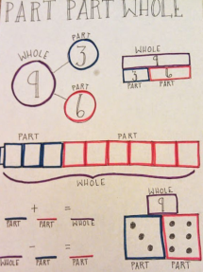In Y1 concrete resources and pictorial representations remain essential to develop children’s conceptual understanding. Primarily children will work with numbers within 20 as they learn to confidently cross the ten boundary. Developing the children’s ability to do this efficiently and in a number of different ways is a crucial step in understanding future calculations:

**Part-part whole**

Use this as a way of showing addition is commutative:

3 + 6 = 9

6 + 3 = 9

Progress to show = means the same as and move the = symbol:

? = 6 + 3

Counting on – learning that starting from the larger number is more efficient.

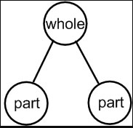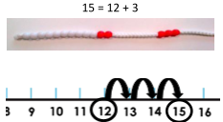

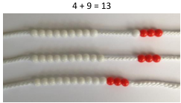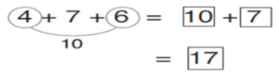

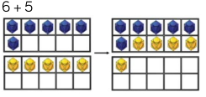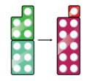

The Power of 10!

Learning the ‘power of making ten’ to aid addition is an important skill that will support later addition strategies.

**Year 2**

**Statutory Requirements:**

* solve problems with addition using concrete objects and pictorial representations, including those involving numbers, quantities and measures, apply their increasing knowledge of mental and written methods.
* recall and use addition facts to 20 fluently, and derive and use related facts up to 100
* add numbers using concrete objects, pictorial representations and mentally, including: a two-digit number and ones. a two-digit number and tens, two two-digit numbers and three one-digit numbers
* show that addition of two numbers can be done in any order (commutative) and subtraction of one number from another cannot
* recognise and use the inverse relationship between addition and subtraction and use this to check calculations and solve missing number problems

It is essential before moving on that children have a secure understanding of place value. The use of concrete resources and pictorial representations are crucial in developing this understanding.

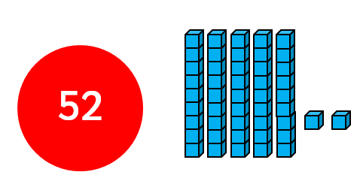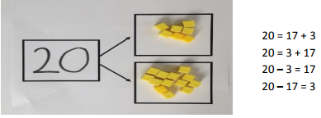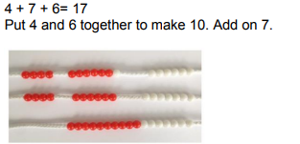 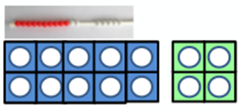

8 + 2 = 10

80 + 20 =100

800 + 200 = 1000

? = 8 + 2

10 = ? + 2

100 = ? + 20

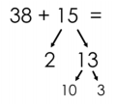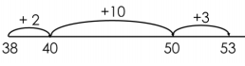

Addition is commutative.

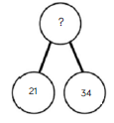**Year 3**

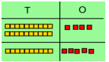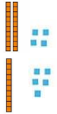

24+ 15 =

Concrete resources should be used to support mental calculation and not as an alternative to developing effective mental strategies.



**Statutory Requirements:**

* add numbers mentally, including: a three-digit number and ones, a three-digit number and tens and a three-digit number and hundreds
* add numbers with up to three digits, using formal written methods of column addition
* estimate the answer to a calculation and use inverse operations to check answers
* solve problems, including missing number problems, using number facts, place value, and more complex addition.

As in Y2 it is crucial that children have a secure understanding of place value as they move to more formal calculation strategies for addition; continuous checks and references should be made.

A review of addition without regrouping should be made before moving onto the methods outlined below.

*Concrete resources and pictorial representation remain essential in developing understanding, e.g. base 10 and place value counters.*

**Always calculate from the ones.**

**Checks should be made to ensure that children can make decisions about appropriate methods:**

**234+102 =**

**“Is a column method the best strategy? Why?”**

|  |  |  |  |  |  |
| --- | --- | --- | --- | --- | --- |
|  | H | T | O |  |  |
|  | 1 | 4 | 6 |  |  |
| + | 5 | 2 | 7 |  |  |
|  |  | 1 | 3 |  |  |
|  |  | 6 | 0 |  |  |
|  | 6 | 0 | 0 |  |  |
|  | 6 | 7 | 3 |  |  |

100 + 40 + 6

500 + 20 + 7

600 + 60 +13

600 + 70 + 3

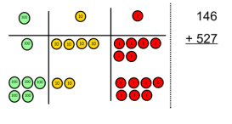

**Year 4**

**Statutory Requirements:**

* add with up to 4 digits using the formal written methods of column addition where appropriate
* estimate and use inverse operations to check answers to a calculation
* solve addition two-step problems in contexts, deciding which operations and methods to use and why

In Y4 the children will progress further from the expanded methods used in Y3. However children need to have a clear understanding of the concepts involved – again place value knowledge is crucial. It may be appropriate to revisit the methods taught in Y3 as a starting point.

**Concrete resources such as place value counters are useful way to develop conceptual understanding.**

It is beneficial to model this more compact alongside the expanded method initially (see Y3 addition).

2634 + 4517 =

= 2634 + 4517

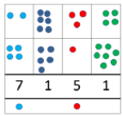

**Checks should be made to ensure that children can make decisions about appropriate methods:**

**3999 + 1001 =**

**“Is a column method he best strategy? Why?”**

**Throw in deliberate mistakes as a check for understanding.**

**Greater Depth – problem with missing digits.**

|  |  |  |  |  |
| --- | --- | --- | --- | --- |
|  | Th | H | T | O |
|  | 2 | 6 | 3 | 4 |
| + | 4 | 5 | 1 | 7 |
|  | 7 | 1 | 5 | 1 |
|  | 1 |  | 1 |  |

**Year 5**

**Statutory Requirements:**

* add whole numbers with more than 4 digits, including using column addition where appropriate
* add numbers mentally with increasingly large numbers
* use rounding to check answers to calculations and determine, in the context of a problem, levels of accuracy
* solve addition multi-step problems in contexts, deciding which operations and methods to use and why.

In Y5 the children will build on previous learning by working with bigger numbers and decimals (it is beneficial to put such numbers in context e.g. money). Larger groups of numbers may also be added e.g. three or four numbers.

Skill such as estimation and rounding to check the relevance of answers should also be taught.

|  |  |  |  |  |  |
| --- | --- | --- | --- | --- | --- |
|  | TTh | Th | H | T | O  When working with larger numbers model the correct placement of the comma:  96,646  Check children can confidently read these numbers. |
|  | 4 | 3 | 2 | 0 | 1 |
|  | 2 | 2 | 1 | 2 | 4 |
| + | 3 | 1 | 3 | 2 | 1 |
|  | 9 | 6 | 6 | 4 | 6 |

As a starting point ensure that children are clear that the decimal point **does not move** and this boundary is carried around.

Limit the amount of carrying initially so that the process is clear.

|  |  |  |  |  |  |  |
| --- | --- | --- | --- | --- | --- | --- |
|  | H | T | U |  | t | O |
|  | 1 | 3 | 2 |  | 5 | 2 |
| + | 2 | 1 | 3 |  | 8 | 3 |
|  | 3 | 4 | 6 |  | 3 | 5 |
|  |  |  | 1 |  |  |  |

£132.52 + £213.83 =

**Year 6**

**Statutory Requirements:**

* solve addition multi-step problems in contexts, deciding which operations and methods to use and why.

By the time the children reach Y6 they will be consolidating and building on existing strategies that have been taught but will be using bigger numbers and more complex decimals (to three decimal places).

They will select methods and use these methods as an efficient way of problem solving.

|  |  |  |  |  |  |  |
| --- | --- | --- | --- | --- | --- | --- |
|  | 1 | 2 | 0 | 5 | 3 | 7  When working with larger numbers model the correct placement of the comma:  678,029  Check children can confidently read these numbers. |
|  | 2 | 3 | 4 | 2 | 7 | 1 |
| + | 3 | 2 | 3 | 2 | 2 | 1 |
|  | 6 | 7 | 8 | 0 | 2 | 9 |
|  |  |  | 1 | 1 |  |  |

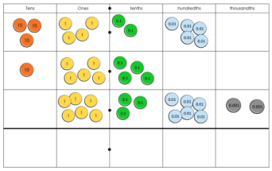

|  |  |  |  |  |  |  |  |
| --- | --- | --- | --- | --- | --- | --- | --- |
|  |  | 3 | 4 | **.** | 2 | 5 | 0  With a more complex decimal calculation draw attention to the role of 0 as place holder to ensure a clear understanding of place value.  Concrete resources and pictorial representations remain appropriate. |
|  |  | 1 | 5 | **.** | 4 | 0 | 0 |
| + |  |  | 6 | **.** | 3 | 6 | 2 |
|  |  | 5 | 6 | . | 0 | 1 | 2 |
|  |  | 1 | 1 |  | 1 |  |  |

**Subtraction**

**EYFS**

**Statutory Requirements:**

* **Early Learning Goal** - Children should count reliably with numbers from one to 20, place them in order and say which number is one more or one less than a given number. Use quantities and objects, add and subtract two single-digit numbers and count on or back to find the answer.

The starting point of subtraction should involve plenty of first-hand experience with concrete apparatus and modelling of physically removing objects when ‘taking away’.



Count how many are left when two are taken away.

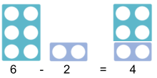

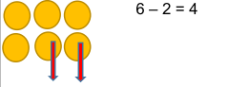

Children should begin to construct simple number sentences verbally and with pictures initially before moving onto formal recording.

**A range of language linked to subtraction should be used:**

**take away**

**leave**

**how many are left/left over?**

**how many have gone?**

**one less, two less . . .**

**difference between**



Early Problem Solving

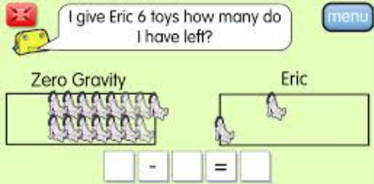**Year 1**

Using number lines to count back in steps of one.

**Statutory Requirements**

* read, write and interpret mathematical statements involving subtraction (-) and equals (=) signs
* represent and use number bonds and related subtraction facts within 20
* subtract one-digit and two-digit numbers to 20, including zero
* solve one-step problems that involve subtraction, using concrete objects and pictorial representations, and missing number problems such as 9 = □ - 7.

In year 1 children build on their learning in the EYFS. Concrete resources and pictorial representations remain essential in building conceptual understanding.

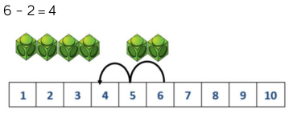

Children should continue to make use of number lines and number tracks to aid calculation but move on to using their number bond knowledge as they become more efficient.

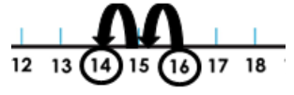

Progress to finding the difference.

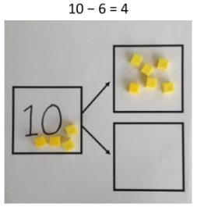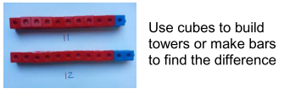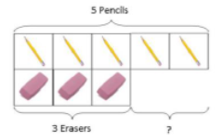

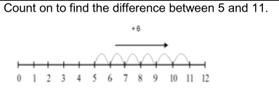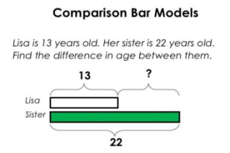

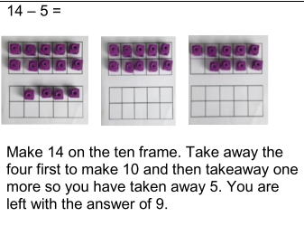

Part-part whole

Teach addition alongside subtraction

Variation – this is essential:

7 – 3 = ? 7 - ? = 4 ? – 3 = 4

? = 7-3 4 = ? – 3 4 = 7-?

**Year 2**

**Statutory Requirements:**

* solve problems with subtraction: using concrete objects and pictorial representations, including those involving numbers, quantities and measures and apply their increasing knowledge of mental and written methods
* recall and use subtraction facts to 20 fluently, and derive and use related facts up to 100
* subtract numbers using concrete objects, pictorial representations, and mentally, including: a two-digit number and ones, a two-digit number and tens, two two-digit numbers and subtract three one-digit numbers
* show that addition of two numbers can be done in any order (commutative) and subtraction of one number from another cannot
* recognise and use the inverse relationship between addition and subtraction and use this to check calculations and solve missing number problems

Children build on the learning in year one by initially using a number line to take away and then progress to using a number line to show the difference with larger numbers; including crossing tens boundaries.

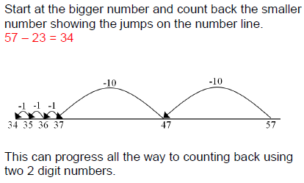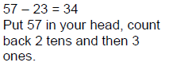

Towards the end of Y2 it may be appropriate to introduce the children to the very early stages of the column method – with no regrouping and using concrete resources (base 10). This does not include formal recording.

Taking away on a number line. Progression to taking away in larger steps.

Progression to Abstract.

**Count on to find the difference.**

Model ‘jumping’ to the next 10 to make jumps straight forward.

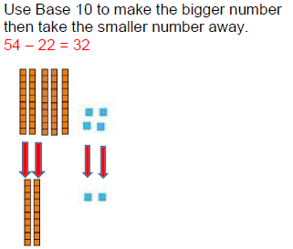

Such methods should not replace effective mental calculation strategies in the first instance.



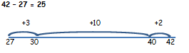**Year 3**

**Statutory Requirements:**

* subtract numbers mentally, including: a three-digit number and ones, a three-digit number and tens, a three-digit number and hundreds, a three-digit number and thousands
* subtract numbers with up to three digits, using formal written methods of column subtraction where appropriate
* estimate the answer to a calculation and use inverse operations to check answers
* solve problems, including missing number problems, using number facts, place value, and more complex subtraction.

In year 3 the children will be begin to use the formal column method. It is essential that this builds on previous learning and their knowledge and understanding of place value. This formal method **should not** replace effective mental strategies and at all stages children should be encouraged to use their number sense to decide on the most appropriate methods.

Introduction to the formal method should begin with concrete resources to support.

When/if children are secure with this then they can be exposed to exchanging using concrete resources initially. **Start with single exchanges.**

Show the exchange of 1 ten for 10 ones.

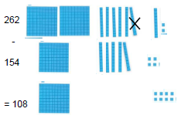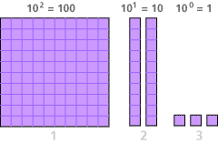

346 – 123 =

= 346 - 123

|  |  |  |  |
| --- | --- | --- | --- |
|  | H | T | O |
|  | 3 | 4 | 6 |
| - | 1 | 2 | 3 |
|  | 2 | 2 | 3 |

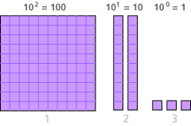

**No exchange at this stage**

262 – 154 =

200 50 **12**

-100 50 4

100 0 8 = **108**

**Year 4**

**Statutory Requirements:**

* subtract with up to 4 digits using the formal written methods of column subtraction where appropriate
* estimate and use inverse operations to check answers to a calculation
* solve subtraction two-step problems in contexts, deciding which operations and methods to use and why

Subtraction in year 4 builds on the concepts taught in year 3. Numbers will increase in size and the children will be exposed to more exchanging. The methods taught in Y3 should be the starting point and concrete resources and pictorial representations remain essential.

Progress to 4 digit numbers and subtract 3 and 4 digit numbers – initially with one exchange.

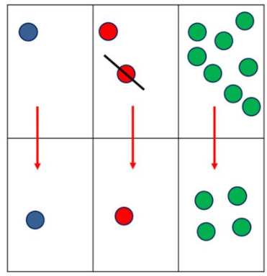

H

T

O

Teach skills of estimation and using the inverse to check answers.

|  |  |  |  |
| --- | --- | --- | --- |
|  | H  2 | T  1 | U |
|  | 2 | 3 | 2 |
| - | 1 | 1 | 4 |
|  | 1 | 1 | 8 |

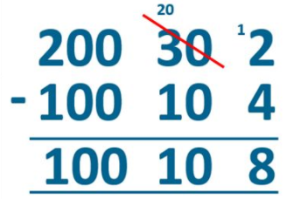

Begin to apply the method into problem solving contexts.

Model writing the formal method alongside the practical example

Take care with choice of number initially.

Avoid examples where a mental strategy is more appropriate.

**Year 5**

**Statutory Requirements:**

* subtract whole numbers with more than 4 digits, including the use of column subtraction
* subtract numbers mentally with increasingly large numbers
* use rounding to check answers to calculations and determine, in the context of a problem, levels of accuracy
* solve subtraction multi-step problems in contexts, deciding which operations and methods to use and why.

Subtraction in year 5 builds on the previous learning in lower KS2 but now the children will begin work with larger numbers; initially up to 100,000 and then up to 1,000,000. The amount of exchanges that are involved will progress from one to two. Children should use the skills of estimation to check if their answers are reasonable.

Support using concrete resources and pictorial representations remains appropriate: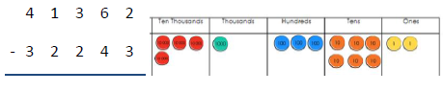

Modelling using concrete resources alongside the abstract helps to embed understanding.

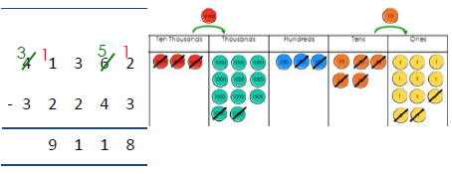

It is crucial that effective and efficient mental strategies are not replaced by this standard method.

Children should be given opportunities to look at numbers and decide when other strategies are more appropriate:

30,001 – 29,999 = ?

24,220 – 1120 = ?

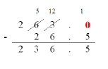

**PROGRESS TO DECIMAL NUMBERS – real life contexts (£)**

Teach what happens when a new exchange is placed next to a previous exchange.

**Year 6**

**Statutory Requirements:**

* solve subtraction multi-step problems in contexts, deciding which operations and methods to use and why.

By the time the children reach Y6 they will be consolidating and building on existing strategies that have been taught but will be using bigger numbers (up to 10,000,000)and more complex decimals (to three decimal places).

They will select methods and use these methods as an efficient way of problem solving.

Children will need to use their knowledge of decimal points to line up their numbers and to place zeroes in any empty places.

Pupils apply their prior learning of subtraction strategies to solve more complex problems and word problems:

632, 465 + (745, 676 – 325,534) =

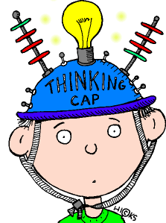

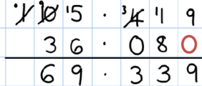

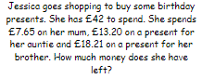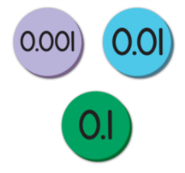

Use of concrete resources to support e.g. place value

**EYFS**

**Multiplication**

**Statutory Requirements:**

* **Early Learning Goal** - Children count reliably with numbers from one to 20, place them in order and say which number is one more or one less than a given number. Using quantities and objects, they add and subtract two single-digit numbers and count on or back to find the answer. **They solve problems, including doubling, halving and sharing.**

As in the other operations the use of concrete resources is essential in develop understanding. Early understanding of multiplication will build on previous learning with addition – initial links should be introduced **by doubling**. Progression will see the use of concrete resources and pictorial representations to help children visualise repeated addition of the same number.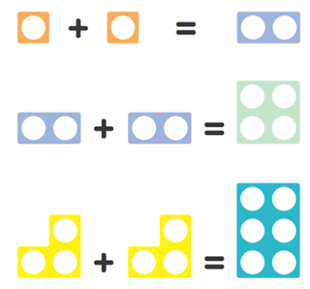



**A range of language linked to multiplication should be used:**

**lots of**

**groups of**

**times (once, twice etc.)**

**multiply**

**add again and again**

**double**

Double 1 is . . .

Double 2 is . . .

Doubling with Numicon



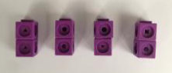**Year 1**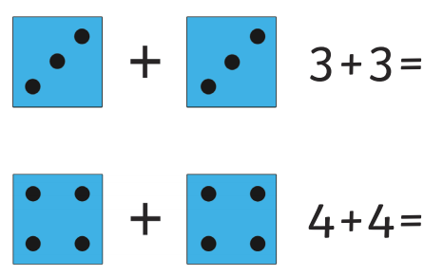

How many of groups of 2?

2+2+2+2+2 =

*5 groups of 2*

Make clear that doubling is adding the same number.

**Statutory Requirements:**

* solve one-step problems involving multiplication, by calculating the answer using concrete objects, pictorial representations and arrays with the support of the teacher.

Multiplication in year 1 builds on the learning in EYFS. It is important that children have a secure understanding of doubling before moving on. Concrete resources and pictorial representations should be then used to develop children’s understanding of multiplication being ‘groups of’.

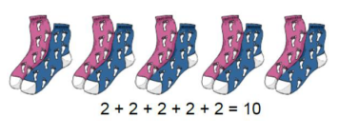

Use concrete resources to model objects being put in groups. Children initially count in groups e.g. 2,4,6,8.

Progress to lining with the calculation:

**4 x 2 = 8**

**Count in multiples of 2, 5, and 10.**

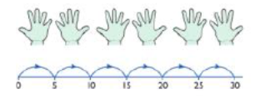

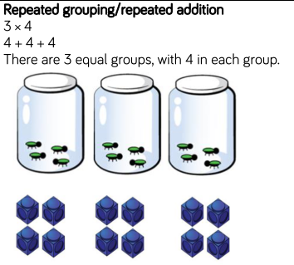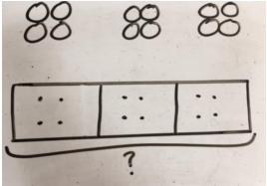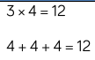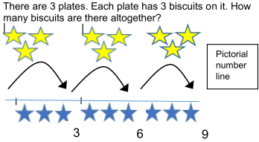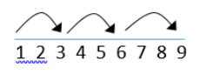

Simple one step problems using number lines to support.

Repeated addition

**Year 2**

**Statutory Requirements:**

* recall and use multiplication facts for the 2, 3 and 5 and 10 multiplication tables, including recognising odd and even numbers
* calculate mathematical statements for multiplication within the multiplication tables and write them using the multiplication (×) and equals (=) signs
* show that multiplication of two numbers can be done in any order (commutative) and division of one number by another cannot
* solve problems involving multiplication and division, using materials, arrays, repeated addition, mental methods, and multiplication and division facts, including problems in contexts.

Times Tables - Pupils recall x2, x5, x10 and x3. Doubling and doubling again should be used to progress to x4.

Multiplication in year 2 builds on the children’s prior learning and at this stage children should have fluent recall of the **2,5 and 10 times table** (progression may take place to the 4 times table by doubling and doubling again). A lot of focus should be on the use of arrays, both through the use of concrete resources and pictorial representations, to demonstrate that multiplication is commutative; a bar model can also be used to show this. 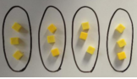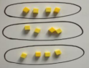

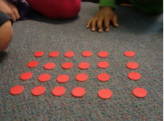

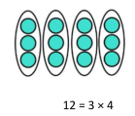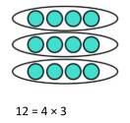

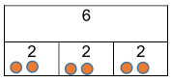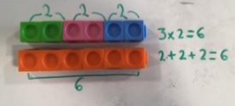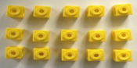**Year 3**

Use arrays to write a range of multiplication sentences and to reinforce repeated addition:

5+5+5 = 15

3+3+3+3+3 = 15

5x3 = 15

3 x5 = 15

**Statutory Requirements:**

* recall and use multiplication facts for the 3, 4 and 8 multiplication tables
* write and calculate mathematical statements for multiplication using the multiplication tables that they know, including for two-digit numbers times one-digit numbers, using mental and progressing to written methods
* solve problems involving missing number problems involving multiplication including positive number scaling problems and correspondence problems where n objects are connected to m objects.

In year 3 multiplication builds on the use of arrays that were introduced in year 2. The use of concrete resources and pictorial representations remains imperative as the children use strategies which will become the building block for more formal methods.

Times Tables - Pupils recall x2, x5, x10, x3, x4, x6, ,x8 and x9. For x4 and x8 use doubling to help recall.

Arrays used as a way of initially introducing the grid method. After this base 10 can then be used as the children use more compact methods and recording.

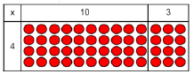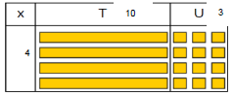

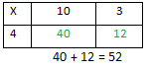

Progress to using this expanded ‘grid’ method alongside the other methods initially.

4 x 13

10 3

4 x 3 = 12

4 x 10 = 40

30 + 12 = 52

Encourage children to think about and show the steps that they have taken.

Begin to draw links with multiples of 10 and 100 through carefully selected variation:

4 x 6 = 24

4 x 60 = 240

4 x 600 = 2400

60 x 4 = 240

600 x 4 = 2400

**Year 4**

**Statutory Requirements**

* use place value, known and derived facts to multiply mentally, including x0 x1 and multiplying together three numbers
* recognise and use factor pairs and commutativity in mental calculations
* multiply two-digit and three-digit numbers by a one-digit number using formal written layout
* solve problems involving multiplying, including the distributive law to multiply two-digit numbers by one-digit including positive number scaling problems and correspondence problems where n objects are connected to m objects

At this stage children build in previous strategies. They should be using their times table knowledge and apply this to multiples of 10 e.g. 3 x4 = 12 and 3 x **40** = 120.

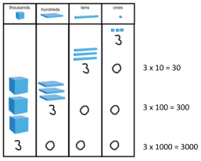

Times Tables - Pupils recall and use all table facts up to and including 12 x 12

Applying place value knowledge.

In the early stages of multiplying 1 digit numbers by 2 and 3 digit numbers use this expanded method. Remind children to draw on place value knowledge.

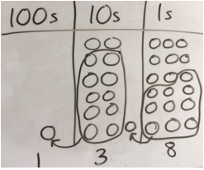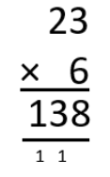

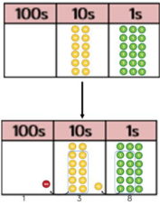

When children are confident with previous methods progress to a more formal method of multiplication.

Concrete resources (place value counters) are **essential** at this stage. Do not rush this stage and make sure children are confident in showing and understanding any exchanging.

**Year 5**

**Statutory Requirements:**

* identify multiples and factors: all factor pairs of a number, common factors of two numbers, establish whether a number up to 100 is prime and recall prime numbers up to 19
* multiply numbers up to four digits by a one- or two-digit number using a formal written method
* multiply whole numbers and those involving decimals by 10, 100 and 1000.

In year 5 the children begin to multiply bigger numbers and progress to multiplying by 2 digits. However, it is entirely appropriate to revisit and check methods from year 4 to ensure that their place value knowledge and understanding of carrying is secure.

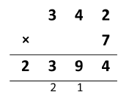

Short multiplication – at all stages check that the children understand the process of carrying. If necessary revisit with the use of concrete resources.

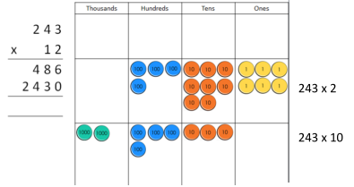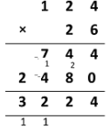

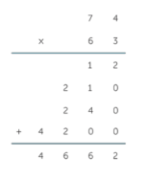

3 x 4

3 x 70

60 x 4

60 x 70

When multiplying by 2 digit numbers start with this extended method. Children should initially write the calculations used down at the side.

Draw attention to zeros as place holders and use place value knowledge.

Extend understanding as the children move to formal long multiplication by using place value counters; at first with no carrying. If children are ready then progress to simple calculations using formal long multiplication.

**Year 6**

**Statutory Requirements:**

* identify multi-digit numbers up to 4 digits by a two-digit number using formal, long multiplication
* identify common factors, common multiples and common prime numbers
* use their knowledge of the order of operations to carry out calculations involving the four operations

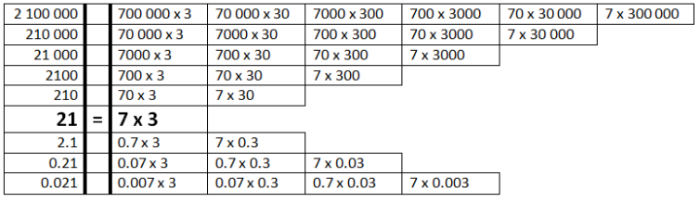Multiplication in year 6 builds on and consolidates on the formal methods taught in year 5. As in other operations it is crucial that the children’s use of formal methods is based upon a clear understanding of the mathematical processes involved, particularly place value knowledge and carrying.

Multiplication facts from a known fact.

When multiplying decimals, initially begin by using the extended method.

As confidence grows children may find other strategies e.g. multiply by 10 to eliminate decimal pint and then adjust the answer.

|  |  |  |  |  |
| --- | --- | --- | --- | --- |
|  | 2 | 3 | 1 | 4 |
|  | X |  | 2 | 3 |
|  | 6 | 9 | 4  1 | 2 |
| 4 | 6 | 2 | 8 | 0 |
| 5  1 | 3  1 | 2  1 | 2 | 2 |
|  | 3 | 6 |  | 2 |
| x |  | 7 |  |  |
|  |  | 1 |  | 4 |
|  | 4 | 2 |  | 0 |
| 2 | 1 | 0 |  | 0 |
| 2 | 5 | 3 |  | 4 |

Reinforce zero as a place holder

**Division**

**EYFS**

**Deadly Divider**

**Statutory Requirements:**

* **Early Learning Goal** - Children count reliably with numbers from one to 20, place them in order and say which number is one more or one less than a given number. Using quantities and objects, they add and subtract two single-digit numbers and count on or back to find the answer. **They solve problems, including doubling, halving and sharing**

Early division should be introduced in EYFS predominately using language such as halving and sharing. To develop an understanding of the concepts children should use concrete resources and see representations of division as both grouping and sharing.

Sharing

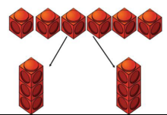

Early division needs to include lots of practical opportunities to halve various objects.



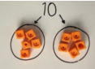

**Year 1**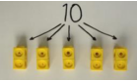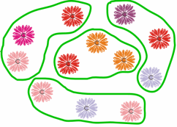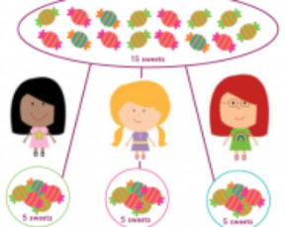

**A range of language linked to division should be used:**

**halve**

**share – share equally**

**groups of**

**divided by**

**left, left over**

Mum had 6 socks. She grouped them into pairs. How many pairs did she have?

Grouping

**Statutory Requirements:**

* solve one-step problems involving division, by calculating the answer using concrete objects, pictorial representations and arrays with the support of the teacher.

In year one the children continue to work practically with concrete resources to develop a greater understanding of division as grouping or sharing. They will progress to using pictorial representations but will need continued support to avoid misconceptions.

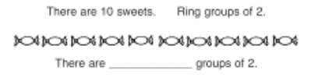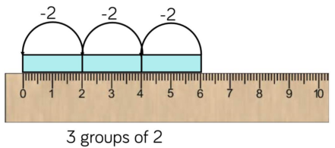

Introduce practical problems and allow children to use concrete resources to support:

*12 cakes are shared between 4 friends. How many does each friend get?*

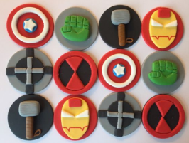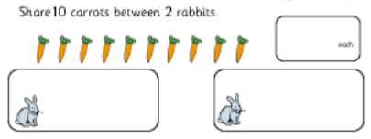

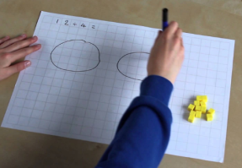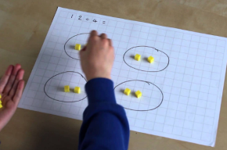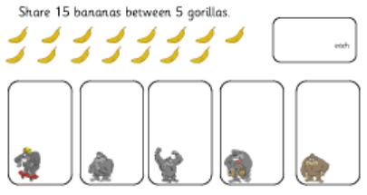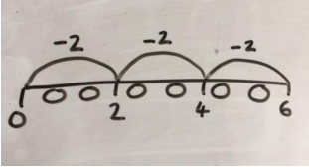

Use a range of problems and give opportunities for the children to **share equally.**

Introduce a number line to show the number ‘chunks’ when sharing.

**Year 2**

**Statutory Requirements:**

* recall and use multiplication and division facts for the 2, 3, 5 and 10 multiplication tables, including recognising odd and even numbers
* calculate mathematical statements for division within the multiplication tables and write them using the signs ÷ and =
* show that multiplication of two numbers is commutative but division is not
* solve problems involving division using materials, arrays, repeated addition, mental methods and division facts, including problems in contexts.

Division in year 2 builds on and follows on from the learning in year 1 with multiplication and is again linked to the use of arrays to develop greater conceptual understanding. The use of concrete resources and pictorial representations remains essential. The focus should be around using divisors of 2,5 and 10 (before progressing to 3).



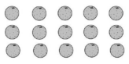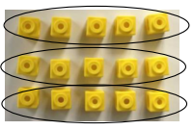

Link division to multiplication.

As children become more confident they can explore other divisors.

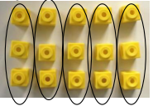

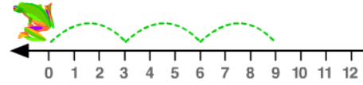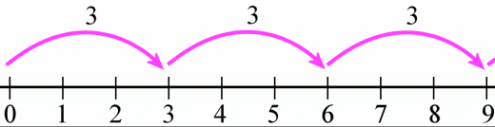**Year 3**

No remainders at this stage.

Add variation by looking at grouping e.g. How many 3s make 9?

Division as repeated subtraction

Link to multiplication and show how number sentences are linked.

**Statutory Requirements:**

* recall and use multiplication and division facts for the 3, 4 and 8 x tables
* write and calculate mathematical statements for division using the multiplication tables they know, including 2-digit divided by 1-digit using mental and progressing to formal written methods
* solve problems, involving missing number problems, involving division, including positive number scaling problems and correspondence problems where n objects are connected to m objects.

In order to access the curriculum at this stage it is essential that the children are developing fluency with their times tables as they will be beginning to work with a wider range of divisors: x2, x5, x10, x3, x4, x6, ,x8 and x9. Strategies should be supported heavily at the beginning with concrete resources and pictorial representations.

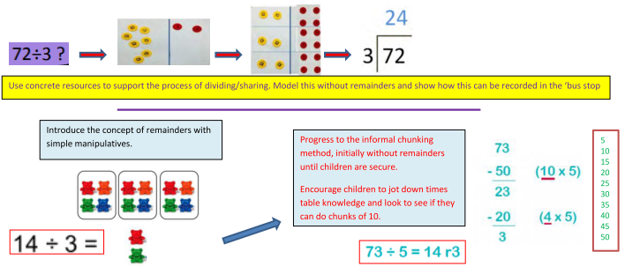

Use concrete resources to support the process of dividing/sharing. Model this without remainders and show how this can be recorded more formally. Ensure that questions are appropriate and do not include examples where a mental strategy is the most appropriate.

**Year 4**

**Statutory Requirements:**

* recall multiplication and division facts up to 12 x 12
* use place value, known and derived facts to divide mentally, including dividing by 1
* solve problems involving dividing a three-digit number by one-digit and number using a formal layout

Division in year 4 builds on the informal method taught in year 3. It is crucial that the children are becoming increasingly fluent with their times table knowledge and associated facts. As they begin to divide using bigger ‘chunks’ it is also essential that their place value knowledge is secure, in order to readily access the concepts involved.

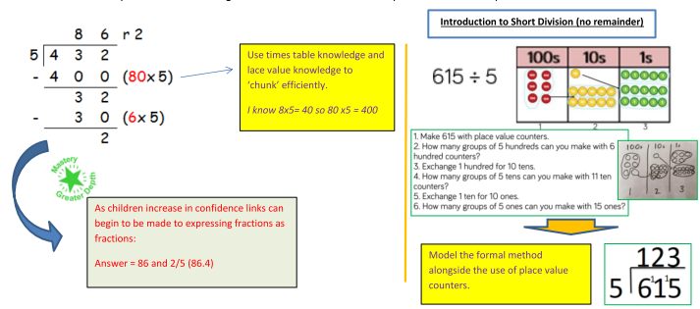

**Year 5**

**Statutory Requirements**

* identify multiples and factors, including finding all factor pairs of a number, common factors of two numbers, know and use the vocabulary of prime numbers and establish whether a number up to 100 is prime
* multiply and divide numbers mentally drawing on known facts
* divide numbers up to 4 digits by a one-digit number using a written method and interpret remainders appropriately for the context
* divide whole numbers and those involving decimals by 10, 100 and 1000.

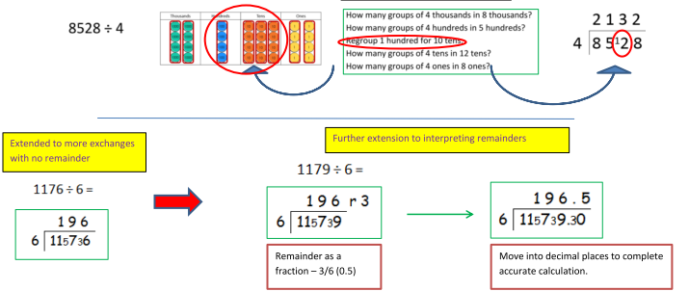In year 5 the children will begin to work with bigger numbers and a wider range of divisors. They will need to spend time the challenging concepts taught in year 4, particularly with exchanging. It is appropriate to continue to use place value counters as a mechanism for support.

**Year 6**

**Statutory Requirements:**

* divide numbers up to 4 digits by a two-digit number using the formal written method of long division, and interpret remainders as whole number remainders, fractions, or by rounding as appropriate for the context.
* divide numbers up to 4 digits by a two-digit number using the formal written method of short division as appropriate.

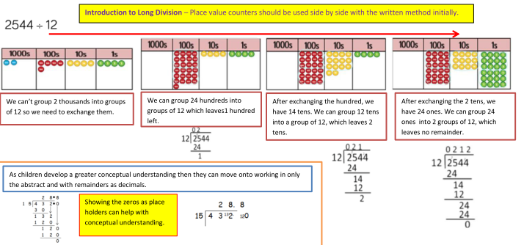In year 6 checks should be made to ensure children are confident in the formal method of short division (see year 5). Following this they will be introduced to long division, initially supported with concrete resources (place value counters).