Goonhavern Primary School- Music
TOPIC: How does music teach us about looking after our planet? | YEAR: 1 | STRAND: Explore sound and create a story

What should I know already? | What will I know by the end of the unit?
I am able to sing songs and make pieces of music using a range of sounds. I can improvise on a glockenspiel or xylophone. I can recognise high and low notes. I can play and sing songs by ear. I can recognise rests and create melodies using music technology. I can compose pieces of music which start and end on the same note. | I can explain the story told by a song.
 | I can compose a melody using up to 5 notes.
 | I can write down my composition so I can play the same thing a number of times.
 | I can start my composition on note 1 and end it on note 1.
 | I can play along to a song using natural notes and sharp notes.
 | I can sing along to songs and perform to others.
School Values
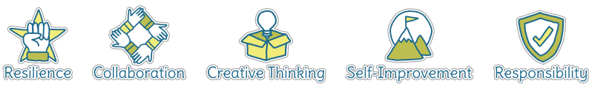
Five Ways to Wellbeing
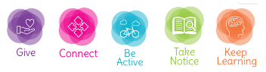

Vocabulary
Improvise | To create and perform without preparation.
Composition | To make up a piece of music.
Melody | A sequence of single notes that makes a musical tune.
Sharp | It looks like a hashtag and has to be played a semitone higher than the natural note. On a glockenspiel, it’ll be a black note instead of a white note.
Natural notes | The notes A, B, C, D, E, F and G - represented by the white notes on a glockenspiel, keyboard or piano.
Notes | A written sign to represent the pitch and duration within music.

Image/diagram that helps me to articulate my knowledge/understanding | Investigate!

