Goonhavern Primary School- Music
TOPIC: What songs can we sing to help us through the day? | YEAR: 1 | STRAND: Having fun with improvisation

What should I know already? | What will I know by the end of the unit?
I am able to sing songs and make pieces of music using a range of sounds. I can improvise on a glockenspiel or xylophone. I can recognise different pitches. I can play and sing songs by ear. I can recognise rests and create melodies using music technology. | I can play up to 6 notes along to a song using a glockenspiel.
 | I can learn the names of notes either by memory or when they’re written down.
 | I can treat instruments with respect.
 | I can compose a melody using up to 5 notes.
 | I can write down my composition so I can play the same thing a number of times.
 | I can start my composition on note 1 and end it on note 1.
School Values
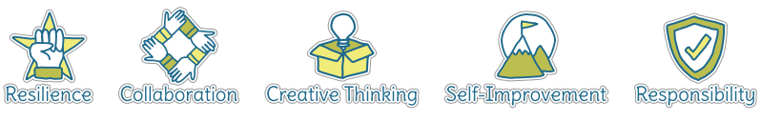
Five Ways to Wellbeing
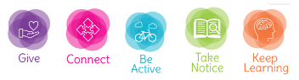

Vocabulary
Improvise | To create and perform without preparation.
Composition | To make up a piece of music.
Melody | A sequence of single notes that makes a musical tune.
Notes | A written sign to represent the pitch and duration within music.
Beat | A regular, rhythmic (and sometimes strong) sound.

Image/diagram that helps me to articulate my knowledge/understanding | Investigate!

