Goonhavern Primary School- Music
TOPIC: How does music make us happy? | YEAR: 2 | STRAND: Music that makes you dance

What should I know already? | What will I know by the end of the unit?
I am able to sing songs and make pieces of music using a range of sounds. I can improvise on a glockenspiel or xylophone. I can recognise high and low notes. I can play and sing songs by ear. I can recognise rests and create melodies using music technology. I can explain what the words ‘tempo’ and ‘dynamics’ are. I can copyback rhythms and make up rhythms for others to play back. | I can use musical language when describing music.
 | I can clap rhythms back including quaver rests and recognise the note values.
 | I can improvise using a range of notes along to a backing track.
 | I can recognise and sing low and high notes.
 | I can explain my thoughts, feelings and emotions towards songs.
 | I can sing in a group and develop confidence to sing a solo.
 | I can perform my compositions to others.
 | I can play music by listening with my ear or using standard notation.
School Values
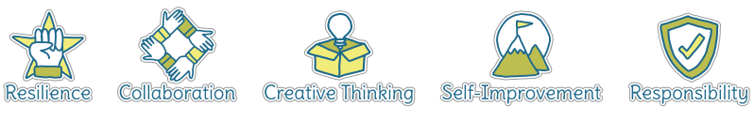
Five Ways to Wellbeing
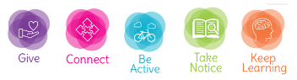

Vocabulary
Dynamics | How loud or quiet a piece of music is.
Composition | To make up a piece of music.
Quavers | A musical note worth half a beat.
Crotchets | A musical note worth one full beat.
Minims | A musical note worth two full beats.
Melody | A sequence of single notes that makes a musical tune.
Tempo | How fast or slow a piece of music is.
Notes | A written sign to represent the pitch and duration within music.
Beat | A regular, rhythmic (and sometimes strong) sound.
Rests | A pause within a piece of music (worth one whole note value).
Standard notation | The universal visual symbols for sound.

Image/diagram that helps me to articulate my knowledge/understanding | Investigate!

